100第一次國民中學基本學力測驗 英語科題本
班級： 座號： 姓名：

第一部分：下列各題（題號1-20），請依據題意選出一個正確或最佳的答案。
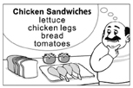
（C） 1. Look at the picture. What did the man forget to prepare?
(A) Bread.
(B) Chicken legs.
(C) Lettuce.
(D) Tomatoes.
（A） 2. Alice really likes having noodles for breakfast,
?
(A) doesn’t she (B) is she
(C) hasn’t she (D) did she
（A） 3. Mr. Hu speaks good English he lived in the U.S. for many years.
(A) because (B) but
(C) so (D) whether
（C） 4. Reese likes to sleep with music on, so she usually turns on the before she goes to bed.
(A) coffee machine (B) lamp
(C) radio (D) washing machine
（A） 5. Although the rich woman has everything, she still feels with her life and wants to try something new.
(A) bored (B) easy
(C) lazy (D) strong
（B） 6. Every time Grandpa forgets where he puts his cellphone in the house, he always calls his own number with my cellphone to it.
(A) count (B) find
(C) notice (D) pick
（A） 7. Gina worked late and was worried she might not be able to catch the bus. , she saw a bus coming just after she arrived at the bus station.
(A) Luckily (B) Quickly
(C) Safely (D) Truly
（D） 8. My daughter is much now. The pants she wore last year are already too short for her.
(A) higher (B) longer
(C) older (D) taller
（B） 9. I usually carry a camera on my trips; taking pictures a good way for me to remember the experience.
(A) to be (B) is
(C) being (D) are
（C）10. When I entered the house for the first time, I found
was a big round table in the living room.
(A) it (B) that
(C) there (D) this
（D）11. The noise those boys are making is giving me a(n)
. Can you do anything about it?
(A) break (B) excuse
(C) hand (D) headache
（D）12. After a big party, it took me time to clean the apartment. I’m tired now.
(A) enough (B) every
(C) little (D) some
（C）13. Gary is the best teacher I’ve ever known. No one
teaches so well.
(A) all (B) another
(C) else (D) other
（D）14. Most of the along this road were knocked down during the typhoon. So make sure no cars are coming when you cross the street.
(A) bus stops (B) motorcycles
(C) public phones (D) traffic lights
（A）15. My dog, Lucy, was lying on the sofa the fan on the wall. So when the fan fell, she was hit right on the head.
(A) under (B) off
(C) from (D) down
（D）16. Bob: Why is the house full of ?
Liz: Oh, no! Looks like it got on fire. I hope
everyone in there has run out.
(A) joy (B) kids
(C) mice (D) smoke
（A）17. Elise: I need a dress for tomorrow’s party, but I
don’t have one.
Fiona: Why don’t you try on my red one?
I bought last week.
(A) it (B) one
(C) ones (D) them
（C）18. Mom: Lily, can you help me ?
Lily: Sure. Where’s the brush?
(A) mail the letters (B) move the boxes
(C) paint the door (D) turn off the light
（C）19. Rose: Who’s that man wearing a white jacket?
Lisa: He’s Dr. Wu’s son.
Rose: Really? They look like brothers
than father and son.
(A) as (B) less
(C) more (D) not
（D）20. Linda: Jenny, will you still be here this afternoon?
Jenny: Yeah, I think I’ll stay five. Then
I’ll leave for dinner.
(A) at (B) for
(C) since (D) until
第二部分：下列十個題組，共有25題（題號21-45），請依據選文或所附圖表資料，選出一個正確或最佳的答案。
(21-24)
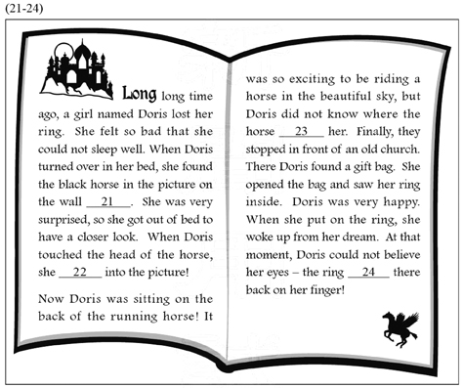
（C）21. (A) is moving (B) has moved
(C) was moving (D) will move
（B）22. (A) is pulled (B) was pulled
(C) has been pulled (D) would be pulled
（D）23. (A) took (B) is taking
(C) has taken (D) would take
（B）24. (A) is (B) was
(C) has been (D) would be
(25-26)
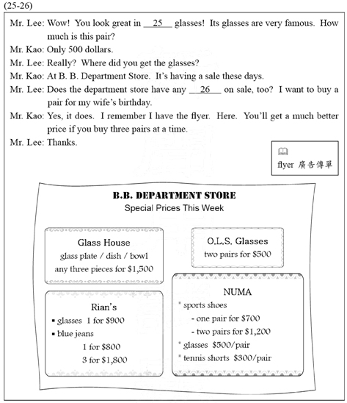
（D）25. (A) Glass House (B) O.L.S.
(C) Rian’s (D) NUMA
（B）26. (A) glass plates (B) blue jeans
(C) sports shoes (D) tennis shorts
(27-28)
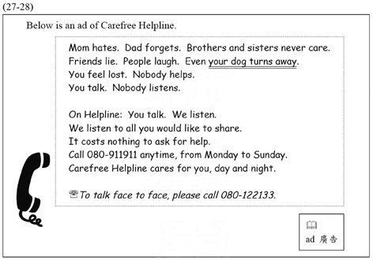
（C）27. Which is NOT said about Carefree Helpline?
(A) They listen to people in trouble.
(B) People can talk face to face with them.
(C) They collect money for people in need.
(D) People can call them anytime, any day.
（B）28. What does your dog turns away mean in the
reading?
(A) Your dog bites other people.
(B) Your dog does not care about you.
(C) Your dog is kicked and runs away.
(D) Your dog cannot find its way home.
(29-31)
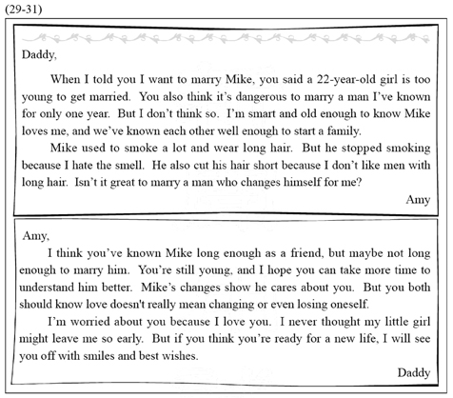
（A）29. What is Amy trying to tell her father?
(A) Mike is the right person for her.
(B) Mike cares a lot about her family.
(C) She feels sorry about breaking her father’s heart.
(D) She thanks her father for what he has done for her.
（D）30. What can we learn about Amy’s father?
(A) He has known Mike for over one year.
(B) He will not let Amy leave him so early.
(C) He thinks love means changing for another person.
(D) He is afraid Amy has not thought carefully enough.
（C）31. What do we know from the reading?
(A) Mike is too young for Amy.
(B) Mike does not like a girl who smokes.
(C) Amy thinks she is ready for a new life.
(D) Amy loves Mike the way he used to be.
(32-33)
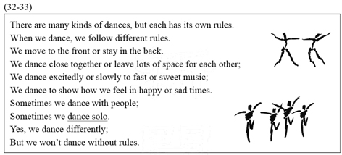
（A）32. Which is NOT said about dancing?
(A) It is a difficult job.
(B) It has rules to follow.
(C) It shows how people feel.
(D) It is done in several ways.
（B）33. What do you do when you dance solo?
(A) You dance excitedly.
(B) You dance by yourself.
(C) You dance in a public place.
(D) You dance without shoes on.
(34-35)
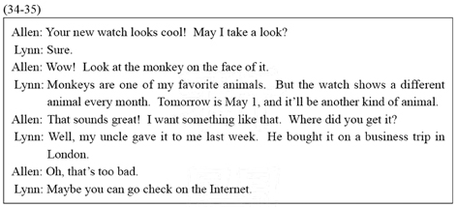
（B）34. Where was Lynn’s watch bought?
(A) On the Internet.
(B) In an English city.
(C) In the zoo near her school.
(D) At a gift shop near her house.
（C）35. What may Lynn’s watch look like on May 1?
(A)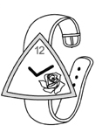 (B)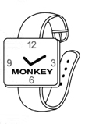
(C)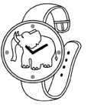 (D)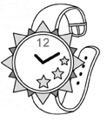
(36-37)
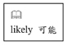
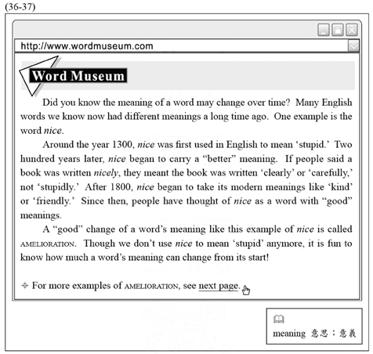
（B）36. Here are four sentences from the Word Museum. Which is most likely to appear on the next page?
(A) The word silly used to mean ‘happy,’ but now it means ‘stupid.’
(B) The word terrific used to mean ‘terrible,’ but now it means ‘excellent.’
(C) The word girl used to mean ‘a young person,’ but now it means ‘a young woman.’
(D) The word telephone is cut short to phone, but the two words mean the same thing.

（A）37. What can we learn about the word nice?
(A) It started to mean ‘clear’ around 1500.
(B) It was first used in English around 1100.
(C) It still keeps its old meaning that was used around 1300.
(D) It was used to talk about an important person around 1800.
(38-39)

（C）38. Four people have called Ms. Wu. Below are Ms. Wu’s notes about the jobs they are looking for and their work experience.
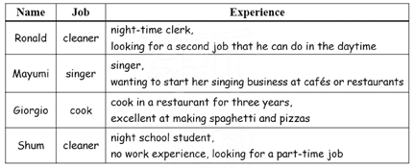
Who would NOT get a call from Ms. Wu for an interview?
(A) Ronald.
(B) Mayumi.
(C) Giorgio.
(D) Shum.
（D）39. What can we learn about Tea Cottage from this ad?
(A) They are looking for singers and bands for weekend music shows.
(B) They need cooks who can work both at lunchtime and dinner time.
(C) One who knows about tea-making has a better chance of working there.
(D) The waiters will be paid over USD$60 a day for working during lunchtime.

(40-42)
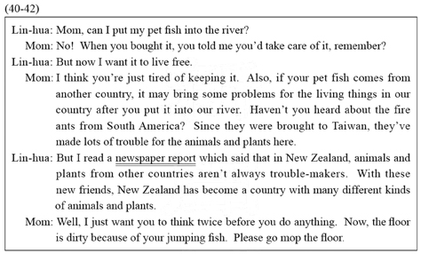
（D）40. What is talked about in the newspaper report?
(A) Some animals and plants from abroad grow better in New Zealand.
(B) Some animals and plants from New Zealand are very popular in Taiwan.
(C) In Taiwan, some animals and plants from New Zealand do not grow well.
(D) In New Zealand, some animals and plants from abroad do not hurt nature.
（B）41. What does the reading say about fire ants?
(A) They are afraid of light.
(B) They come from South America.
(C) They look as bright as burning fire.
(D) They will attack each other for food.
（B）42. What does Lin-hua’s mother ask her to do now?
(A) Feed her fish.
(B) Clean the floor.
(C) Check where her fish comes from.
(D) Find out whether the report is true.
(43-45)
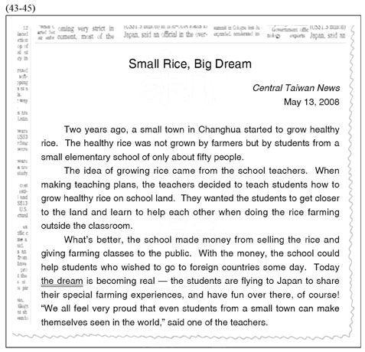
（A）43. What is the reading about?
(A) A successful teaching plan.
(B) A new way of cooking rice.
(C) A language class for farmers.
(D) A famous teacher from a small town.

（B）44. Which is said in the reading?
(A) Farming makes students healthy.
(B) Farming helps the school make money.
(C) The school bought the land for the farming classes.
(D) It is important for farmers to make good use of land.
（C）45. What is the dream?
(A) Growing healthy rice.
(B) Building more schools.
(C) Visiting a foreign country.
(D) Learning outside the classroom.

試題結束

