100學年度國中第二次基本學力測驗 英語領域
解析：陳潔老師

第一部份：下列各題（題號1~20），請依據題意選擇一個正確或最佳的答案。
1. Look at the picture. The top five movies are _____ on the paper.
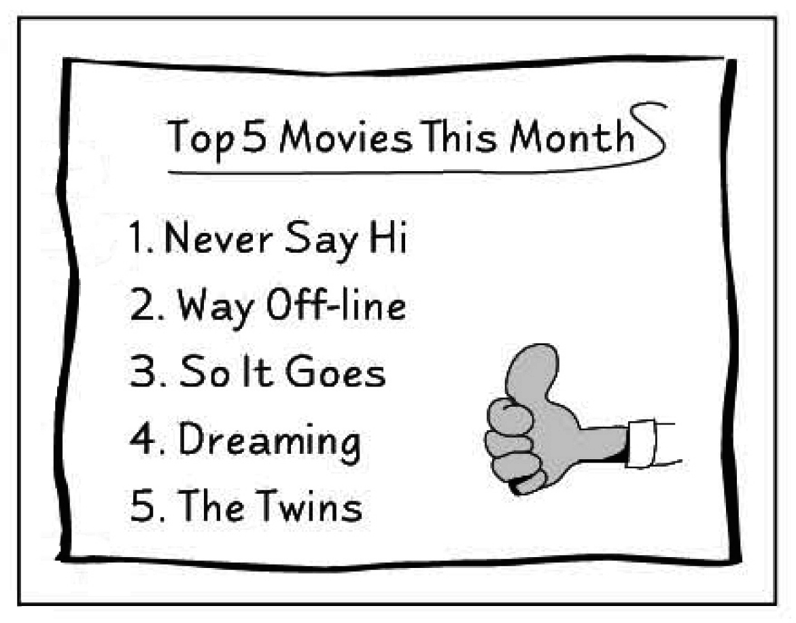
(A) listed
(B) made
(C) played
(D) repeated

答案：(A)
解析： 在圖片裡最棒的五部電影是被排列在紙上，依照中文意義，故答案選(A) listed。
2. I couldn’t find a _____ when I got on the bus because it was filled with people.
(A) driver (B) seat (C) sidewalk (D) ticket

答案：(B)
解析： 因為公車擠滿了人，因此我找不到坐位，依照中文意義，故答案選(B) seat。
3. The turtle is the animal my sister is most ____ of. She cries and runs away even when she sees a picture of one.
(A) sure (B) shy (C) proud (D) afraid

答案：(D)
解析： 烏龜是我姐姐最害怕的動物，她看到烏龜的圖片會哭甚至會跑開。
故答案選(D) afraid。
4. Karen began collecting toy cars at the age of nine. Since then, she has spent lots of time and money on this ____.
(A) example (B) festival (C) hobby (D) package

答案：(C)
解析： Karen在九歲時就開始收集玩具汽車。從那時起，她花了很多時間和錢在這個嗜好上。因為是收集物品，故答案選(C) hobby。
5. House prices are ____, so you can buy a house at a lower price than before.
(A) moving (B) growing (C) dropping (D) climbing

答案：(C)
解析： 房子的價格一直在下跌了，因此你現在可以用比以前低的價錢買房子了。依照中文意義，故答案選(C) dropping。
6. To build a bridge over this big river is a very ____ job. Most people do not believe it can be done.
(A) common (B) difficult (C) helpful (D) popular

答案：(B)
解析： 要越過這條大河去建造一條橋樑是個困難的工作。大多數的人不相信它可以完成。多數的人不相信，故為困難的、艱辛的意義，故答案選(B) difficult。
7. There are two supermarkets near my house. The one on the corner sells bread, but _____ doesn’t.
(A) another (B) that (C) the next (D) the other

答案：(D)
解析： 靠近我家有兩家超級市場。在街角的一家賣麵包，另一家則否。有兩樣東西時，一項是one，另一項則為the other。
故答案選(D) the other。
8. Steve was _____ late for school this morning; the bell rang right after he walked into the classroom.
(A) almost (B) already (C) really (D) seldom

答案：(A)
解析： Steve今早上學幾乎遲到了；在他進教室之後，鈴聲立刻響起。因為是進教室之後，鈴聲才響起，因此是幾乎遲到，故答案選(A) almost。
9. Michelle Walden, _____ of the best basketball players in our school history, was called “Flying Walden” because she could jump very high.
(A) any (B) each (C) one (D) who

答案：(C)
解析： Michelle Walden是我們學校歷史上最棒的籃球員之一，她被稱為“飛躍的Walden”是因為她可以跳非常高。這題是為不定代名詞，文法為one of the….，故答案選(C) one。
10. _____ going shopping, Dad asked me if Mom would eat at home tonight. He wanted to know what he should buy for the dinner.
(A) Without (B) Until (C) By (D) Before

答案：(D)
解析： 爸爸想知道他應該買什麼當晚餐，因此意義之中是在採購東西之前，
故答案選(D) Before。
11. If you want to drink the water from the lake, _____ it first, or you may get sick.
(A) boil (B) burn (C) carry (D) cook

答案：(A)
解析： 如果你要喝這湖裡的水，先煮沸它，否則你會生病，在此中文是煮沸。
故答案選(A) boil。
12. _____ exercise after work is a good way for me to forget the troubles in the office.
(A) Playing (B) Making (C) Going (D) Doing

答案：(D)
解析： 對我而言，在下班後做運動是忘記辦公室裡煩惱的好方法。
此題為動名詞為首的句子。做運動的英文為do exercise。
故答案選(D) Doing。
13. The medicine I ____ you this morning should be taken three times a day.
(A) to give (B) given (C) giving (D) gave

答案：(D)
解析： 今天早上我給你的藥應該一天服用三次。
今天早上是為過去式，故答案選(D) gave。
14. Jo likes summer the _____ because she has serious problems sleeping in the summer heat.
(A) least (B) last (C) first (D) best

答案：(A)
解析： 因為Jo在炎熱的夏季裡有嚴重的睡眠問題，因此她最不喜歡夏季。在此是為劣等比較，最少的最高級為least。
故答案選(A) least。
15. Joan: Which looks good on me? The black shirt or the red shirt?
Betty: Both are , but you look thinner in black.
(A) convenient (B) easy (C) great (D) welcome

答案：(C)
解析：Joan: 我穿那一件比較好看，是黑色還是紅色的襯衫？
Betty: 兩件都很好看，但是你穿黑色看起來較瘦。
在此為衣服很漂亮，故答案選(C) great。
16. John: What’s wrong with Wendy?
Jean: Her knees hurt. She was _____ by a motorcycle this afternoon.
John: Oh, that’s too bad!
(A) caught (B) hit (C) killed (D) saved

答案：(B)
解析： John: Wendy怎麼了？
Jean: 她的膝蓋受傷了，今天下午她被摩托車撞了。
在此為過去被動式，被撞為was hit。故答案選(B) hit。
17. Nancy: Did the teacher tell us _____ to get to the station?
Susan: Yes. She said we should meet there at ten.
(A) how (B) what (C) when (D) where

答案：(C)
解析： Nancy: 老師有沒有告訴我們何時到車站？
Susan: 有啊。她說我們應該十點在那裡碰面。
此題為名詞片語，回答為十點，所以用何時when，
故答案選(C) when。
18. Mrs. Luo: Who put these socks in the refrigerator?
Mr. Luo: I don’t know. They’re not _____. Ask your son.
(A) me (B) mine (C) my (D) myself

答案：(B)
解析： Mrs. Luo: 誰放這些襪子在冰箱裡？
Mr. Luo: 我不知道。他們不是我的。問問你兒子。
在此我的是代替我的襪子，是為所有代名詞。
故答案選(B) mine。
19. Allan: Want to try Uncle Joe’s pumpkin pie? I heard it’s quite good.
Jamie: No, thank you. I think nobody _____ my mom can make good pies.
(A) with (B) than (C) for (D) except

答案：(D)
解析： Allen: 想要試試Uncle Joe的南瓜派？我聽說它相當好吃。
Jamie: 不用了，謝謝。我想除了我媽媽之外，沒有人會做好吃的派。
在此為排除~~之外，故答案選(D) except。
20. Noah: I’ve had too many cookies. My throat is so dry.
Quinn: What would you like to drink then?
Noah: _____ you can get. Just get it now!
(A) Something (B) Nothing (C) Everything (D) Anything

答案：(D)
解析： Noah: 我吃了太多的餅乾了。我的喉嚨好乾。
Quinn: 那麼你想喝什麼？
Noah: 只要你可以拿到的都好。
在此任何東西都好，故答案選(D) anything。
第二部份：下列十個題組，共有25題（題號21~45），請依據選文或所附圖表資料，選出一個正確或最佳的答案。
(21-24)
My mother likes to tell me the story about my name, Stella. She 21 about it
many times.
I was born on a night full of stars. My mom 22 a hard time when the doctor
said I was too big to be pulled out. At that moment, Mom looked into the sky, making
a wish with all her heart, “Let the baby live, please, even if I may die!”
Just then, a very bright star 23 from the sky. All her troubles were soon
gone, and my little head came out of her body.
With the falling of a star came a new life. That’s how I 24 the name “Stella,” which means “star.”

21. (A) talked
(B) is talking
(C) has talked
(D) will talk
答案：(C)
解析： 媽媽告訴我許多次有關我名字的由來。
因為時間上是許多次，所以用現在完成式。故答案選(C) has talked。
22. (A) was having
(B) has
(C) has had
(D) will have

答案：(A)
解析： 當醫生告訴我媽媽因小嬰兒的頭太大而無法順利生出時，媽媽在當時歷經一段辛苦的時間。
在此是因為連接詞when，所以一段辛苦的時刻用過去進行式。故答案選(A) was having。
23. (A) would fall
(B) fell
(C) falls
(D) is falling
答案：(B)
解析： 在當時，有一顆明亮的星星從天空降落。
在此是指當時。所以用過去式。故答案選(B) fell。
24. (A) got
(B) get
(C) am getting
(D) will get

答案：(A)
解析： 隨著這墜落的星星帶來新生命。這就是我如何得到“Stella”這個名字。
在此是當時她出生時，為過去式。故答案選(A) got。


(25-27)

Could it be possible to live in a house made of ice? What is it like to sleep on an ice bed? North Hotel is the magic place that brings people from all over the world to 25 in the cold. Here you can have dinner at an ice table, watch movies in an ice chair, and even take a bath in a large ice box. Worried about catching a cold?
26 ! North Hotel keeps you warm and makes you feel comfortable all the time. You can live in this dreamland for a few days and enjoy many special experiences in the snow. It is not easy to tell you about everything here at North Hotel; you must 27 . Pack now and get ready to be COOL!

25. (A) have fun
(B) start a new life
(C) get some exercise
(D) learn to make friends
答案：(A)
解析： North Hotel是ㄧ個可以帶領全世界的人去享受在冰冷環境的神奇地方。在文章裡的中文意義應為好好享樂。故答案選(A) have fun。
26. (A) Good idea
(B) You don’t have to be
(C) Take care of yourself
(D) Don’t forget your heavy coat

答案：(B)
解析： 前一句是擔心在冰旅館裡會感冒嗎？
下一句提及North Hotel會總是保持溫暖和使你舒適，因此你不必擔心在冰旅館裡會感冒。故答案選(B) You don’t have to be。
27. (A) think about it carefully
(B) come to see it for yourself
(C) check out the weather first
(D) wait and see what will happen

答案：(B)
解析： 你必須自己來North Hotel冰旅館看看。
現在趕快打包好行李，準備cool一下吧！
依照中文意義，故答案選(B) come to see it for yourself

(28-29)

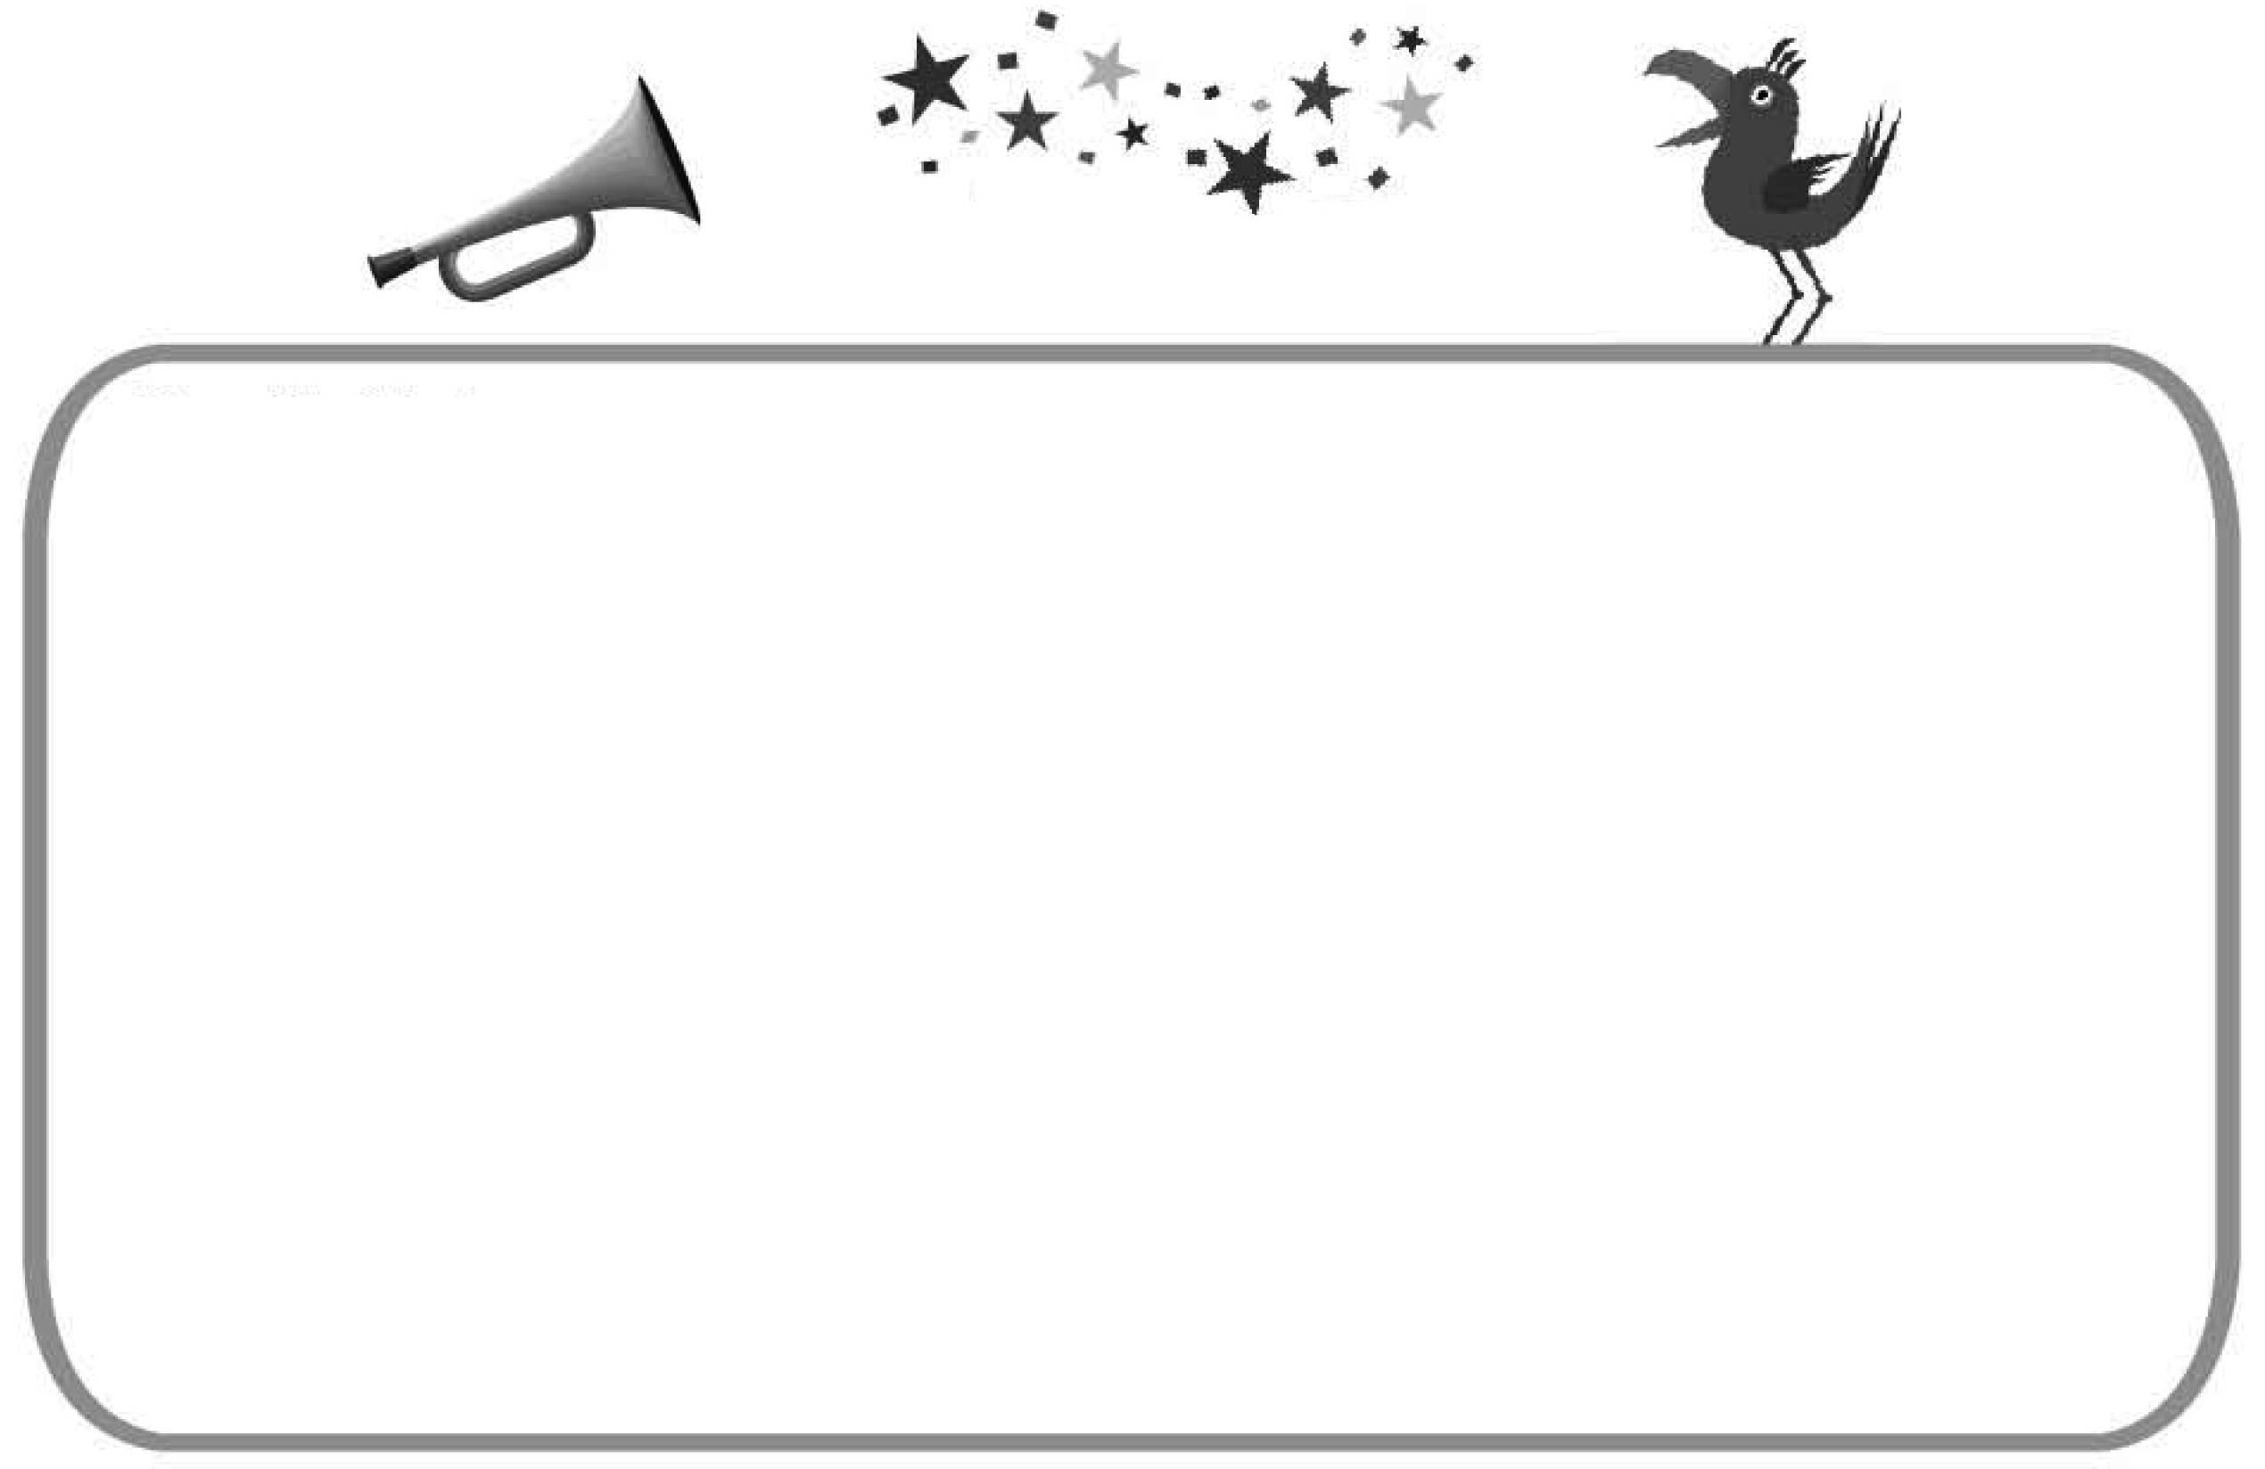
Dear Mr. Hush,
I just learned over the radio that you feel as bad as I do about the way people use their cellphones. Very often in pubic places, people speak loudly on their cellphone, and we have to hear about other people’s business. But who cares about that? Not me! Why should I know the life of people I don’t even know? It’s really nice that someone famous like you speaks out for a quiet living space.
And it’s even more wonderful to know that you yourself always talk quietly when you have to use the cellphone in public places. Thanks for NOT sharing what you are talking about. We have shared too much noise already!
A Person on Your Side

28. What does that mean in the letter?
(A) Being quiet.
(B) The cellphone.
(C) Others’ business.
(D) Talking with stangers.
答案：(C)
解析： 在文章中的that是什麼意思？
在文章裡第三及第四行提及：我們必須傾聽有關他人的事情。因此that是指他人的事情。故答案選(C) Other’s business。
29. What does the writer mean by saying “Thanks for NOT sharing what you are talking about”?
(A) It is kind to forget about other people’s mistakes.
(B) It is wrong to listen to others talking on the phone.
(C) It is polite to use a low voice when you talk on the phone in public places.
(D) It is dangerous to say something important over the cellphone in public places.
答案：(C)
解析： 作者說“ 謝謝你並沒有和我們分享你談論的事”是什麼意思？
在文章裡倒數第三行提及：當你在公共場所使用行動電話時，你本人總是小聲地說話。故答案選(C)。
(30-31)
Ron: Excuse me, sir, but I missed your words because I was asking Amy about the coming quiz.
Mr. Lin: Well, I said, “I have to finish this lesson by the end of this class, so stop asking questions from now on.” Got it? Now turn to page 53….
Ron: What kind of question?
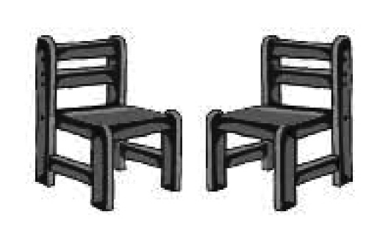
Mr. Lin: Any question. Now turn to page 53….
Ron: And stop asking who? You or the classmates?
Mr. Lin: Just stop talking when I’m busy teaching, Ron. From now on, anyone who moves his lips will come sit in the front. Now turn to page 53….
Ron: Are you serious? Where in the front?
(Mr. Lin moves Ron’s chair next to the blackboard.)
Mr. Lin: Now you’re got the answers, Ron.
30. What do we know from the reading?
(A) Mr. Lin thinks Ron is lazy.
(B) Ron does not like going to school.
(C) Ron has missed Mr. Lin’s classes several times.
(D) Mr. Lin does not think Ron took his words seriously.

答案：(D)
解析：在這篇文章裡我們知道了什麼事？
在文章裡第八句提及：
林老師說：當我教書時大家停止說話。從現在起任何說話的人就坐到前排。
Ron說：你是認真的嗎？
故答案選(D) 林老師認為Ron並沒有認真思考他的話。
31. What does the reading say about Ron?
(A) He did not study for the quiz.
(B) He did not take notes in class.
(C) He kept asking questions in class.
(D) He moved Amy’s chair next to him.

答案：(C)
解析： 在文章裡是如何描述Ron？
在文章裡第一句開始Ron就不斷問老師問題與發問。
故答案選(C) 他在課堂上持續地發問。
(32-33)

We’re soon going back to Taiwan, and have to say goodbye to Mr. Brown, the excellent helper for our family since we came to the U.S. Mr. Brown helps us clean the house, prepare dinner and take care of our two little girls. The girls call him “ Uncle Bill” and have a good time with him. Mr. Brown lives near the train station with his wife. If you need somebody to help around your house, he can work for you from 1:00-6:00 p.m., from Monday to Friday. Please call him at 388-5566. If you need him to stay later, feel free to talk to him. Mr. Brown can speak a little Chinese and will be the best helper for your family.

32. What is the ad for?
(A) To find a missing man.
(B) To find a new job for a man.
(C) To look for a Chinese teacher.
(D) To look for someone to work for a family.

答案：(B)
解析： 這篇廣告是做什麼用的？
在整篇文章裡提及布朗先生可以幫忙你清理房子，準備晚餐，照顧小孩等等。他可以為你從星期一到星期五工作。
故答案選(B)幫忙一位男士找新工作。
33. Which is NOT said about Mr. Brown?
(A) His age.
(B) His phone number.
(C) The person he lives with.
(D) The place he lives around.

答案：(A)
解析： 在文章裡有關布朗先生哪一項是沒有提及的？
故答案選(A)他的年齡。

(34-35)
Here is a table about Aqua City. Read it and answer the questions.
Season of the Year | Weather | What to Do
Spring ( September-November ) | Cool & Wet | Whale Season
Summer ( December-February ) | Warm &Clear | Butterfly Season
Fall ( March-May ) | Windy & Dry | Wind Surfing
Winter ( June- August ) | Cold & Snowy | Ice Skating

34. Kate just spent the Christmas holiday in Aqua City. Which picture was most likely taken when she was there?
 table表格
 likely可能
(A)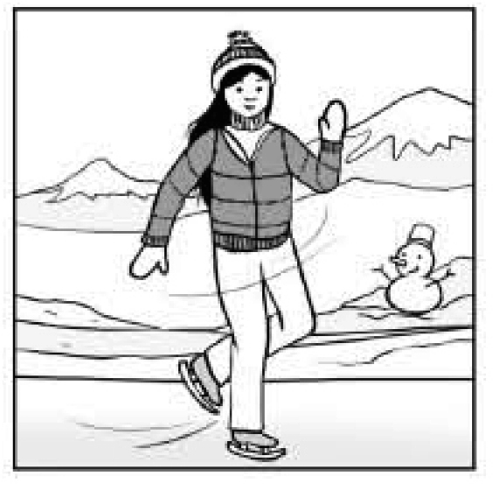 (B)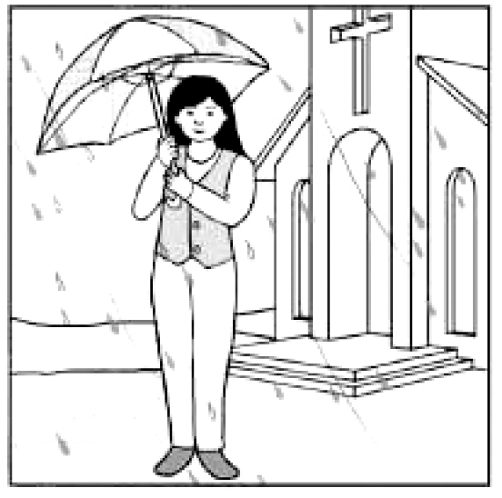
(C)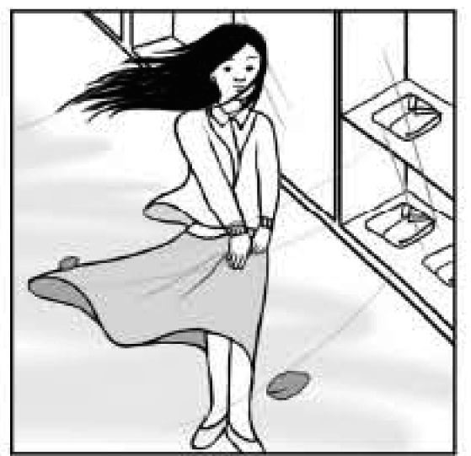 (D)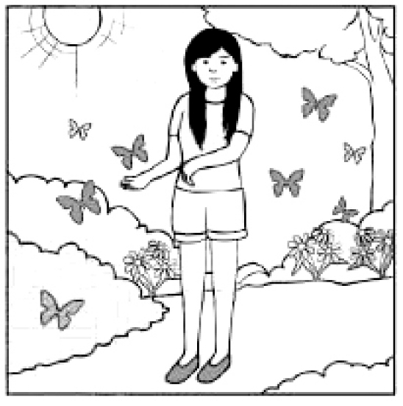

答案：(D)
解析： Kate在Aqua City過聖誕假期，哪一張圖片是最有可能是當地的情況？
在圖表裡第二段說明：夏季(12月--2月)。天氣：溫暖和晴朗。它是一個蝴蝶飛舞的季節。故答案選(D)。
35. During his visit to Aqua City, Gary wrote an e-mail to his friends:
“. . . . I felt sick because the boat went up and down. But I was really lucky to see three of them. These large sea animals just didn’t mind our boat getting near them. They swam around the boat in a cute way, bringing out the smile of everyone on the boat ….”
In which season of the year did Gray most likely go to Aqua City?
(A) Spring.
(B) Summer.
(C) Fall.
(D) Winter.

答案：(A)
解析： 在上述的文章裡Gary最有可能在一年中哪一個季節去Aqua City？
在文章裡第一及二行提及：他很幸運見到這大型動物用一種可愛的方式在船隻旁邊游泳。故該動物應為whale鯨魚，答案選(A)春季。
(36-37)
When you hear birds singing, do you want to sing with them? When the light wind blows, can you feel its friendly touch on your face? Are you excited to see the first little flower in the early spring?
Nature can color our everyday lives with lovely surprises. All we have to do is get close to it and feel it from our heart. If we find some time to enjoy the simple, easy moments under the clear sky, along the quiet river, or just in the park near our houses, we can feel many wonderful things out there.
Why not get away from your busy work and take a rest in Mother Nature’s arms? Sing to Nature’s music, dance with the wind, and look for the magic of life. You’ll find the gift Nature has prepared for you.
36. What is the writer trying to say about Nature?
(A) It is badly hurt by us.
(B) It gives us lots of joy.
(C) It is hard to understand.
(D) It gives us ideas for writing.
答案：(B)
解析： 作者試著想要說有關大自然什麼？
在文章裡第一段提及：想要和鳥一同唱歌、感受微風吹拂臉上、興奮見到早春新生的小花。第三段提及為何不遠離你繁忙的工作而回到大自然母親的懷抱休息一會。故答案選(B)。
37. Which experience is NOT said in the reading?
(A) Singing with birds.
(B) Fishing in the river.
(C) Feeling the wind’s touch.
(D) Seeing the first spring flower.

答案：(B)
解析： 文章裡哪一種經驗是沒有被提及的？
(A)和鳥一起唱歌。(B)在河裡釣魚。
(C)感受微風的輕觸。(D)欣賞早春的花朵。
故答案選(B)。

(38-40)

Read what people said on the Internet about a restaurant and answer the questions.
Is Goodies good? 7:02 PM 08/26

Does anyone know about Goodies next to the Mad-Eye Theater? I want
to go there with my friends this Saturday. Thanks!

RE: Is Goodies good? 7:30 PM 08/26
My dad took me there yesterday. I don’t know if it’s expensive. He
paid. The food was fine, not the best, though. But you must try its
papaya ice cream. I just can’t get enough of it! Dinner is $50 cheaper
if you eat there on your birthday.

RE: Is Goodies good? 8:11 PM 08/26
Its food is good but its waiters are not. For that price, I think you should
go to Awe’s. It’s a little far from the theater, but the waiters there are
friendly, and the food is wonderful. It’s celebrating its fifth birthday, so
lunch is only half price this week.

RE: Is Goodies good? 9:56 PM 08/26
It’s the best restaurant I’ve ever been to. It’s a little expensive. But it
costs $100 less for lunch. Crazy _ P is right about the papaya ice cream.
There’s no other word for it!

RE: Is Goodies good? 11:11 AM 08/27
There’s only one good thing about Goodies: After you eat there,
everything else on Earth tastes good! About the waiters, do they have
any?




38. Which is true?
(A) Crazy _ P thinks of Goodies as her favorite.
(B) Cool Marc likes Goodies better than Awe’s.
(C) Kenny likes Goodies’ papaya ice cream.
(D) Teddy0530 enjoyed himself at Goodies.

答案：(C)
解析： 哪一項是事實？
Kenny在文章裡提到Crazy_P正確地談到了木瓜冰淇淋。
沒有任何其他的言語可以形容它的好吃。故答案選(C)。
39. What can we learn from the reading?
(A) Crazy_ P was not happy about Goodies’ prices.
(B) Jane.TW has not been to Goodies’ before.
(C) Awe’s is a new restaurant.
(D) Awe’s is next to Goodies.

答案：(B)
解析： 我們可以在這篇文章裡知道什麼事?
(A) Crazy_P並不知道是否這家餐廳很貴。
(B) Jane想在這個星期六去Goodies 餐廳。因此表示她不曾去過。
(C) Awe’s在慶祝第五年開幕。因此表示並非新的。
(D) Awe’s離電影院較遠的距離。因此表示並非在Goodies旁邊。
故答案選(B)。
40. Which is the ad of Goodies?
 ad 廣告
(A) 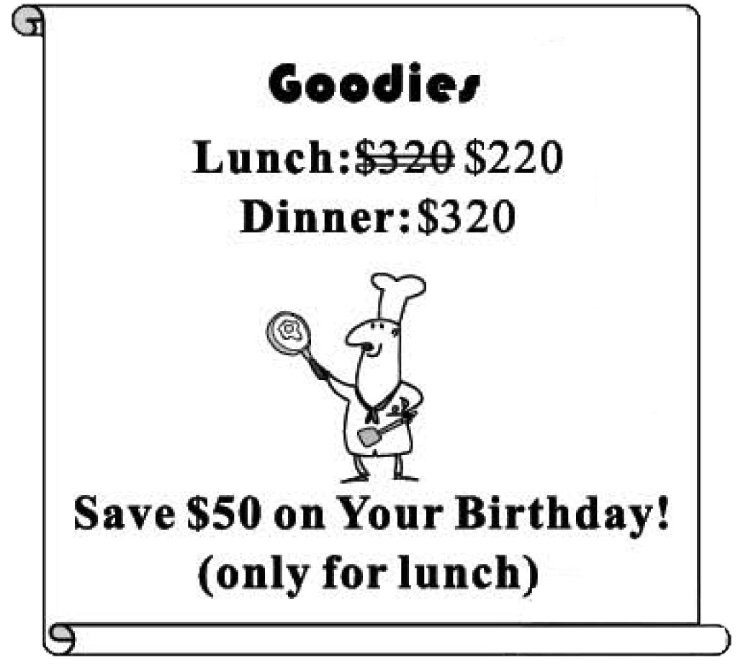 (B) 
(C) 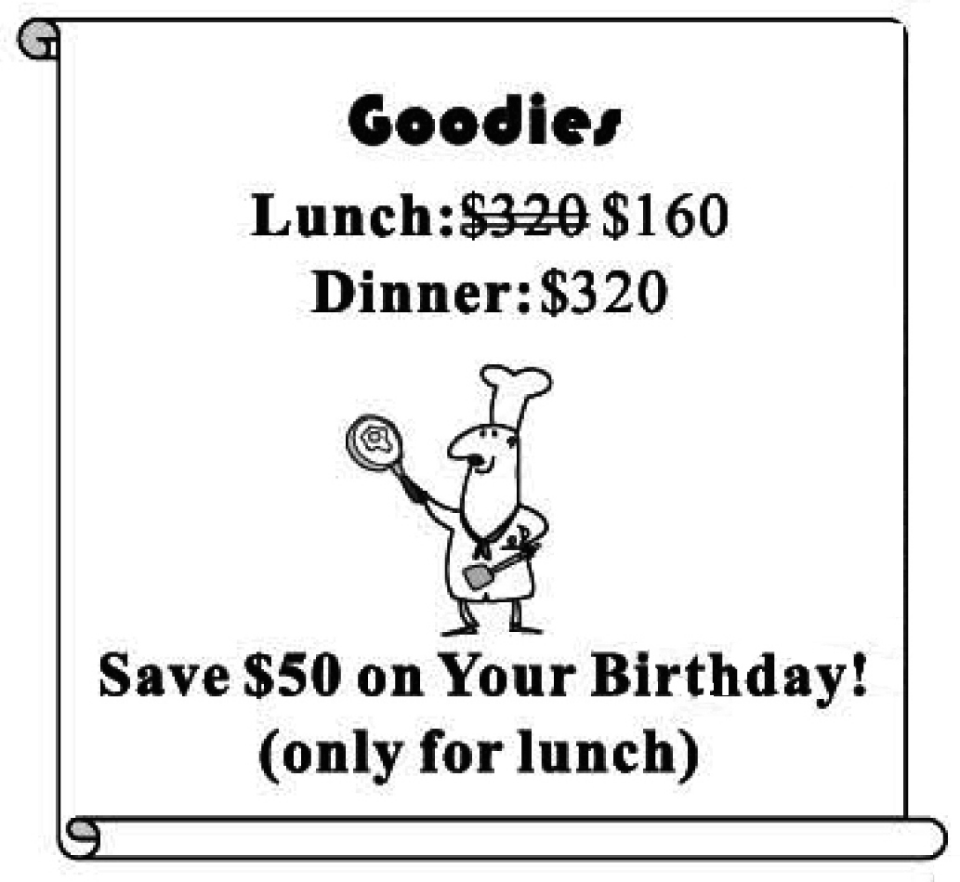 (D) 
答案：(B)
解析： 哪一個圖片是Goodies的廣告？
在文章裡Crazy_P提及：在你生日當天，晚餐將便宜50元。
Kenny提到午餐比晚餐少100元，故答案選(B)。
(41-42)
Charlie can’t remember when he lost his heart
Though he knows who took it.
The girl ran away with Charlie’s heart,
And he kept looking for her.

Years later Charlie met the girl on the road.
But she wasn’t the one he used to know.
He tried to talk to her the same way as before.
But nothing showed she was the one of years ago.

Now Charlie knows:
He can take his heart back and say goodbye to the girl.
It’s time for him to let her go, to let it go.
It’s time to find someone else to lose his heart to.
41. Which is NOT said or implied in the reading?
(A) A past love.
(B) A lost heart.
(C) A life lesson.
(D) A forgotten land.
 imply隱喻；暗示
答案：(D)
解析： 在文章裡哪一項是沒有被提及或隱喻的？
在文章裡第一段：有個女孩偷走了Charlie的心而跑走了。他還一直在尋找那個女孩。
第二段：Charlie遇到了那個女孩，但是她與多年前的那個女孩已經大不相同了。
第三段：現在Charlie知道應該要向那個女孩說再見。是他應該再去尋找另一個女孩的時間了。
故答案選(D)。
42. What does Charlie decide in the end?
(A) To stop thinking of the girl.
(B) To start to write love stories.
(C) To find out where the girl had been.
(D) To take a long trip to a foreign country.

答案：(A)
解析： 什麼事是Charlie最後決定做的？
在文章最後提及：他可以將心拿回，是讓事情成為過去的時候。Charlie知道應該要向那個女孩說再見。是他應該再去尋找另一個女孩的時間了。故答案選(A)。
(43-45)
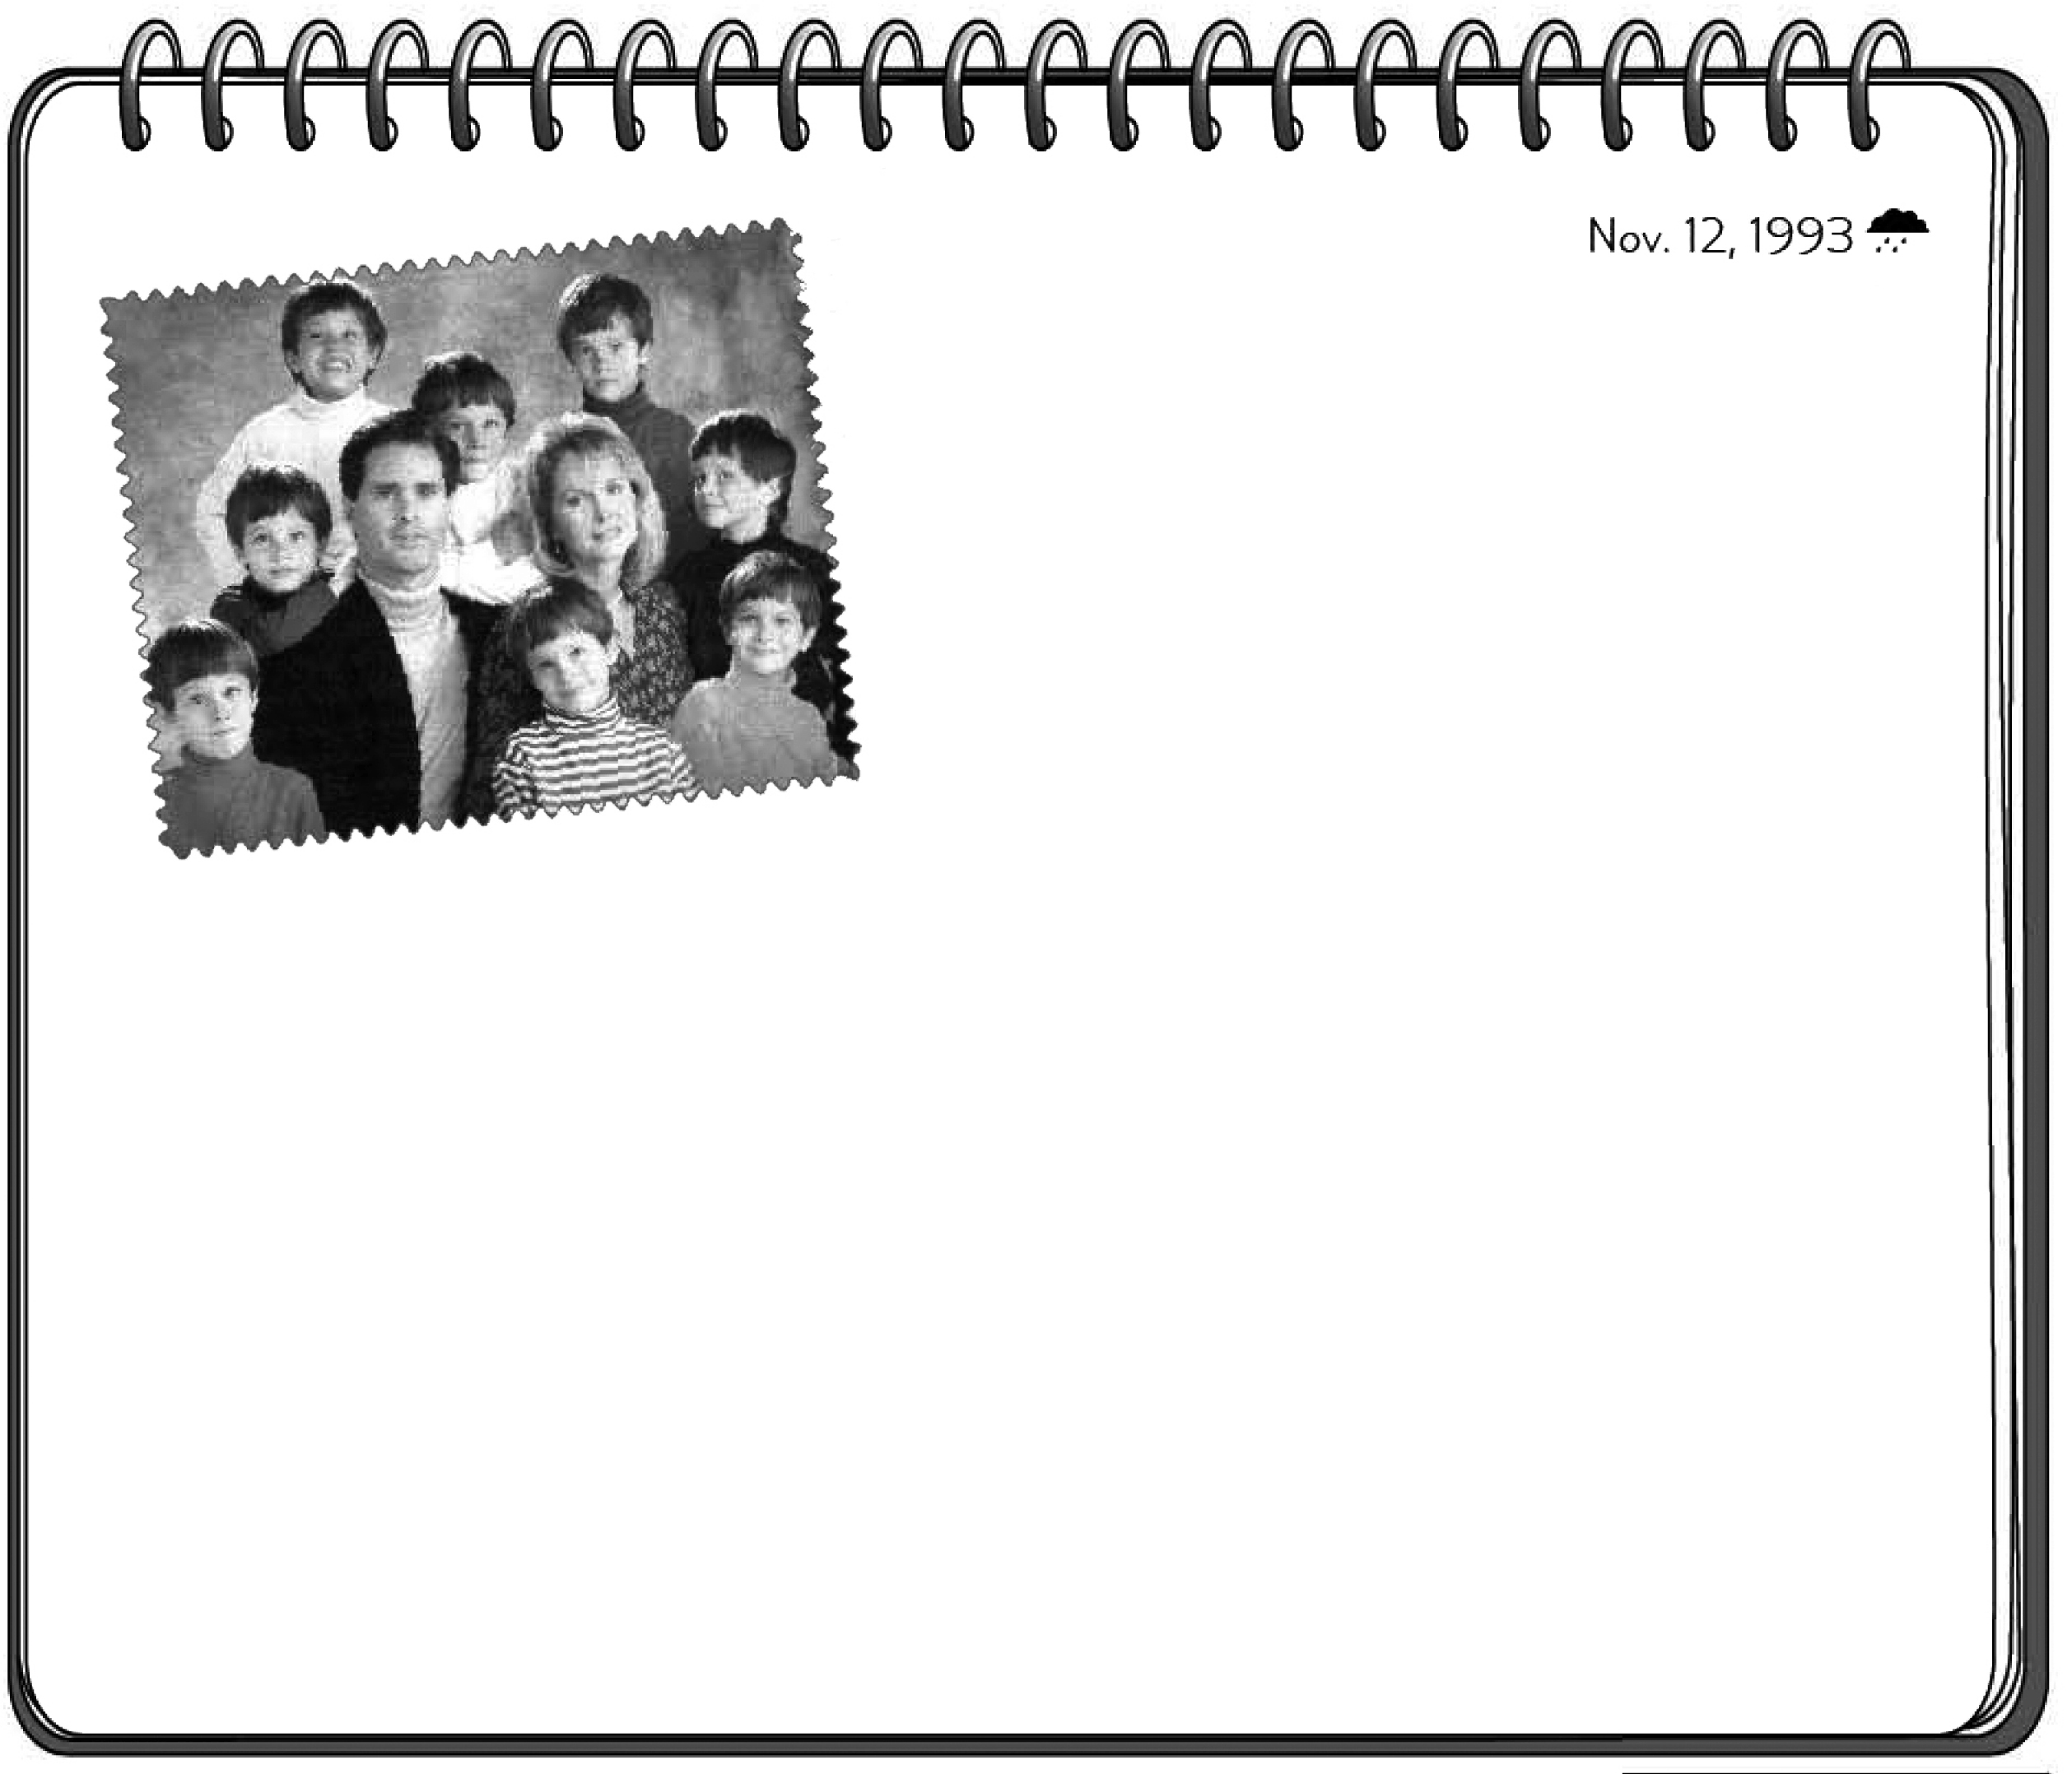
I saw this picture in this week’s Time magazine. A photographer named Gregory Heisler sent the picture to Time. The boys in the picture are all wearing different clothes, but they all share the same face. They do not just look like each other. In fact, they are the same person. Heisler “made” this funny picture on the computer. But in the
future, with the science of ‘cloning ’(copying living things), a picture like this one may not just be a computer trick.
The idea of cloning began a long time ago. It became real when some animals like frogs were successfully cloned. At first, I didn’t care much about these studies. However, when some studies showed that even “people” could be cloned, I felt the studies had gone too far.
I don’t know much about science, but I do know I would hate to live on a planet full of copies of me. I found myself scared by the smiles of the copied boys when I looked at the picture again. To me, a world of cloned people is a world where the rules of nature are broken, which may bring a lot of problems we’ve never thought of.

 magazine 雜誌 photographer 攝影師

43. What is the writer trying to say?
(A) Good simple things bring us the same joy.
(B) Science and art can both help us look better.
(C) A world of people with the same face is terrible.
(D) People will share the same health problems some day.

答案：(C)
解析： 作者想要說什麼事情？
在文章倒數第三行提及：在一個都是複製人的世界，將會打破了大自然的規則，或許會帶來我們從未想到的許多問題。故答案選(C)。
44. Which is said about cloning?
(A) It will make our living space smaller.
(B) Many rules have been made for its use.
(C) It has been talked about for a long time.
(D) Most people do not think it is a good idea.

答案：(C)
解析： 關於複製有哪一項被提及？
在文章第二段第一行提及：在很早以前就有複製這個概念。故答案選(C)。
45. Which is said about the picture?
(A) It is an example of computer tricks.
(B) It was taken of Gregory Heisler’s family.
(C) It first appeared in Gregory Heisler’s picture book.
(D) The parents in it are in fact worried about their children.

答案：(A)
解析： 有關這張照片，哪一項被提及？
(A)這是一張電腦合成技巧的例子。
(B)這是Heisler合成的照片，並非他家人。
(C)這是Heisler寄給Time雜誌的。並非在他的相簿裡。
(D)並沒有提及照片中的父母與小孩的情況。
故答案選(A)。

