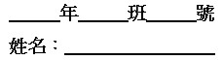

第一部分：辨識句意 (第1-3題)
作答說明：每題均有三張圖片，請依據所聽到的句子，選出符合描述的圖片，每題播放兩次。
示例題：你會看到
(A) (B) (C)
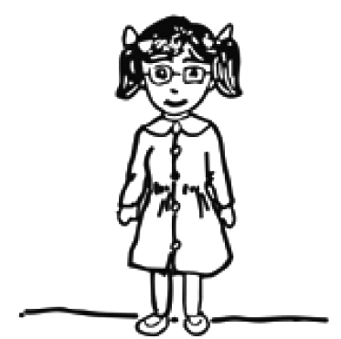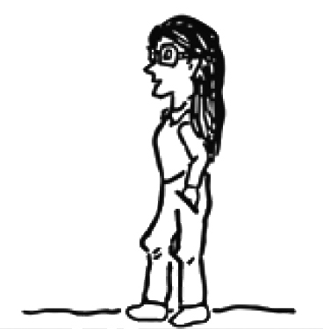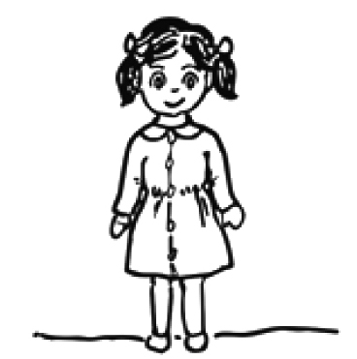
然後你會聽到……(播音)。依據所播放的內容，正確答案應該選 A，請將答案卡該題「」的地方塗黑、塗滿，即：
（ A ）第1 題 1. Joseph is reading a book when waiting for the bus.
(A) (B) (C)
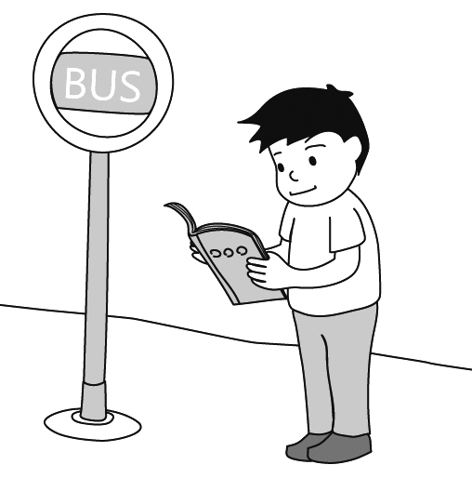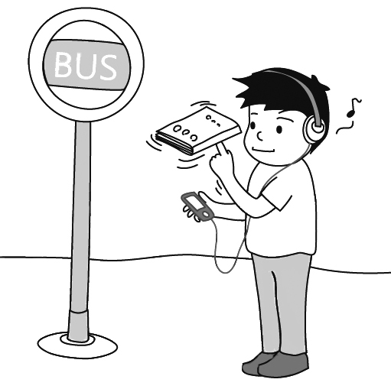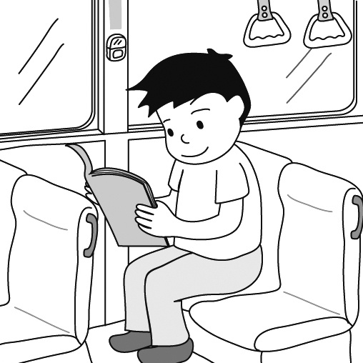
2. After the teacher entered the classroom, he saw two students fighting with each other.
（ B ）第2 題
(A) (B) (C)
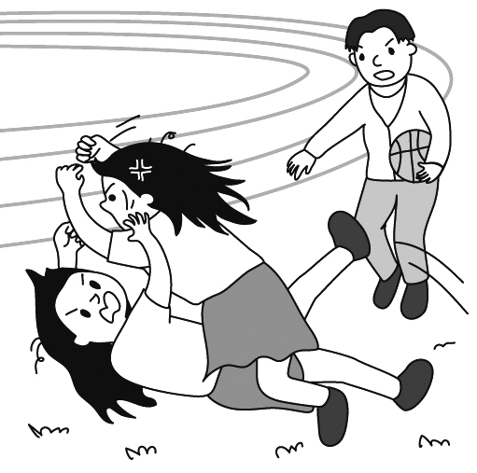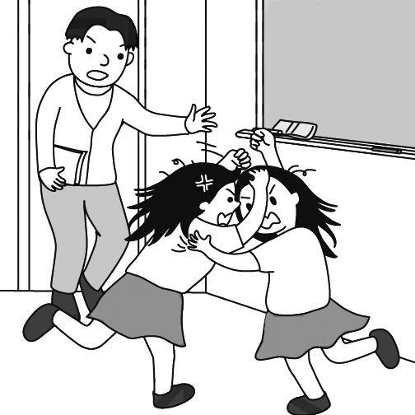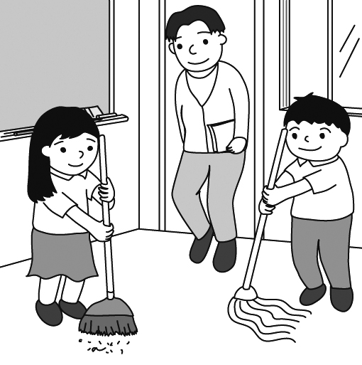
（ B ）第3 題
3. The old man finds the TV program interesting, but the little girl doesn’t look like she does.
(A) (B) (C)
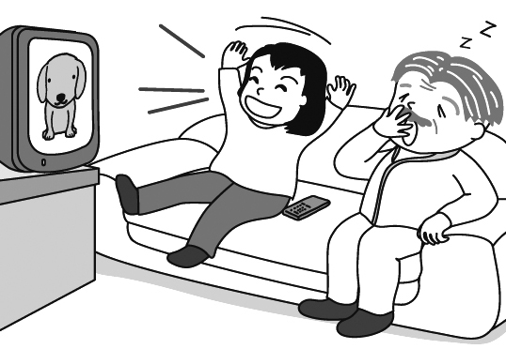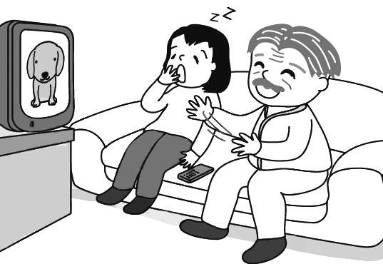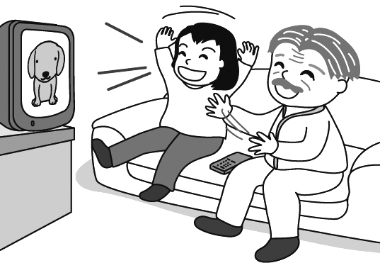

第二部分：基本問答 (第4-10題)
作答說明：每題均有三個選項，請依據所聽到的內容，選出一個最適合的回應，每題播放兩次。
示例題：你會看到
(A) She is talking to the teacher.
(B) She is a student in my class.
(C) She is wearing a beautiful dress.
然後你會聽到……(播音)。依據所播放的內容，正確回應應該選 B，請將答案卡該題「」的地方塗黑、塗滿，即：
4. I can’t talk right now. Can I call you back?
（ C ）第 4 題
(A) Since when?
(B) Almost there.
(C) No problem.

5. How did you spell your name, Lindy?
（ B ）第 5 題
(A) I got it from my grandparents.
(B) L-I-N-D-Y.
(C) My name is Lindy.

6. Excuse me, could I use your computer?
（ A ）第 6 題
(A) Sorry. I need it right now.
(B) Thanks. You’re very nice.
(C) I already have one.

7. Hurry up, we are late. The taxi is waiting.
（ A ）第 7 題
(A) Give me five more minutes.
(B) It’s not early enough.
(C) The taxi driver will be late.

8. I can’t believe it! I won two plane tickets from Taipei to London.
（ C ）第 8 題
(A) I can’t believe you got the job!
(B) What a small world!
(C) You’re really lucky!

9. Jack, I need to use the bathroom. You’ve been in there for hours.
（ A ）第 9 題
(A) I’ll be out in a minute.
(B) Sorry. Let me help you.
(C) You don’t have much time.
10.W: Can you go shopping with us on Saturday?
M: I’d love to, but I have to go to school.
（ C ）第 10 題
(A) I’m happy to hear that.
(B) That’s a good idea.
(C) That’s too bad.

第三部分：言談理解 (第11-21題)
作答說明：每題均有三個選項，請依據所聽到的對話或短文內容，選出一個最適合的答案，每題播放兩次。
示例題：你會看到
(A) 9:50. (B) 10:00. (C) 10:10.
然後你會聽到……(播音)。依據所播放的內容，正確答案應該選 B，請將答案卡該題「」的地方塗黑、塗滿，即：
（ B ）第 11 題
11. W: Which one do you like, tea, coffee, or water?
M: Water, please. My doctor does not want me to drink coffee and tea.
Question: What does the man want?

12. G: Dad, I want to buy a pair of Rockets.
M: Don’t you already have three pairs of shoes?
G: Yes, but Rockets are different. All the sports stars wear them.
Question: What are Rockets?
13. W: Oh! Look at this special yellow skirt. Just three thousand dollars.
M: It will cost you an arm and a leg. You only make ten thousand dollars a month.
Question: When the man tells the woman “It will cost you an arm and a leg,” what does it mean?
(A) Coffee.
(B) Water.
(C) Tea.

（ A ）第 12 題
(A) Shoes.
(B) A ball.
(C) A dress.

（ B ）第 13 題
(A) The skirt will be on sale next week.
(B) The skirt is too expensive for her to buy.
(C) The skirt is too long for her.
14. W: Excuse me, sir. I bought this book yesterday, and found one page missing. Can I have a new one?
M: Let me see. I’m sorry. This book’s been sold out, but I can order you a new one if you don’t mind waiting for five days.
W: Oh, that’s a long time!
M: Or you can choose another book at the same price.
W: OK. I think I will do that.
Question: What is the woman going to do?

（ B ）第 14 題
(A) Ask for her money back.
(B) Choose a different book.
(C) Wait for the new order.

（ C ）第 15 題
(A) In a bank.
(B) In a police station.
(C) In a post office.
15. M: May I help you?
W: Yes, I’d like to mail this package to Hong Kong. How much should I pay?
M: Let me check. Could you write down your name and phone number, please?
W: Sure.
M: What’s inside the package?
W: Clothes and hats.
Question: Where are the man and the woman?
（ C ）第 16 題
(A) A museum that collects old things.
(B) A supermarket that sells cheaper things.
(C) A shop that sells old things.
16. W: Walter’s House is now open on Hope Street. When you shop in Walter’s House, you can find everything you need at low low prices. Many of the old things in this store look like new. We have beautiful clothes, special toys, useful tools, and interesting books and CDs. You won’t think they were used before. Why spend lots of money buying new things? Stop by today, and you will find how wonderful old things are.
Question: What is Walter’s House?

（ A ）第 17 題
(A) She doesn’t really like it.
(B) She is excited about it.
(C) She knows nothing about it.

（ C ）第 18 題
(A) He got lost in the train station.
(B) He got off at the wrong station.
17. W: Ever since the shopping center opened here, our town has not been as quiet as before. Hundreds of people and cars come in every day. The traffic is terrible.
M: Yeah, but it’s easier for us to buy things, isn’t it?
W: I know the shopping center is convenient. But now my kids often ask me to take them there to buy things or have some food.
Question: What does the woman think about the shopping center?

18. M: Excuse me, is this train going to Peyton?
W: I’m afraid we’re going north.
M: Oh, no. I should go south. I need to be in Peyton by eleven. What’s the next station I need to get off?
W: We’re getting close to Avon. You can get off there.
M: Thanks.
Question: What happened to the man?

19. W: Hello!
M: Hey, Jenny. Do you want to go see a movie today?
W: Hmm, I don’t think I can. I need to clean the house.
M: Then can we go tomorrow?
W: Well, I have to go to a dance class.
M: How about the day after tomorrow?
W: I’m afraid I’m going to be busy all year.
Question: Why doesn’t the woman go to see a movie with the man?

20. W: Hello, this is Jenny. I just remember the shop we’re going to won’t open until 12 tomorrow. If we meet up at 11, we have to wait for an hour. Can we meet up later? Please call me back before ten.
Question: What time may Jenny want to meet up with her friend?

21. M: It’s time for the top 3 songs on the music list this week. No.3 is I Still Believe. It just came out this Monday and has already hit No.3 this week. No.2 is Listen to Your Heart. It dropped one place after staying on top for three weeks. Finally, climbing from No.5 Slow Dance becomes our No.1. Now we’re going to play our No.1 song.
Question: Which song is new on the music list this week?
(C) He took the wrong train.

（ B ）第 19 題
(A) She may be too lazy.
(B) She may not like him.
(C) She may have to stay home.

（ C ）第 20 題
(A) 10:00.
(B) 11:00.
(C) 12:00.

（ A ）第 21 題
(A) I Still Believe.
(B) Listen to Your Heart.
(C) Slow Dance.

0聽力試題播音結束0

