


第一部分：單題 (1～12題，共12題)
（ D ） 1. Look at the picture. The girl drew two on the wall.
(A) circles (B) lines
(C) points (D) squares
（ B ） 2. This dress is pretty, it does not look good on me.
(A) so (B) but (C) or (D) if
（ D ） 3. Getting up early on a cold morning is not easy, ?
(A) are you (B) do you (C) does it (D) is it
（ A ） 4. Tonight I’ll stay at the office until I the work.
(A) finish (B) am finishing (C) finished (D) will finish
（ B ） 5. Charles a day in the department store looking for a hat for his wife.
(A) cost (B) spent (C) saw (D) made
（ B ） 6. Tom ten pounds over the past two months. He looks much thinner now.
(A) loses (B) has lost (C) will lose (D) was losing
（ D ） 7. I don’t like any one of these three watches. Can you show me one?
(A) the others (B) other (C) either (D) another
（ B ） 8. The waiters are asked to be ; they should always smile and remember to say “Welcome” and “Please.”
(A) honest (B) polite (C) special (D) strong
（ D ） 9. On Children’s Day, Ms. Lee, a famous storybook writer, to Molly’s Bookstore to talk about her new book. My two little kids just can’t wait to see her.
(A) came (B) was coming (C) has come (D) is going to come
（ D ）10. No one thought James would appear at Katie’s party. So when he , everyone was surprised and could not believe their eyes.
(A) would (B) was (C) had (D) did
（ B ）11. B&J Café known as the tallest building in town. However, O&G Restaurant became the tallest building in 2010.
(A) has been (B) had been (C) is (D) would be
（ D ）12. Actor David Piper became tired of talking about the movie after he was interviewed about it many times.
(A) he is famous (B) that he is famous
(C) that is famous for (D) he is famous for
第二部分：題組（13～40題，共28題）
（13～15）
From: Lisa Clyne (lisaclyne@mail.com)
To: Mary Faber (maryfaber@mail.com)
Date: Thursday, April 2, 2015
Subject: Welcome
------------------------------------------------------------------------------------------------------------------------------
Dear Mary,
Uncle Billy and I are excited about your visit.
The weather has 13. these days. Like today, it was sunny in the morning, but rained heavily at noon. So we’ve 14. : If the weather is nice, I’m going to take you to Smith Farm. They’re having a special horse show this week. I’m sure you’ll like it. And 15. . We can go shopping at Mimi’s Department Store; there we can walk around without getting wet. Rain or shine, we hope you will have a good time here.
See you tomorrow at the train station at 9:00 a.m.
Love,
Aunt Lisa
（ C ）13. (A) got better (B) been warm
(C) changed a lot (D) become wet and cold
（ A ）14. (A) made two plans for you
(B) worried about your trip to here
(C) decided to take you to a nice place
(D) prepared everything you’ve asked for
（ B ）15. (A) we’ll agree with each other (B) don’t worry if it rains
(C) we all love animals very much (D) don’t forget to check the weather
（16～18）
---------------------------------------------------------------------------
Kieran Hardy 11/07/2013
For years, we thought our Earth was the only blue dot up there. Now another has been found. Its name is HD189773b. HD189773b is an exoplanet, a planet outside our Solar System, and is one of the nearest exoplanets to Earth. Even so, 16. . Here’s why: It is 63 light years away. That means it is 370,440,000,000,000 miles from us. Even if we fly at 3,500 miles an hour, it will take more than 12 million years to get there.
17. : It is much bigger, it is made of gas and it is burning hot. In heat as great as 1,000°C, life is not possible. What is worse, it rains glass. If 1,000°C does not kill you, glass rain will.
Even so, finding this blue giant 18. . It is the first time that we have been able to see the color of an exoplanet. The color of a planet gives us ideas about what is happening on it. While we have a long way to go before we find a new planet to live on, finding a blue dot is a good start.
 exoplanet 系外行星 Solar System 太陽系

（ A ）16. (A) we cannot really call it a neighbor
(B) we do not know anything about it yet
(C) we might not be able to stay there for long
(D) we are not sure how long it takes to get there
（ C ）17. (A) What’s more, it is not water that makes HD189773b look blue
(B) With its blue color, HD189773b could be a second Earth for us
(C) Except for its blue color, HD189773b is nothing like our home planet
(D) Because of its blue color, people guess there might be life on HD189773b
（ A ）18. (A) gives us hope (B) took hard work
(C) has changed our life (D) helps us know more about Earth
（19～20）
Last Saturday, Ginny and her friends had lunch at Howell’s Bowl. Here is their order, and the poster of the restaurant.
Howell’s Bowl
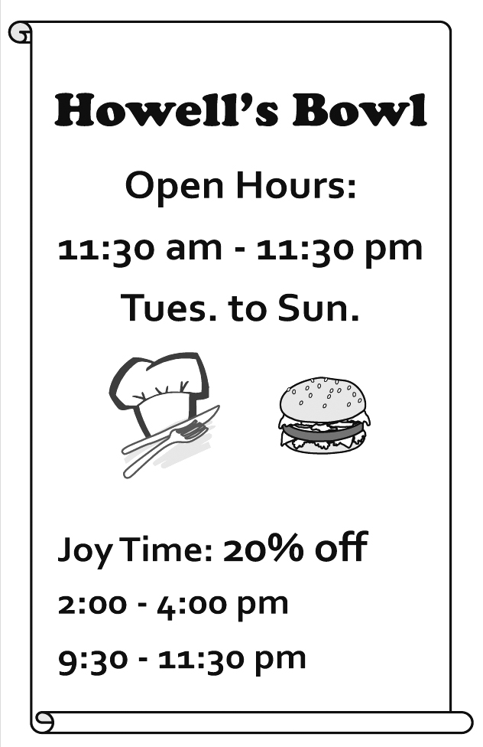  Table 2 |  | 3 person(s) | Order taken by Fred | 12:30 12/23
1 | pumpkin pie |  |  | 220 x 2
2 | cheese cake |  |  | 120 x 1
3 | milk shake (chocolate) (large) |  |  | 200 x 2
4 | milk shake (banana) |  |  | 110 x 1
5 | chicken sandwich |  |  | 100 x 1
6 | chicken sandwich (with cheese) |  |  | 120 x 1
7 | cola (no ice) |  |  | 65 x 1
8 | orange juice (no ice) |  |  | 90 x 1
9 | grape juice |  |  | 95 x 1
10
Total Price: $1,540
Thank You & Hope to See You Soon!!
 poster 海報
Tel: XXX-XXXX

（ B ）19. On the order list, Ginny ordered a sandwich with cheese, a fruit milk shake, and a fruit drink without ice. How much did she have to pay for her food?
(A) $300. (B) $320. (C) $385. (D) $410.
（ D ）20. Ginny wants to go to Howell’s Bowl again during Joy Time. When will she possibly go there?
(A) 11:00 a.m. on Wednesday. (B) 2:30 p.m. on Monday.
(C) 8:00 p.m. on Friday. (D) 10:00 p.m. on Thursday.
（21～23）
Below is how four students answered their teacher’s question in class.
Lily: I like shopping and talking to people. I think I can learn how to do business. Maybe selling clothes is a good business for me.
Ryan: My hobbies are playing computer games and making friends online. We often share our funny stories by e-mail. I guess I will learn more about computers and make super-smart computer programs.
Bill: My parents have kept lots of pets since I was little. We’ve experienced many things together, good and bad, happy and sad. Those stories have always stayed in my mind. One day, I will share them with people by drawing and writing books.
Anna: Though my mom and two sisters are all doctors, I’m sure I will stay as far away from a hospital as I can. I hate being sick, and I’m afraid of seeing sick people looking weak and sad. I’ll keep strong by playing my favorite sport, tennis, every day. One day I’ll join the national team and be another Lu Yen-Hsun.
（ A ）21. What question did the teacher most likely ask in class?  likely 可能
(A) “What do you want to do in the future?”
(B) “What’s your plan for the coming vacation?”
(C) “What do you like to talk about with your friends?”
(D) “What’s your favorite thing to do with your family?”
（ C ）22. What do we know from the reading?
(A) Lily is good at making clothes.
(B) One of Bill’s parents is an animal doctor.
(C) Ryan enjoys meeting people on the Internet.
(D) Anna was once very sick and stayed in the hospital for a long time.
（ C ）23. What does them mean?
(A) Pets. (B) Books. (C) Stories. (D) Parents.
（24～25）
Here is the preface of Nick Foster’s new book Married to Food.
Preface
My mother was lousy at cooking. To her, cooking was more like an exciting experiment. You put some of this and some of that in a pot, and you wait and see what will happen. “No experiments, no experiences.” is what she would say when her experiment did not turn out good, and I heard that a lot.
My father was a good cook, and he loved to cook, too. He often said that he got my mother to marry him with a table of delicious food, not with a beautiful ring. “A family needs only one good cook,” he said.
Now I am a cook myself. And I have my own restaurant. I learned how to cook from my father, of course. From him, I learned the art of cooking. But I did learn one thing from my mother. It’s her famous saying: “No experiments, no experiences.”
 preface 前言 experiment 實驗
（ B ）24. What does it mean when someone is lousy at something?
(A) They are famous for it. (B) They cannot do it well.
(C) They think it is important. (D) They are not interested in it.
（ C ）25. What can we learn from the preface?
(A) How Foster started his own restaurant.
(B) When Foster’s father married Foster’s mother.
(C) What Foster’s mother taught him about cooking.
(D) How Foster learned the art of cooking from his father.
（26～27）
Here are the rules for a game called “Trip to Dreamland.”
1. Each player begins at START.
2. In each turn, first take one of the four cards  to decide how many spaces to move:  for one space,  for two spaces,  for three spaces, and  for four spaces. Then follow the words next to the , if there is a at the place you arrive at.
3. The first one who gets to Dreamland wins the game.  turn 回合 space 步、格
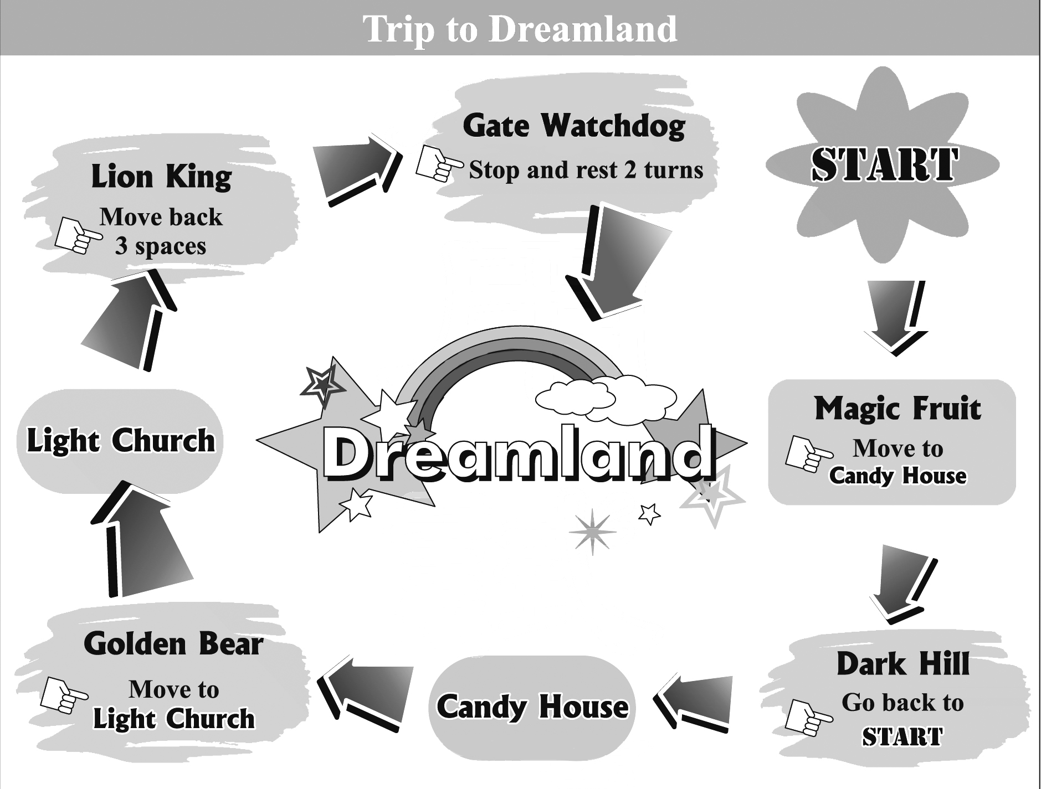
（ C ）26. Below are the cards which four kids have taken since they began the game.
Who has won the game?
(A) Anna: →→. (B) Kate: →→.
(C) Billy: →→. (D) Ivan: →→.
（ A ）27. What can we learn about the game?
(A) One can never begin his turn from Lion King.
(B) The cards can be used to decide who goes first.
(C) One can never get to Light Church at the first turn.
(D) The cards can be used to decide where to start the game.
（28～31）
The idea may hit you once or twice a year. You come home on a hot summer day, hoping to have a cool bath, and find out there is no water. Then you see how important water is in your everyday life. However, in many parts of the world, water is not just about one’s everyday needs.
In countries like Tanzania, water is hard to get, and the job of collecting water falls on women’s shoulders. Girls are often kept home from school to collect water while their brothers stay at school studying. Studies show Tanzanian girls who live 15 minutes from clean water spend 12% more time at school than those who live an hour away. More time spent collecting water means less time for learning. For these girls, “Knowledge is power” is not just words; it is a sad fact in real life. With less time spent at school, their chances of getting well-paid jobs are small, and they often have no voice in important matters, like who to marry. These girls are often married into poor families. They have little money or knowledge to take care of their children, who often end up dying young. For the baby girls who are lucky enough to live, their life may still center around “water,” just like it did for their mothers.
（ A ）28. What does The idea mean in the reading?
(A) Water is important in one’s everyday life.
(B) Water is not just about one’s everyday needs.
(C) It is nice to have a cool bath on a hot summer day.
(D) We should not take a bath when there is little water.
（ C ）29. What is the reading mostly about?
(A) Why it is important to save water.
(B) How water may give a country power.
(C) How water may play a part in one’s future.
(D) Why it is hard to get water in poor countries.
（ B ）30. What do we know from the reading?
(A) Children in poor countries die from drinking dirty water every day.
(B) Girls who spend little time at school have a harder life when they grow up.
(C) Girls in countries like Tanzania are often paid less for the same job than the boys are.
(D) Children from poor families are often kept from school to take care of younger children.
（ D ）31. Families in the countries of Benin, Ghana, Guinea and Madagascar deal with the job of water-collecting the same way Tanzanian families do. From the reading, which chart best shows the fact?
(A) (B)
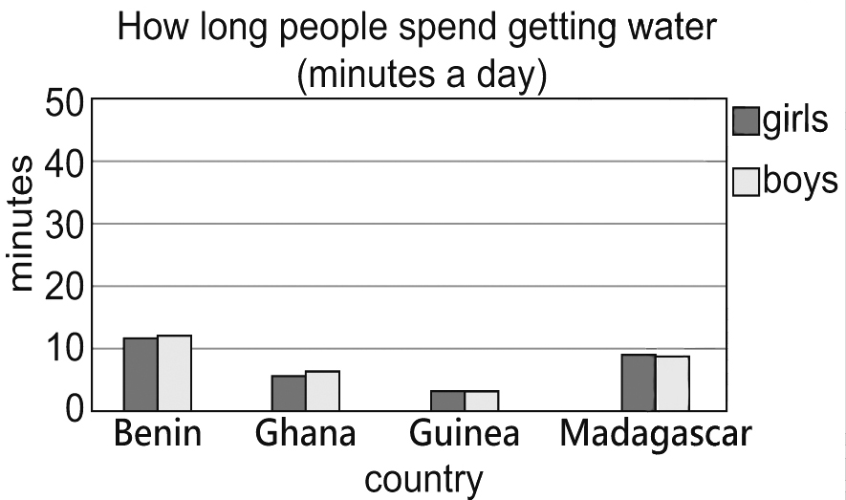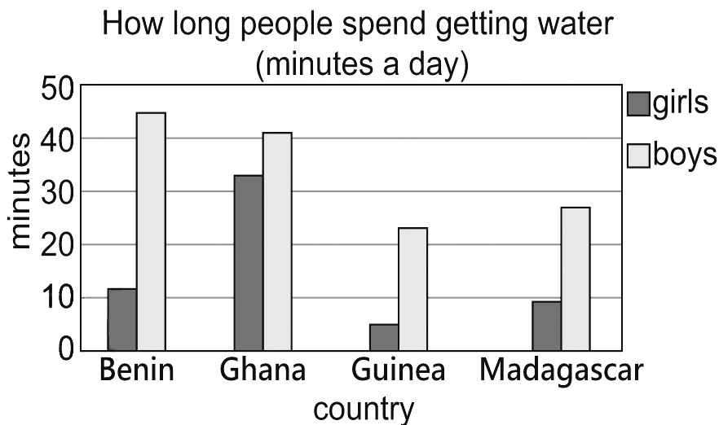
(C) (D)
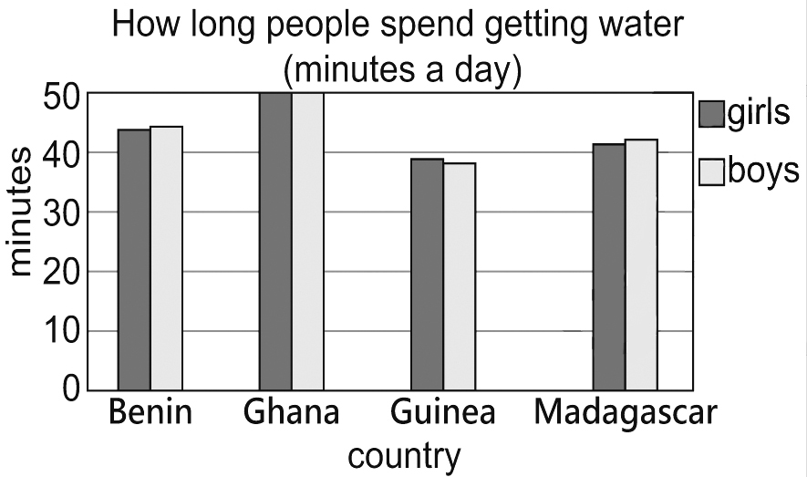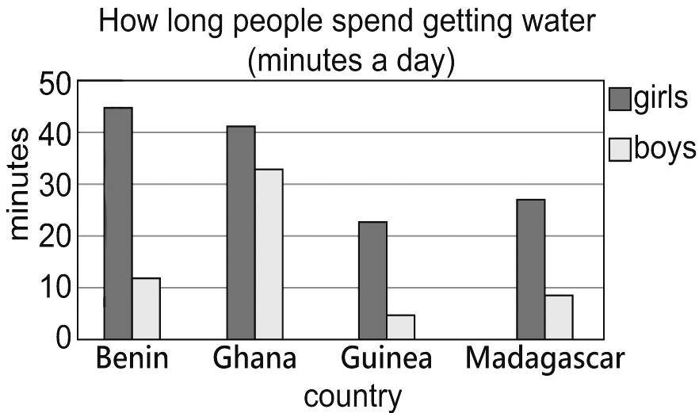
（32～34）
(At Liz’s birthday party)
Amber: Don’t tell me you didn’t go to Garden House.
Keith: Why would I go there?
Amber: For Liz’s birthday cake! I left you a voice message this morning!
Keith: But you said Matt would go to the bakery! And why did you come here without me? I was waiting outside your apartment for an hour!
Amber: No! I said I’d have lunch with Matt, and we’d come straight here from the restaurant. So I asked you to help get the cake after work.
Keith: No, you did not! And why didn’t you answer my calls?
Amber: My cellphone is dead! I said in the message that you could call Matt’s number if you wanted to find me. Now please tell me you did bring the gift we got for Liz.
Keith: What gift? I’m sure you didn’t say anything about a gift in the message.
Amber: I told you that yesterday!  message 留言
（ A ）32. What is Garden House?
(A) A bakery. (B) A gift shop.
(C) A flower shop. (D) An apartment.
（ C ）33. What can we learn about Keith?
(A) He forgot to meet Amber and Matt for lunch.
(B) He did not know how to get to Amber’s apartment.
(C) He called Amber without knowing her phone was not working.
(D) He did not know Amber left him a voice message this morning.
（ A ）34. Which sentence was most likely part of the message that Amber left Keith this morning?  likely 可能
(A) “Matt and I will go to the party after lunch.”
(B) “Don’t forget to buy a birthday gift for Liz.”
(C) “You can go straight to the party from your office.”
(D) “I need to talk to you about the party this weekend.”
（35～36）
Froggie was a frog who never remembered where he had been. His biggest dream was to find the best pond to swim freely without worrying about water snakes. One day, Froggie hopped to a kitchen and jumped into a pot full of hot water. Froggie felt the burning heat and hurried out of the water as fast as his legs could carry him. “I almost died there!” Froggie thought.
A few days later, Froggie went back to the same kitchen, totally forgetting he had been there. He again hopped into the same pot. This time, the water inside was cool. He looked around and thought, “There’s no water snake trying to eat me and I can have this place all to myself!” At that moment, Froggie knew it was his dream pond. What he didn’t know was that the water was warming up over a low heat.
After thirty minutes of swimming, Froggie felt the water was warmer but he thought of this as a nice surprise. “This sure is the best place for swimming. I get to have a hot bath, too.” During his comfortable bath, the water kept getting warmer and warmer. Froggie was so comfortable that he fell asleep. And he never woke up.
（ C ）35. What lesson can we learn from Froggie’s story?
(A) Life is too short; one should live it to the fullest.
(B) Those who use their time well will win in the end.
(C) People are blind to problems that slowly get worse over time.
(D) It is difficult to give up old habits, but easy to pick up new ones.
（ B ）36. What do we know about Froggie?
(A) He learned to share what he liked with others.
(B) He thought what he had hoped for became real.
(C) He once almost lost a dear friend to a water snake.
(D) He wanted to go back to the same pot for a hot bath.
（37～40）
The Metro Times
Oct. 1. 2020
These years churches are in a calamitous state. To start with, the number of church-goers is dropping sharply (see Figure 1). Many say they do not belong to any church, and those who do go less often than they used to. Going to church appears less and less on people’s to-do list. Another worrying fact is that fewer and fewer young people go to church, which leads to an older church (see Figure 2).
And there is also the problem with money. Keeping a church door open is not cheap. Fewer people going to church means little money coming in. This makes it harder to keep a church open.
When the time comes for a church to close, there is little to do but to sell it. Churches that were lucky enough to find a buyer were put to other uses. Some were changed into restaurants or school gyms, and some even became nightclubs, for example. Churches that had little luck were knocked down in the end.
Just like a store that keeps losing business needs to think of ways to save itself, it is perhaps time for the church to try to win people’s hearts back and play an important part in people’s lives again. This is not something that one can simply pray to get an answer to.
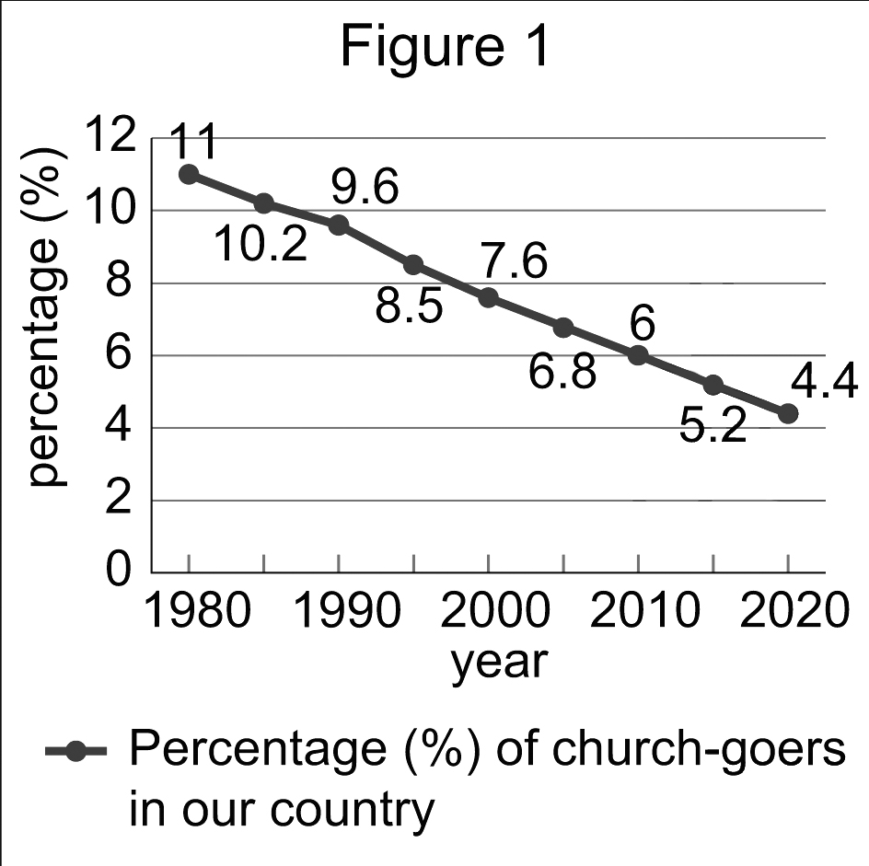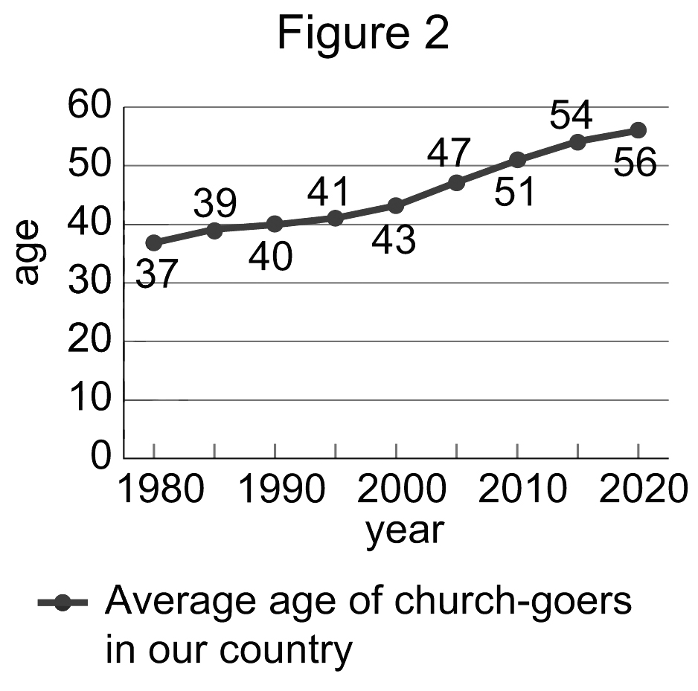
 figure 圖 average 平均
（ A ）37. What does it mean when someone is in a calamitous state?
(A) They have serious trouble.
(B) They try to change themselves.
(C) They are looking for a second chance.
(D) They lost interest in the outside world.
（ C ）38. What can we learn about the church-goers from the report?
(A) Between 1980 and 2005, few church-goers were younger than 50.
(B) In 2010, only 6% of church-goers were younger than 50 years old.
(C) In 2020, the percentage (%) of church-goers drops to lower than half that in 1980.
(D) Between 1980 and 2020, the rising number of old church-goers has led to an old church.
（ C ）39. What is talked about in the report?
(A) Where the church’s money goes.
(B) How people decide to join a church.
(C) What happens to churches that are closed.
(D) Why people have stopped going to church.
（ D ）40. Below are four findings from other reports. Which does NOT agree with the idea of the report?
試題結束
(A) “Reports show over 90% of church-goers go to church because their fathers do. In the last 20 years, 49% of men under 30 have left the church. That means there’s a 90% chance that their children won’t go to church. This is hard for the church to take in.”
(B) “Between 2003 and 2010, over 1,000 new churches were built in the country. This may sound like good news. During the same years, however, more than 2,000 were closed.”
(C) “In the report, 33% of the people that were interviewed say they never go to church and another 33% say they used to. Only 15% go to church at least once a month.”
(D) “Of the 15 countries in the report, the percentage (%) of church-goers in some countries, like Denmark, is lower than 10%; in others, like Poland, the percentage is higher than 70%.”

