90學年度國中第一次基本學力測驗 英文領域

第一部分：下列各題（題號1.～17.），請依文意選出一個正確或最佳的答案。
（Ｄ）1. My son's birthday is coming. I want to buy him a computer as a birthday .
(A) place (B) party (C) poster (D) present
（Ｃ）2. It is to go out on a typhoon day. The sky is dark and the wind is strong.
(A) careful (B) fashionable (C) dangerous (D) convenient
（Ｄ）3. You will become a good learner if you the tips your teachers talk about.
(A) do (B) ask (C) answer (D) follow
（Ａ）4. I'm sorry for breaking your window. It's all my .
(A) fault (B) idea (C) joke (D) question
（Ｄ）5. The town looks very now. It has changed a lot.
(A) serious (B) worried (C) favorite (D) different
（Ｃ）6. John is an active language learner. He always takes a with him.
(A) story (B) sentence (C) dictionary (D) conversation
（Ｂ）7. I feel it great to take in the hot springs in Yangmingshan.
(A) an interest (B) a bath (C) a trip (D) some medicine
（Ａ）8. Our teacher the old lessons before starting a new one.
(A) reviewed (B) noticed (C) previewed (D) remembered
（Ｄ）9. Mary had an accident and was badly hurt. The doctor says it is for her to go to school today.
(A) illegal (B) special (C) convenient (D) impossible
（Ｂ）10.If you want to be strong, every day can help you.
(A) criticizing people (B) going swimming
(C) preparing tests (D) playing video games
（Ｃ）11.The jacket is than the dress or the pants.
(A) expensive (B) very expensive
(C) more expensive (D) the most expensive
（Ｄ）12.Frank read a comic book yesterday, but his brother .
(A) does (B) doesn't (C) did (D) didn't
（Ｂ）13.Mrs. Wang has two sons. of them go to junior high school.
(A) One (B) Both (C) Some (D) Many
（Ａ）14.Do you remember the girl looked worried at the train station yesterday?
(A) who (B) where (C) which (D) what
（Ｃ）15.These pictures when we took a trip to Kenting National Park.
(A) took (B) will take (C) were taken (D) will be taken
（Ａ）16.Paul: What did you find under his desk?
Tom: Oh, all kinds of things: a basketball, pencils, a hat, and fries!
(A) there were (B) it was (C) it had (D) there was
（Ｂ）17.Oscar: I'm going to the museum. Bus Number 286 goes there, ?
David: Yes, but you can take a Number 287, too.
(A) does it (B) doesn't it (C) is it (D) isn't it
第二部分：下列十一個題組，共有27題（題號18.～44.），請依據所附資料、圖、表或選文，選出一個正確或最佳的答案。
（18.～19.）
May 16, 2000
Dear Julia,
It's been two months since I came to England. I have settled down and started to like the life here. I have made several new friends. They are from different countries: Japan, Germany, and Russia. English is the only language we can use for communication. These friends are my classmates, and we also live in the same house. So we are 18. all day－studying, playing basketball and going shopping. It's very interesting to go to the supermarket. People from different countries enjoy different foods. Some of the foods are very 19. to me.
Could you come to England for a vacation this summer? You would love to meet my new friends.
Laura
 settle down 安頓下來

（Ｄ）18.(A) free (B) active (C) bored (D) together
（Ａ）19.(A) strange (B) serious (C) illegal (D) hungry
（20.～22.）
In 1999, there were about 2,482 traffic accidents in Taiwan. Most of the accidents happened because 20. . For example, some drivers drove too fast. Some drivers drank too much wine or beer before they got into the car. And some drivers never tried to stop when 21. .
It is convenient to drive a car. But it also can be dangerous. Accidents can be avoided only when people drive carefully. Everyone should remember 22. .
for example 例如
beer 啤酒

（Ｃ）20.(A) motorcyclists were riding too fast
(B) the MRT system was not built yet
(C) drivers didn't follow the traffic rules
(D) there were too many traffic lights on the road
（Ｄ）21.(A) it started to rain
(B) they drove near a police station
(C) there were too many cars on the road
(D) the traffic light went from yellow to red
（Ｄ）22.(A) driving in a traffic jam is terrible
(B) learning to drive well is very difficult
(C) finding a parking space is always a problem
(D) being safe is more important than anything else
（23.～24.）
Alice: Can you go with me to Jill's bookstore?

I need a notebook.
Ben: Now? It's too early. Today's Sunday.
There is still one hour before it opens.
Alice: Oh! I forgot. Well, then, let's go to Hilda's.
I'm a little hungry.
Ben: It's expensive to eat out. Why not stay for lunch?
My mom is making hamburgers and fries.
Alice: Good idea. I love hamburgers and fries.
（Ｂ）23.At about what time do Alice and Ben have the conversation?
(A) 8:30 in the morning. (B) 11:30 in the morning.
(C) 2:00 in the afternoon. (D) 7:00 in the evening.
（Ｃ）24.What is“Hilda's”?
(A) A factory. (B) A bookstore.
(C) A restaurant. (D) A cram school.
（25.～26.）
Read the records of the four baseball teams and answer the questions.
Teams | Won | Lost | Points
ALS | 1 | 1 | 1
Chicoes | 0 | 4 | 0
Victors | 4 | 1 | 4
New Brooks | 2 | 1 | 2

（Ｄ）25.Judy is a big fan of Chicoes, but Mark doesn't know anything about baseball. Judy is trying to tell him something about the interesting sport. What would she say about the four teams?
(A)“Poor New Brooks! It doesn't have any points yet.”
(B)“ALS is the best. It has won the most games so far.”
(C)“Chicoes is the best. See? It won more games than Victors.”
(D)“Chicoes hasn't won any game yet, but it is still a wonderful team.”
（Ｃ）26.The team which wins more than three games can play in the final round. Now, which
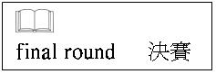
team will surely play in the final round?
(A) ALS. (B) Chicoes. (C) Victors. (D) New Brooks.
（27.～28.）
It is fun and exciting to visit different countries and meet different people. You can see beautiful mountains and seas. You can learn different ways of living and doing things. You can try many kinds of foods. You can buy special presents for yourself and your friends.
It is also a good way to learn a foreign language because you can learn the language by using it. You can practice speaking English when visiting America or England. Or you can practice speaking French in France or German in Germany.
Have you ever taken a trip to a foreign country? Think about it for your next vacation!
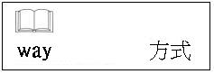
（Ｃ）27.According to the reading, what is a good way to learn a foreign language?
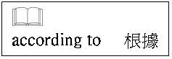
(A) Studying it in school.
(B) Finding a good teacher.
(C) Visiting a foreign country.
(D) Writing e-mails to a foreign friend.
（Ｂ）28.According to the reading, what makes a trip fun?
(A) You can take a lot of pictures.
(B) You can see new ways of living.
(C) You can meet your old friends there.
(D) You can buy presents at better prices.
（29.～31.）
These are the messages Sandy got yesterday. Read them carefully and find the best answers to the questions.
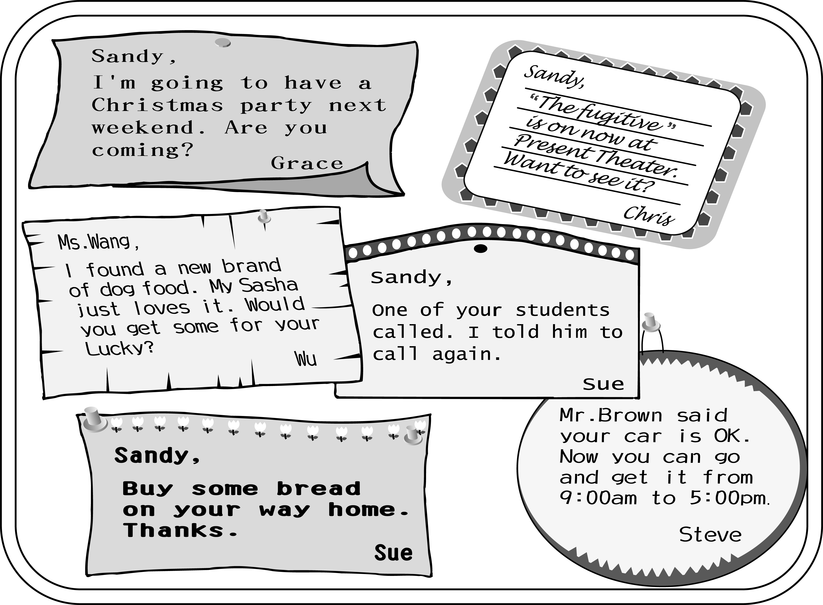
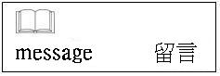
（Ｃ）29.When is Grace going to have a party?
(A) This weekend. (B) This Friday.
(C) Next weekend. (D) Next month.
（Ｂ）30.What is“The Fugitive?”
(A) A books. (B) A movie.
(C) A song. (D) A ball game.
（Ａ）31.What did Mr. Brown do for Sandy?
(A) He examined her car.
(B) He wanted to buy her car.
(C) He prepared dinner for her.
(D) He found a new brand of dog food.

（32.～33.）
Flower Town in July
Summer is the most beautiful season in Flower Town. In the morning, take a walk in Vendo Park between First Street and Third Street. If you enjoy reading, there is a bookstore in the park.

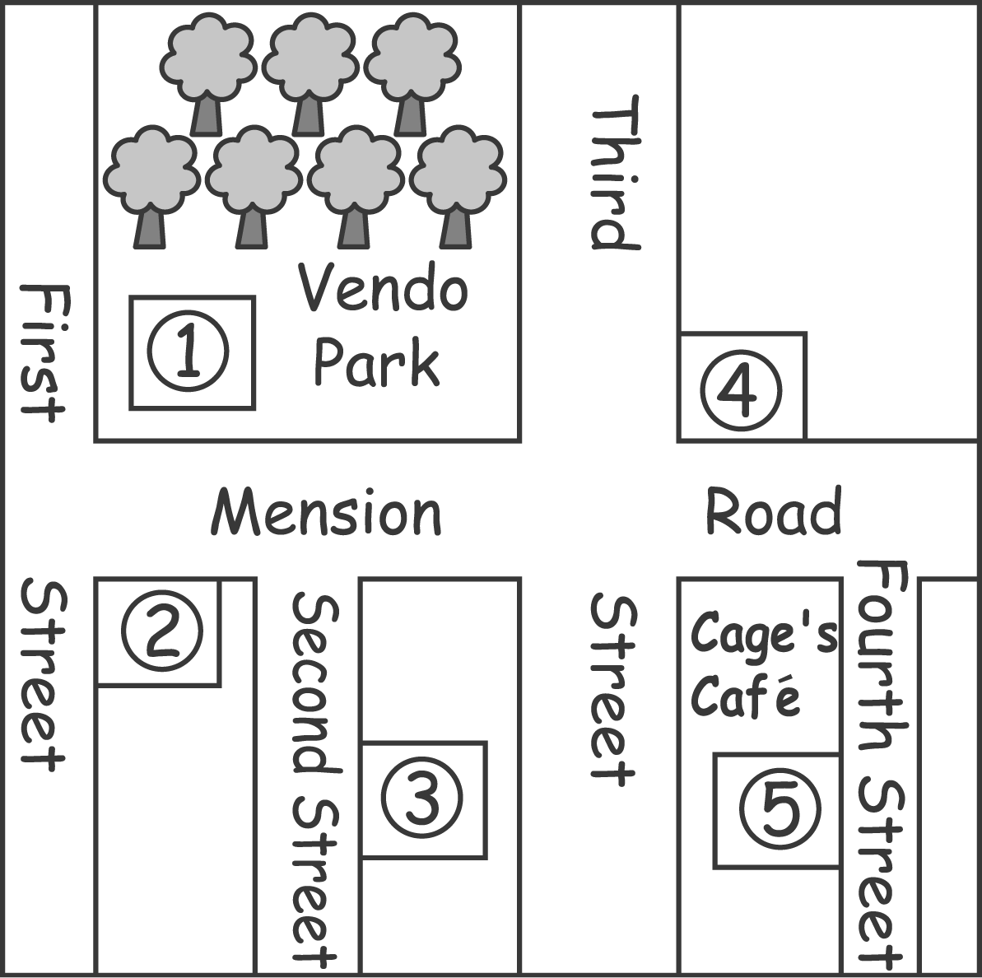
For lunch, have delicious Hamburger Special in Googie's. You can walk there from the park. It is just on the corner of Mension Road and Third Street.

When the weather gets hotter in the afternoon, go to the swimming pool on Fourth Street. It is next to Cage's .

In the evening, movie fans move to Second Street. David Stone Theater has all kinds of movies!

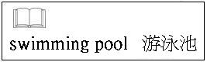
（Ｃ）32.What is Number 4 in the map?
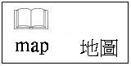
(A) The theater.
(B) The bookstore.
(C) The restaurant.
(D) The swimming pool.
（Ｄ）33.Who will find this poster useful?
(A) Street vendors. (B) Police officers.
(C) People who need jobs. (D) People who visit the town.

（34.～35.）
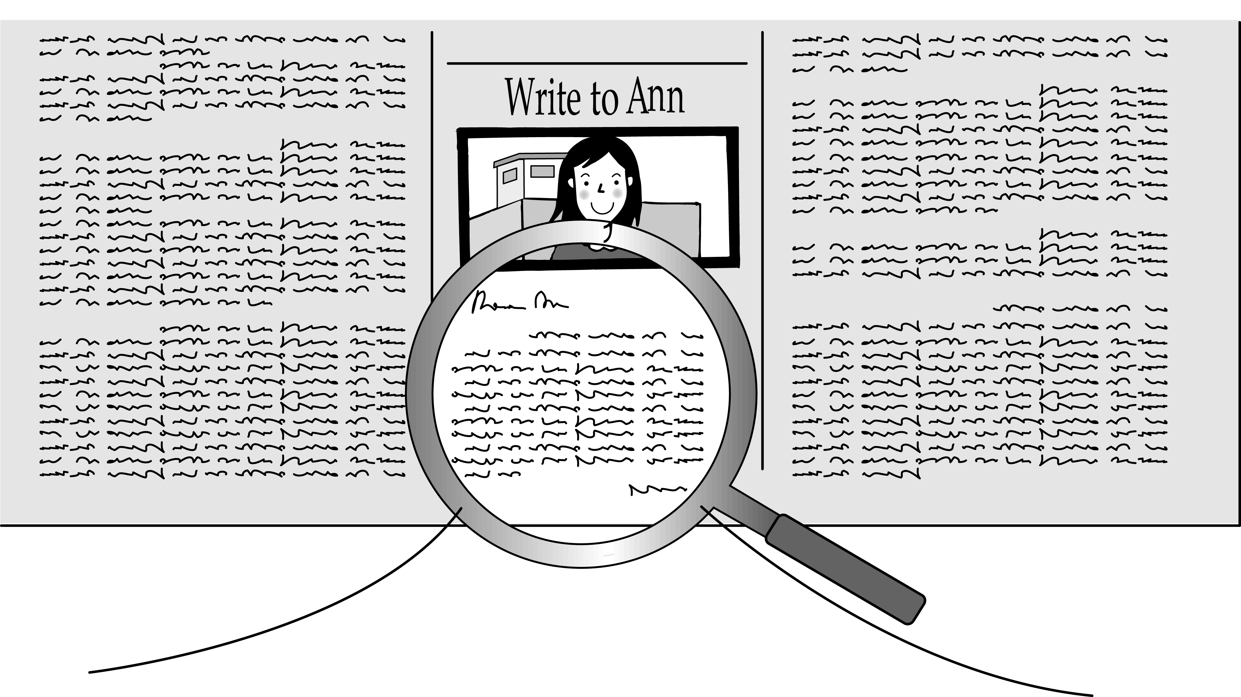

Dear Ann,
I am really worried about my daughter, Shirley. I don't know why, but she always thinks she is too heavy. She eats only a little rice and some vegetables. She refuses fish, beef and pork.“Cake”and“dessert”are taboo words to her.
The problem is that she is NOT heavy at all. In fact, the doctor says she is skinny. But she still believes being thinner will make her prettier. I'm afraid she will get sick before she becomes any“prettier.”
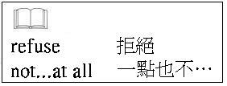
Worried father,
Joseph
（Ｂ）34.What does“taboo words”mean in the letter?
(A) Words that make people happy
(B) Words that should not be said.
(C) Words that are hard to remember.
(D) Words that a father doesn't want to hear.
（Ａ）35.What does the doctor mean by saying Shirley is skinny?
(A) She is too thin. (B) She is very beautiful.
(C) She is seriously sick. (D) She should eat more vegetables.

（36.～37.）
These are the cards for the Chen family. Read them carefully and answer the questions.
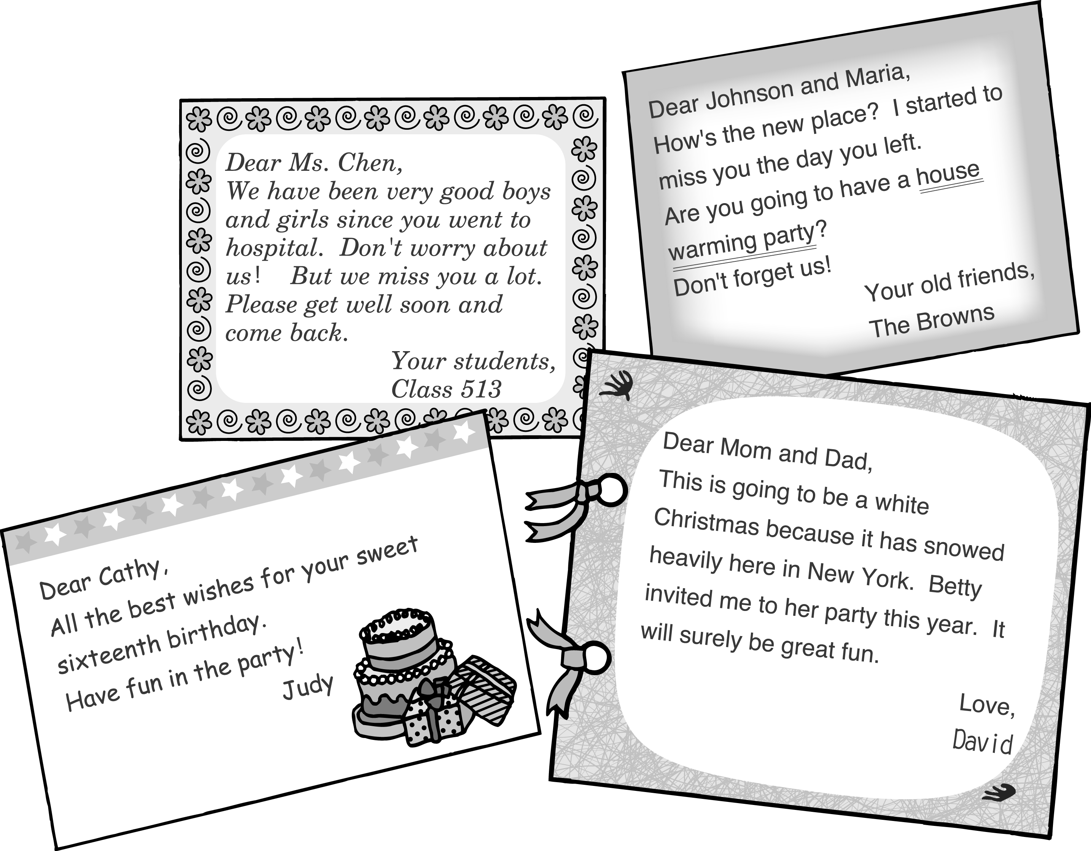
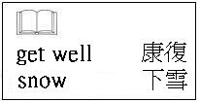
（Ｃ）36.When do people have a“house warming party”?
(A) On their birthday.
(B) On Christmas Eve.
(C) After they just moved.
(D) When they come back home from hospital.
（Ｂ）37.Who will join Betty's party?
(A) Cathy. (B) David.
(C) Maria and Johnson.
(D) David's dad and mom.
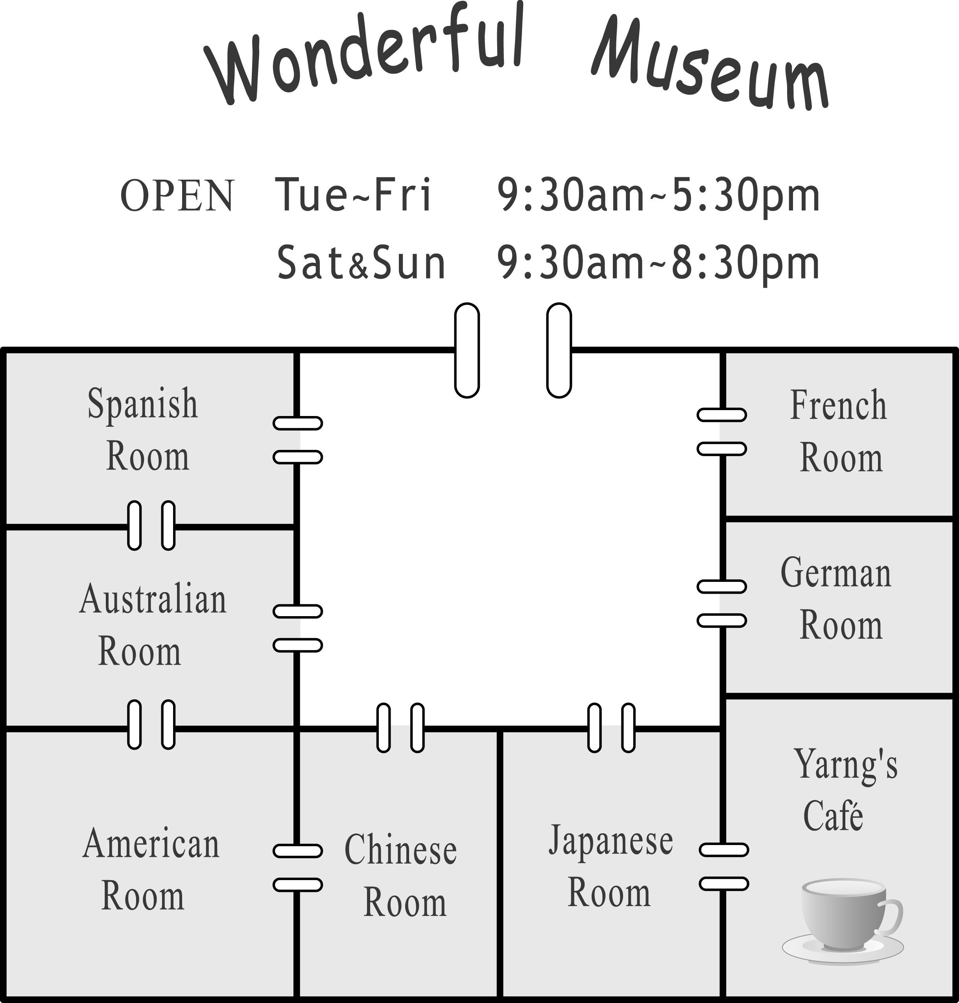
Welcome to Wonderful Museum. This month we are having a special display about old machines from different countries. You can find the ways machines were used to help people one hundred years ago. How did the Germans make their first cars? How did our grandfathers in China use their farming tools? When did the Americans try to make their planes? And when did the Spanish make comfortable shoes in their factories? You will find the answers.
After this trip of the machine history, enjoy some coffee by our wonderful coffee-making machines in Yarng's in the corner of this floor.
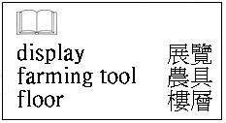
（Ａ）38.The Wang family wanted to visit Wonderful Museum this morning, but it was not open. What day is today?
(A) Monday. (B) Wednesday.
(C) Friday. (D) Saturday.
（Ｃ）39.Henry is a car fan. When he knows about the display, he visits the museum to know more about the history of car making. Which room will he surely visit?
(A) Japanese Room. (B) Chinese Room.
(C) German Room. (D) Spanish Room.
（Ｂ）40.What is the best name for the special display in Wonderful Museum?
(A) Traffic History. (B) Old Machines.
(C) The Business World. (D) The Communication Age.

（41.～44.）
Mrs. Kao couldn't sleep well. How could she? Winnie said she would be home before eleven, but it was almost twelve. Where was she? Mrs. Kao called her on her cell phone. No one answered. She got out of bed, put on a jacket, and went to the living room.
Terry walked out of his room and asked,“What's wrong, Mom?”Oh, is Dad coming home tonight?”“No. Tomorrow. I'm waiting for your sister.”Terry went back to his room and studied. He had a very important exam the next day.
“Terry is a good boy,”Mrs. Kao thought.“He's three years younger, but I seldom need to worry about him.”
Ten minutes later, the telephone rang.“I'm so happy to hear your voice. Where are you?
...I'm happy that you called. No, don't take the taxi. Stay at the door of the theater with Maggie. I'll come and drive you and Maggie home. Don't worry. I'll be there in about ten minutes.”Mrs. Kao took the car key and went out.
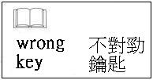
（Ｃ）41.How did Mrs. Kao feel before Winnie called?
(A) Sad. (B) Happy.
(C) Worried. (D) Comfortable.
（Ａ）42.Where did Winnie go?
(A) She went to a night movie.
(B) She went to a morning class.
(C) She went to a baseball game.
(D) She went swimming with Maggie.
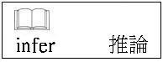
（Ａ）43.What can we infer from the story?
(A) Mr. Kao was not home.
(B) Mrs. Kao cannot drive a car.
(C) Maggie is Mrs. Kao's daughter.
(D) Winnie is three years younger than Terry.
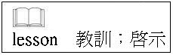
（Ｄ）44.What lesson does the story give us?
(A) Children should not have their own cell phones.
(B) Children should always stay home and study hard.
(C) Children should not go out before an important exam.
(D) Children should always let their parents know where they are.

