90學年度國中第二次基本學力測驗 英文領域

第一部分：下列各題（題號1.～20.），請依文意選出一個正確或最佳的答案。
（Ａ）1. It was a(n) game! Our class won, 56-55. We sang happily after the game was over.
(A) exciting (B) dangerous (C) fashionable (D) embarrassing
（Ｃ）2. With e-mails and telephones, has become easier, and the world is getting smaller.
(A) experience (B) difference (C) communication (D) software
（Ｃ）3. It is not safe to swim in the sea, so Susan's mother asked her to it.
(A) invite (B) draw (C) avoid (D) join
（Ｄ）4. March is the third month of the year. It comes February and April.
(A) about (B) before (C) during (D) between
（Ａ）5. The today was very different from the one we had before; the teacher asked us to draw pictures as the answers.
(A) exam (B) color (C) dessert (D) housework
（Ｃ）6. She didn't finish her work today because she worked too .
(A) quietly (B) clearly (C) slowly (D) politely
（Ｄ）7. When the floor is dirty, my brother is always the first one to it.
(A) finish (B) solve (C) change (D) mop
（Ａ）8. Soccer is a kind of sport. That means you cannot play it by yourself.
(A) team (B) popular (C) funny (D) boring
（Ｂ）9. The idea of this great movie comes from which has already been read and loved by many people.
(A) a brand (B) a novel (C) an answer (D) an experience
（Ｂ）10.Tom: Jack, put the letter in the and send it to Mr. Wu, please.
Jack: Sure.
(A) closet (B) envelope (C) tunnel (D) corner
（Ａ）11.Melissa: I hate summer. It usually rains in the afternoon.
William: But the rain stops in a short time and then everyone feels cooler.
(A) heavily (B) carefully (C) actively (D) clearly
（Ｂ）12.Carl: Did you that Amy's been a little too quiet these days?
Ray: Yes. She didn't even say a word this morning.
(A) imagine (B) notice (C) examine (D) review
（Ｄ）13.Michael: Mom, I got the best grade on the English test today.
Mrs. Lee: Good job, son. I'm of you.
(A) sure (B) sick (C) afraid (D) proud
（Ｄ）14.Lucy and her boyfriend, Daniel, came to Taiwan July 10, 1999.
(A) at (B) in (C) with (D) on
（Ｂ）15.Nana and Fred are good friends, and are baseball fans.
(A) all of them (B) both of them
(C) some of them (D) one of them
（Ｃ）16.Betty fake watches when the police came.
(A) sells (B) is selling
(C) was selling (D) has sold
（Ｃ）17.Christine: Dad, I'm hungry. Do we have anything to eat?
Mr. Chen: You can have some bread I from the supermarket. It's on the table.
(A) am buying (B) to buy
(C) bought (D) will buy
（Ｄ）18.（In the teachers' office）
Miss Huang: Sue, students in the classroom?
Miss Cheng: I don't think so. School's over.
Miss Huang: But I hear people talking over there.
(A) are they (B) do they
(C) is there (D) are there
（Ｂ）19.Robert: Where are the boys playing?
Barbie:
(A) After school. (B) Under the tree.
(C) On Sunday. (D) To the park.

（Ａ）20.Philip: Is that red car Miss Brown's?
Walter: Yes, it's . Beautiful, isn't it?
(A) hers (B) his (C) ours (D) theirs

第二部分：下列十一個題組，共有25題（題號21.～45.），請依據所附資料（圖、表或選文），選出一個正確或最佳的答案。
（21.～23.）
Should Taiwan have the fourth nuclear power plant? People talk a lot about this issue these days. Some people 21. the idea because they think nuclear power is the best way to produce enough electricity for people in Taiwan. But some 22. . They are worried that Taiwan will become a very dangerous place if any problem happens in the future.
It is impossible to make everyone think the same way, but 23. : everyone hates the idea of having a nuclear power plant near their houses. No one thinks it is safe to live near a nuclear power plant.
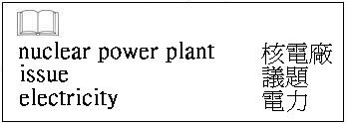
（Ｄ）21.(A) forget (B) give up
(C) criticize (D) welcome
（Ａ）22.(A) think differently about the issue
(B) have never heard about the issue
(C) hope to live a more convenient life
(D) decide to build a new nuclear power plant
（Ｃ）23.(A) one thing is illegal
(B) there will not be so much air pollution
(C) people have the same idea about one thing
(D) it takes a long time to build a nuclear power plant

（24.～25.）
Every day I go to many places and meet different people. Some of them are nice and polite. They say“Please”and“Thank you”to me. Some tell me about their family and jobs. I have made several friends and learned a lot from these people.
But I am not always so lucky. Some people leave their garbage after they eat and drink in my car. Some people are noisy, so I cannot concentrate. Some people are“back-seat drivers.”They never stop telling me“Turn right!”“Turn left!”“Stop!”“Drive faster!”Sometimes more than four people want to get into my car at a time, but it is illegal!
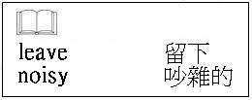
（Ｄ）24.What is most likely the writer's job?
(A) A businessman.
(B) An office clerk.
(C) A street vendor.
(D) A taxi driver.
（Ａ）25.Why does the writer enjoy her／his job?
(A) She／He likes to meet people.
(B) There are a lot of back-seat drivers.
(C) She／He can eat and drink in her／his car.
(D) People help take away garbage.

（26.～27.）
Linda bought a book about Europe. Read the contents of the book and answer the questions.
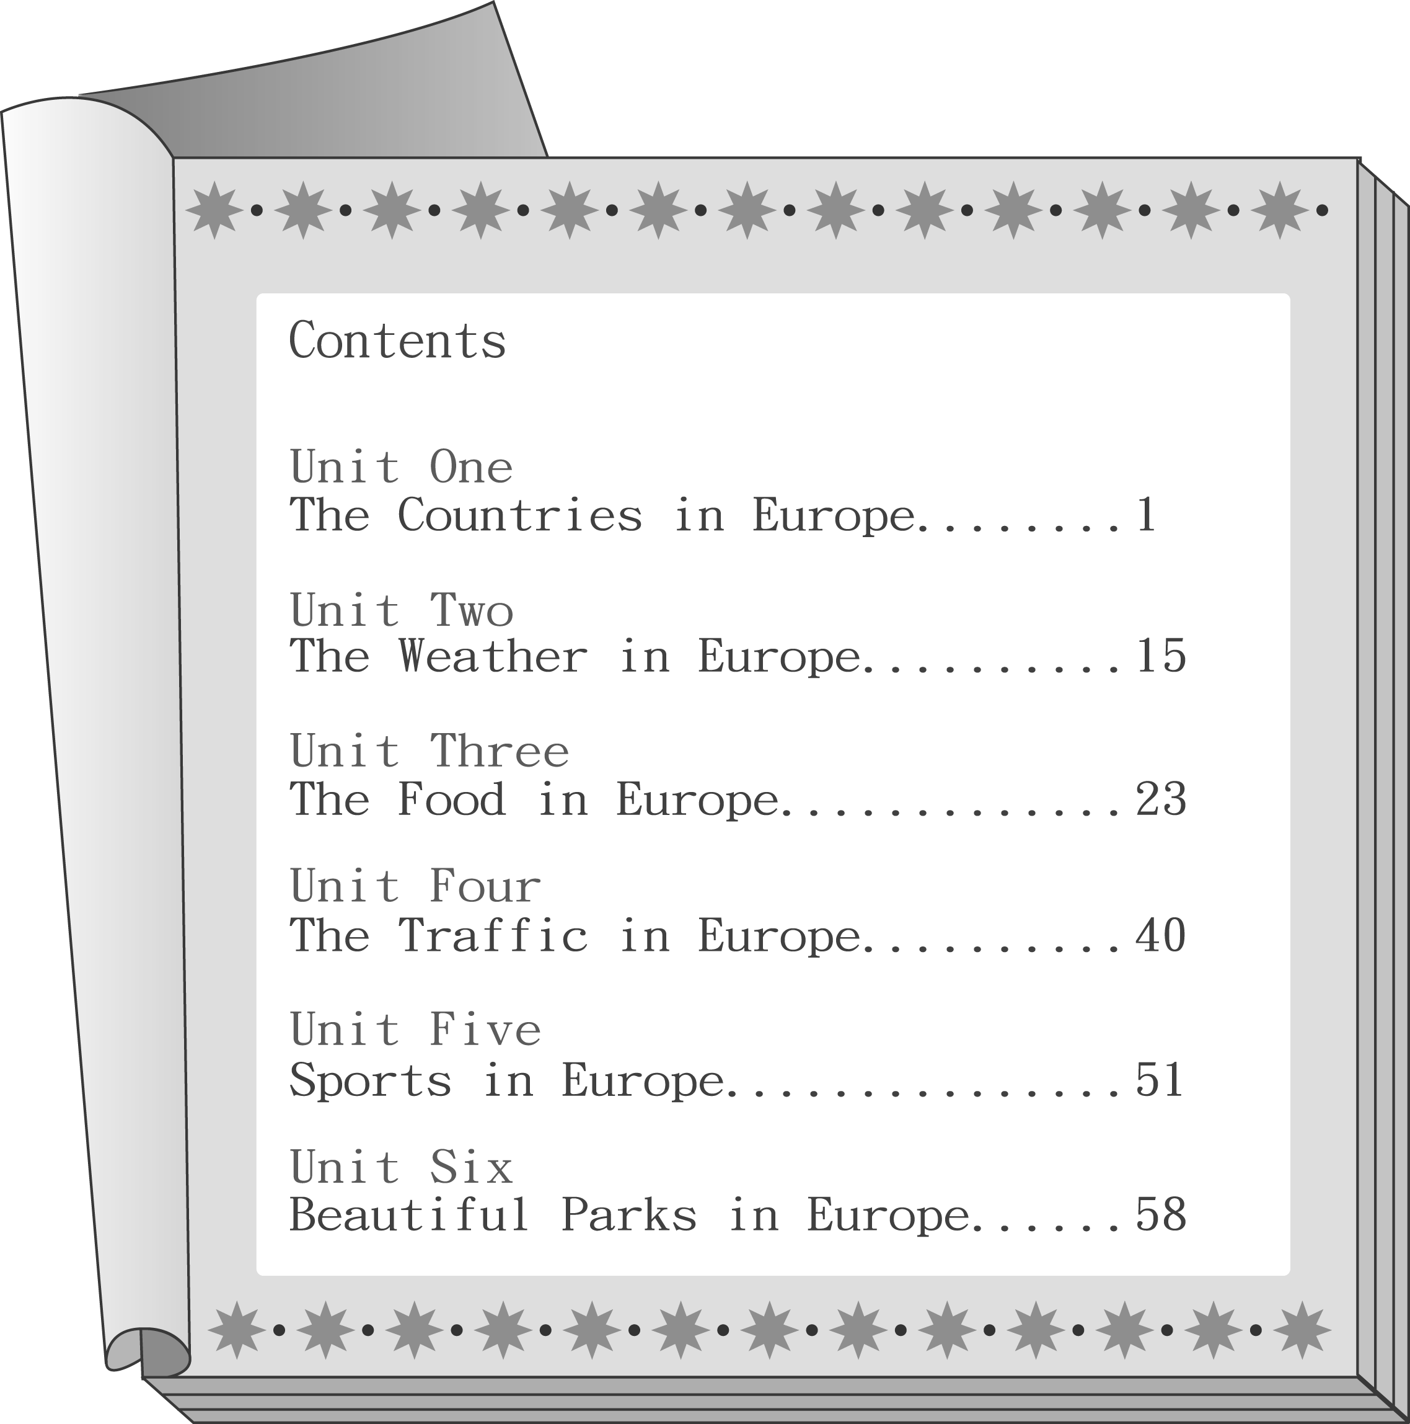
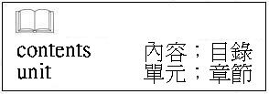
（Ｃ）26.Linda will take a trip to Europe this summer. She wants to visit many places, so she needs to study the subway system in Europe. Which unit is the most useful for her?
(A) Unit Two. (B) Unit Three.
(C) Unit Four. (D) Unit Five.
（Ｂ）27.People all over the world enjoy playing different ball games. For example, the Japanese like to play baseball, and the Americans like to play basketball. Linda wants to know more about the ball games in Europe. Which unit should she read?
(A) Unit Six. (B) Unit Five.
(C) Unit Four. (D) Unit Three.

（28.～29.）
Helen: Here, Frank, this is the schedule for this semester.
Frank: Thanks, Helen. Anything new?
Helen: Yeah. We're going to study Latin this year.
Frank: Latin? Isn't that a dead language? Why should we learn a language that is not spoken
anymore?
Helen: Well, we should. Many important books are written in Latin.
Frank: And Who's going to teach it?
Helen: Mrs. Filch.
Frank: What? That old witch? Well... Yeah... she is the BEST teacher for a DEAD language.
Helen: Don't be so mean, Frank. It's going to be interesting.
Frank: You know Mrs. Filch hates me. If I have to take her class, I'm dead!
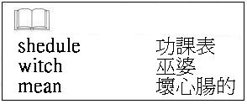
（Ｄ）28.What does Frank think of their new language class?
(A) He thinks it is not easy to learn a dead language well.
(B) He thinks Latin is useful, and studying it will be interesting.
(C) He enjoys Mrs. Filch's classes and thinks she is the best Latin teacher at school.
(D) He does not like the idea of learning a dead language, and he is afraid of Mrs. Filch.
（Ｂ）29.Why does Helen think it is a good idea to study Latin?
(A) Because it is a language that no one else knows.
(B) Because many important books are written in Latin.
(C) Because students have to learn it to know witches better.
(D) Because Mrs. Filch is the most famous Latin teacher at school.
（30.～31.）
Here are the timetable and the price list of Shilla Theater. Look at them and answer the questions.
MOVIE | TIME
The Dead End | 11:50 13:50 15:50 17:50
Tina | 10:00 12:10 14:30 16:50
Summer Time | 11:20 13:20 15:20 17:20
Life Is Wonderful | 10:00 12:10 14:30 16:40
The Singing Bird | 10:30 12:30 14:30 16:30

 | Grownups | Children under 12
Mon～Fri | NT$200 | NT$100
Weekend＆Holiday | NT$250 | NT$150



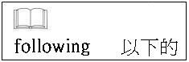
（Ａ）30.School is over at 5:00 in the afternoon from Monday to Friday. Which of the following movies can students go to after school?
(A) The Dead End.
(B) Tina.
(C) Life Is Wonderful.
(D) The Singing Bird.

（Ｄ）31.John is ten years old. If John's parents take him with them to a movie on Saturday, how
much do they have to pay?
(A) NT$350. (B) NT$400. (C) NT$500. (D) NT$650.

（32.～34.）
Tony: What birthday present did you buy for Grandmother?
Mary: A cell phone.
Tony: A cell phone? Why? She already has one, doesn't she?
Mary: Yes, she does. But I think that one is old-fashioned. What did you buy for her?
Tony: I bought a dancing machine.
Mary: A dancing machine! It's not cheap.
Tony: It's very expensive, of course, but I asked Mom and Dad for help. It's a great present
because all of us can enjoy it together!
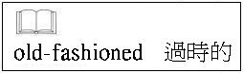

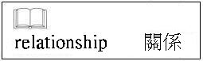
（Ｄ）32.What is the relationship between Tony and Mary?
(A) Friends.
(B) Cousins.
(C) Classmates.
(D) Brother and sister.
（Ｄ）33.Why did Mary buy a new cell phone for her grandmother?
(A) Because she broke her grandmother's cell phone.
(B) Because her grandmother does not like the old cell phone.
(C) Because her grandmother has given Tony the old cell phone.
(D) Because she wants to give her grandmother a fashionable cell phone.
（Ｃ）34.Why does Tony think the dancing machine is a great present?
(A) Because it is not expensive.
(B) Because his parents paid for it.
(C) Because all the family can use it.
(D) Because Grandmother has wanted it for a long time.
（35.～36.）
The table tells us about the climates of four cities. Look at it and answer the questions.
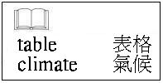
City
MonthPortagoWankooMaramiAlbertoDecember～February3℃dry－5℃wet26℃dry23℃wetMarch～May20℃wet12℃dry18℃wet28℃wetJune～August25℃wet20℃dry8℃wet25℃wetSeptember～November13℃wet6℃wet17℃dry29℃wet
（Ｂ）35.In which of the following months is Marami the coldest?
(A) October.
(B) July.
(C) April.
(D) January.
（Ｃ）36.Joseph hates cold and rainy days. If he wants to take a trip in January. Which city would
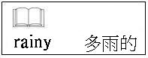
be the best for him?
(A) Portage.
(B) Wankoo.
(C) Marami.
(D) Alberto.

（37.～38.）
Playing computer games is fun. It has become very popular. Young people like to do it in their free time. Here are some important things you have to know when you play computer games.
First, you should learn English well. If your English is good enough, you can understand the computer games more clearly. Then you will play the games better than your friends.
Second, you should not buy illegal software. The fake copies are much cheaper, but they will easily hurt your computers.
Third, you should not spend too much time playing the games. That will make your eyes become weaker. Take a 10-minute rest after you play 50 minutes every time.
Follow these things and you can be a happy computer game player.

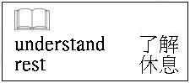

（Ｄ）37.According to the reading, how can you become a good computer game player?
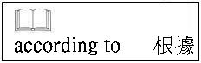
(A) Buy a lot of software.
(B) Follow the game rules.
(C) Spend a long time playing computer games.
(D) Learn English to understand the games better.
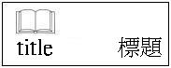
（Ｃ）38.What is the best title for the reading?
(A) The Most Popular Computer Games.
(B) News About Illegal Computer Game Software.
(C) Tips for Playing Computer Games Well and Safely.
(D) Ways to Find Cheap and Fashionable Computer Games.

（39.～40.）
Read Sarah's diary and answer the questions.
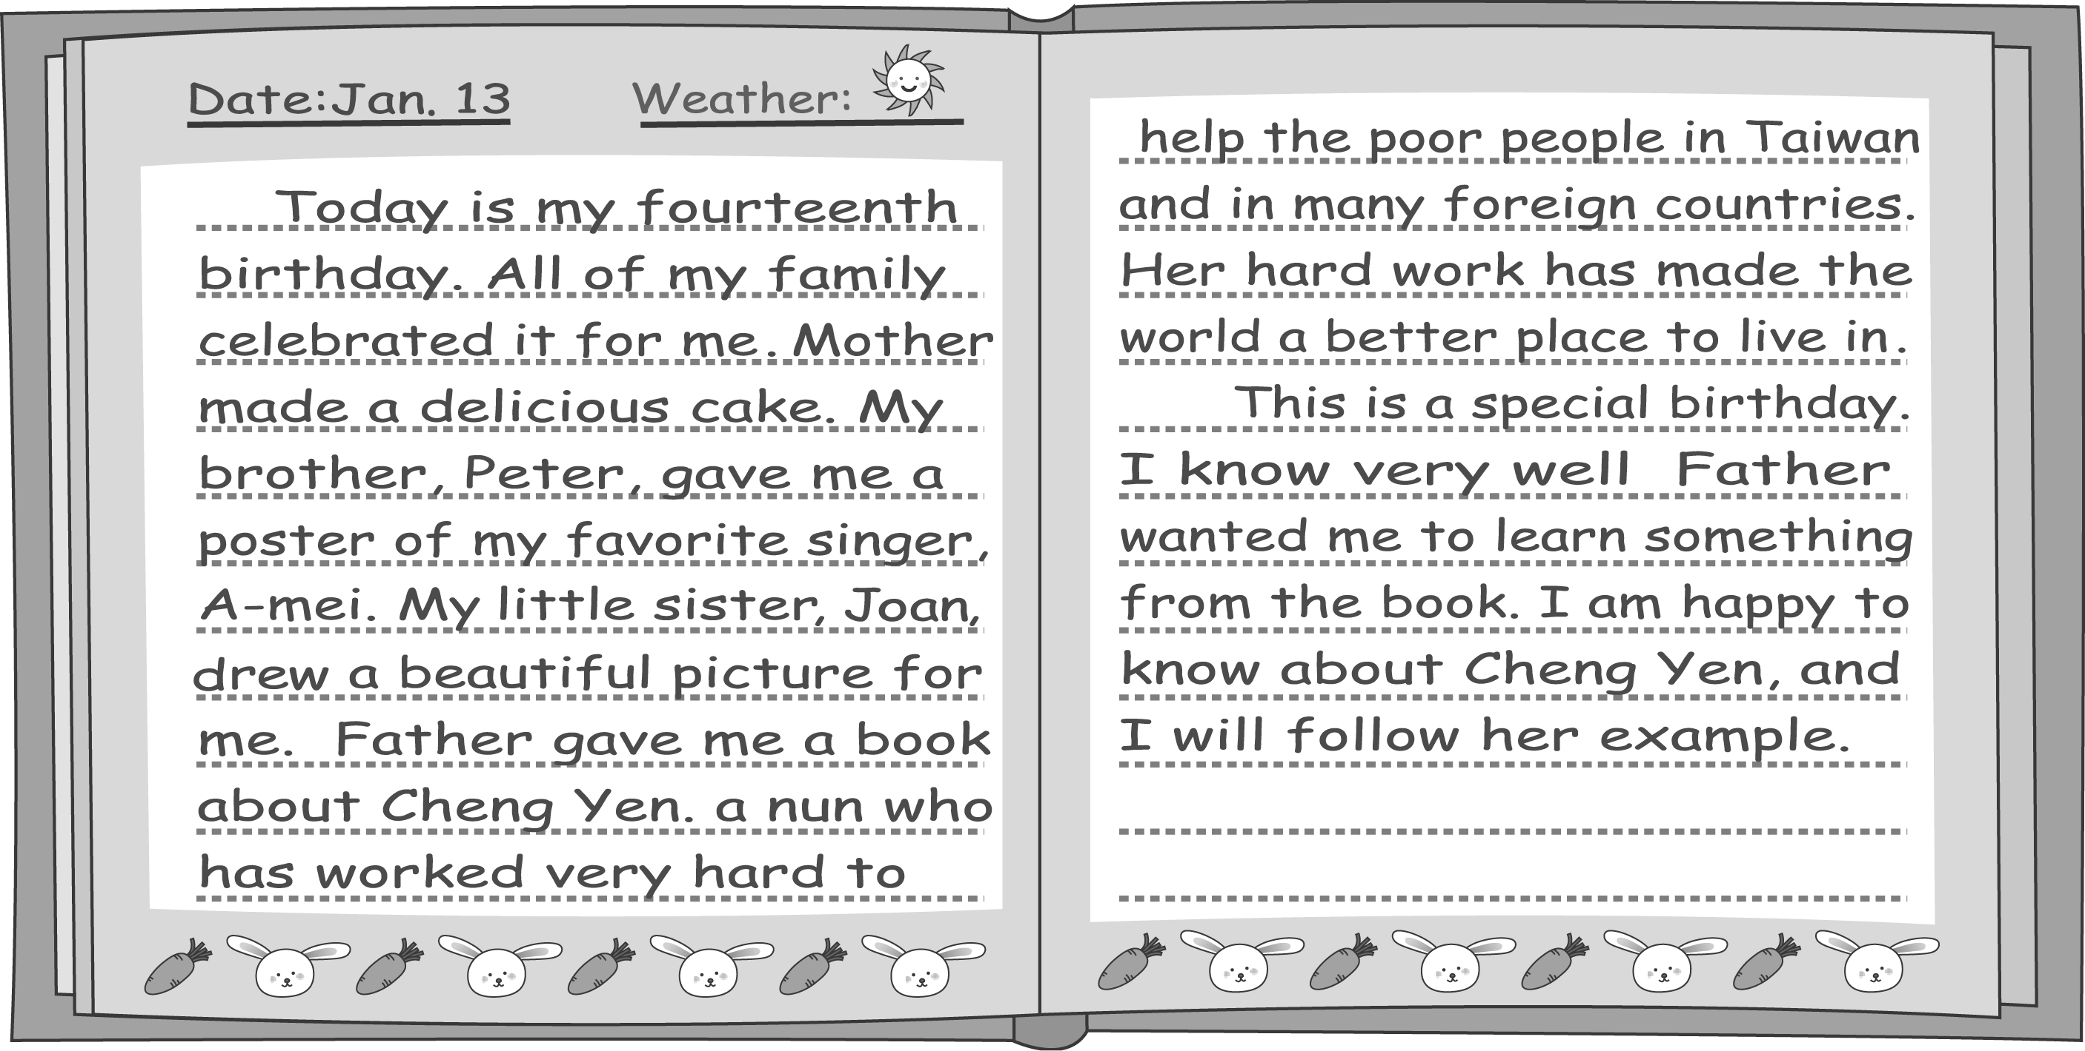
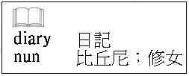

（Ａ）39.How many people are there in Sarah's family?
(A) Five.
(B) Six.
(C) Seven.
(D) Eight.
（Ａ）40.Why did Sarah's father give her the book as a birthday present?
(A) He wanted her to help people.
(B) He wanted her to study harder.
(C) He wanted her to learn to draw pictures.
(D) He wanted her to make friends with Cheng Yen.

（41.～42.）
Bruce found a note on his desk after he went back to his office.
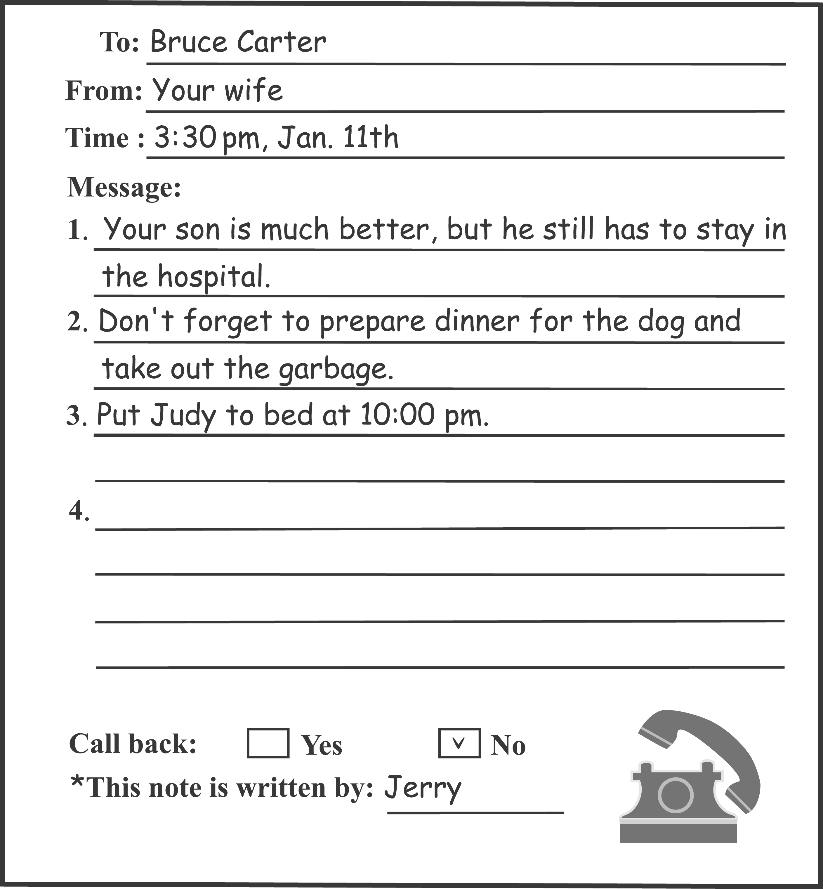
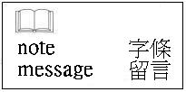

（Ｂ）41.According to the note, what should Mr. Carter do this evening?
(A) Call Mrs. Carter.
(B) Give the dog food.
(C) Stay in the hospital.
(D) Take Judy out for dinner.
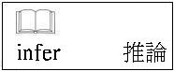
（Ｃ）42.What can we infer from the note?
(A) Jerry is Mr. Carter's son.
(B) Mrs. Carter was very sick in the hospital.
(C) Mr. Carter was out when Mrs. Carter called.
(D) Mr. Carter should go to bed before 10:00 pm.

（43.～45.）
Pearl, Joyce, and Steven are students in summer school. Mr. Green, Miss Chen, and Miss White are their teachers. Look at the poster of their summer school and answer the questions.

Welcome! Enjoy the fun of studying science in beautiful sunshine!
Time | Things to do |  |  |  | Place
7:30 | Morning call
8:20～8:50 | Breakfast |  |  |  | Room 522
9:00～10:50 | Bird watching |  |  |  | Ruby Park
11:00～12:30 | Free time |  |  |  | The gym
11:00～12:30 | (A) Sports: basketball, soccer, baseball／softball |  |  |  | （The lst floor）
11:00～12:30 | (B) Music: singing and dancing |  |  |  | （The 2nd floor）
12:30～13:00 | Lunch |  |  |  | Room 522
13:30～15:30 | Computer class |  |  |  | Room 101
15:40～16:40 | Swimming |  |  |  | The beach
17:00～18:00 | Dinner |  |  |  | Room 522
18:30～20:30 | TV Time: We Have Only One Earth |  |  |  | The theater
21:00～21:30 | Bath |  |  |  | The bathroom
22:00 | Bedtime

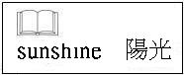
（Ａ）43. Mr. Green: Hi, Pearl. It's time to go to the gym. What do you want to do during the free time?
Pearl: Well, I'm not going to play any ball games. My finger got hurt last time I played softball.
According to the poster, what can Pearl do in the free time?
(A) Go dancing. (B) Play softball.
(C) Go swimming. (D) Play computer games.
（Ｃ）44.Miss Chen: Do you want to tell your friends what's happening in summer school?
Joyce: Now? But there's no telephone here.
Miss Chen: You can send them e-mails. Here, I'll show you.
According to the poster, where are Miss Chen and Joyce?
(A) At the beach. (B) In the gym.
(C) In Room 101. (D) In the theater.
（Ｃ）45. Miss White: Look at the beautiful sea! Steven, come here! Give me your hand.
Steven: No, I'm afraid of water.
Miss White: Don't worry. I'll be with you all the time. The beach is safe and clean. You'll feel comfortable in the cool water.
According to the poster, when does this dialogue happen?
(A) During the free time.
(B) During the bath time.
(C) In the swimming class.
(D) In the bird watching class.

