91學年度國中第一次基本學力測驗 英文領域

第一部分：下列各題（題號1.～15.），請依文意選出一個正確或最佳的答案。
（Ｃ）1. It was very hot when we got to Kenting National Park, we still had a good time there.
(A) or (B) so (C) but (D) because
（Ｂ）2. My husband send me flowers every week before we got married. But now he never does.
(A) should (B) used to
(C) was going to (D) was afraid to
（Ｄ）3. Angela: Do you know Oscar?
George: Of course. I know him very .
(A) often (B) little (C) young (D) well
（Ｂ）4. Eva: What's your ideal mate like?
Ada: Well, I want a husband who well. I enjoy eating, but I hate kitchens.
(A) cook (B) cooks (C) cooking (D) to cook
（Ａ）5. Simon: Why Jerry and Lisa play cards with us?
Henry: Because they want to go to the movies.
(A) don't (B) isn't (C) aren't (D) doesn't
（Ｃ）6. Susan: Oh, no! The door and the window !
Victor: Who could have done this?
Susan: Go in quickly and see if we've lost anything.
(A) are breaking (B) have broken
(C) were broken (D) will break
（Ｄ）7. Bruce: When did Roger change his job?
Laura: He hasn't changed his job. He still works in the same computer store.
Bruce: But I saw him watches on the street corner.
(A) sold (B) to sell (C) have sold (D) selling
（Ｃ）8. I live my office, so I walk to work every morning.
(A) along (B) between
(C) near (D) out of
（Ｂ）9. Victoria's little daughter has beautiful big eyes. Everyone says she is just like a pretty .
(A) ball (B) doll
(C) pair (D) poster
（Ｄ）10.Mark: I've got a lot of exercise these days, but still can't lose weight.
Doris: Exercise is not enough. You should also . Eating the right foods is very important for weight control.
(A) quit eating (B) start an exercise class
(C) take some medicine (D) go on a diet
（Ｄ）11.Louise: How does the dress look on me?
Debbie: Well, not bad, but it's a little too long. Why don't you one in a smaller size?
(A) build (B) see (C) use (D) try
（Ｃ）12.Nana: Come on, let's have dinner together.
Alice: But I'm not yet. I think I'll eat later.
(A) thin (B) fine (C) hungry (D) bored
（Ａ）13.Fred: That's a great song! Who it?
Jean: Arnie did. He's my favorite singer.
(A) sang (B) heard (C) drew (D) reached
（Ａ）14.Jason: When's your ?
Lydia: At two o'clock.
Jason: Then you have to hurry! It's one-thirty already. It takes about 25 minutes to get to the station!
(A) train (B) flight (C) lunch time (D) new semester
（Ｂ）15.Mrs. Kao: Raymond, there was a phone call for you.
Raymond: Oh? Who was it?
Mrs. Kao: I don't know, but it was a girl's .
(A) wish (B) voice (C) answer (D) number

第二部分：下列十一個題組，共有30題（題號16.～45.），請依據所附選文或圖表資料，選出一個正確或最佳的答案。

（16.～18.）
Ted sat next to me when we were in elementary school. He had serious problems in communicating with people. One always had to guess what he was saying. Besides, most of my classmates did not like to be with him because his hands and shirts were always dirty. I 16. let him know the importance of being clean by telling him several times a day to wash his hands. But he just could not understand.
One day, our teacher Miss Hsieh walked up to Ted. Without saying anything, she took Ted to the washroom. Slowly, Miss Hsieh washed his hands and told him that he should keep himself clean. She 17. that every day for one month. Finally, Ted understood.
Miss Hsieh's love has given me a good example to follow when I 18. my job. I always remember to teach my students by showing them the right ways to do things. And most important of all, I always remember to give them more time to learn and to grow up.

（Ａ）16.(A) tried to (B) am trying to
(C) have tried to (D) will try to
（Ａ）17.(A) did (B) was doing (C) has done (D) was going to do
（Ｂ）18.(A) did (B) am doing (C) have done (D) am going to do

（19.～22.）
Weight-training has become very popular all over the world in the past few years. Many years ago, weight-training classes were usually for men only, but today 19. . Weight-training is now a fashionable sport for people who are interested in becoming stronger and healthier. Books and videos about weight-training 20. . Any sports fan can get copies of them easily.
Before you start a weight-training class, you should remember two important things: first, you have to wear the right size clothes. It's impossible for you to enjoy weight- training if your clothes are too big or too small. 21. , never show off, even to yourself. Start with a weight that is not too heavy for you. Showing off is the easiest way to get hurt. Remember, you want to be stronger and healthier. You don't want to 22. after your weight-training class.
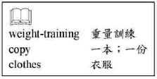
（Ａ）19.(A) many women can also be seen in these classes
(B) both men and women have given up the sport
(C) only married women spend their time on the sport
(D) more and more men are attending weight-training classes
（Ｂ）20.(A) do not sell well in big cities
(B) sell like cold drinks on a hot summer day
(C) are sold only to people older than eighteen
(D) can be found only in those bookstores next to a gym
（Ｄ）21.(A) So (B) In fact (C) After all (D) Second
（Ｄ）22.(A) gain weight (B) become dangerous
(C) be proud of yourself (D) be taken to the hospital
（23.～24.）
John got a letter from his girlfriend, Mary.
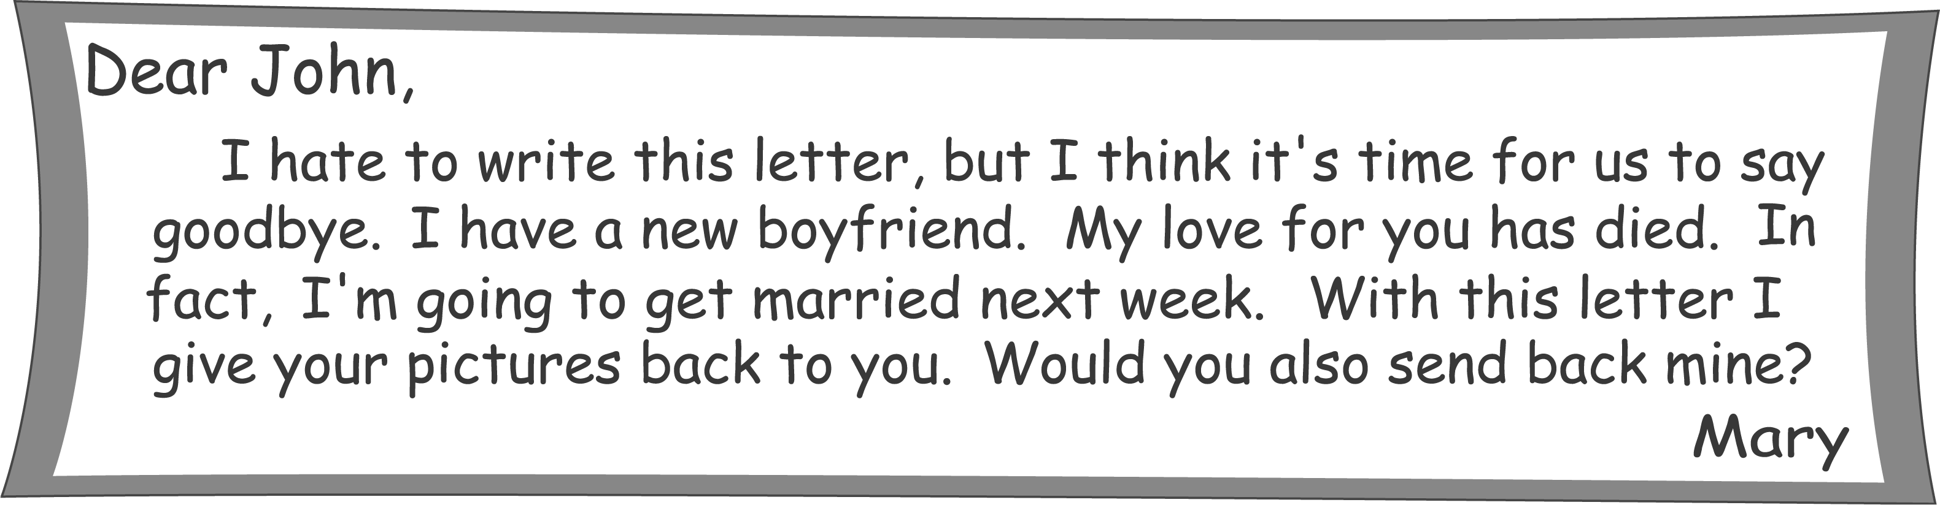
After John finished reading this letter, he was sad and angry. He then collected pictures of his sisters, cousins, and some friends. He put these pictures in an envelope with a letter in it.


collect
收集

（Ｂ）23.What does Mary tell John in her letter?
(A) She wants a picture of John.
(B) She does not love John anymore.
(C) She wants John to write her a letter.
(D) She decides not go get married with her new boyfriend.
（Ａ）24.Why does John send Mary the pictures of his sisters and cousins?
(A) He wants Mary to feel bad too.
(B) He wants Mary to know them.
(C) He wants Mary to collect their pictures.
(D) He wants Mary to find boyfriends for them.
（25.～26.）
Amy: Sandy, look! I've got a driver's license.
Sandy: You do? That's great! Are you going to buy a car?
Amy: Joe has ordered one for me. An AUX.
Sandy: Wow! That's a luxurious car! You're got a good husband
I've heard that it's really fashionable now to drive a blue AUX.
Amy: But mine is beige.
Sandy: Beige is beautiful too, but it's hard to keep clean, isn't it?
Amy: Don't worry. I'll have Joe wash the car every day!

（Ｂ）25.What is“beige”?
(A) A car. (B) A color. (C) A car brand. (D) A driver's license.
（Ｄ）26.Who will keep Amy's new car clean?
(A) Sandy. (B) Sandy's husband.
(C) Amy herself. (D) Amy's husband.
（27.～28.）
Look at the bulletin board of Class 3B and answer the questions.
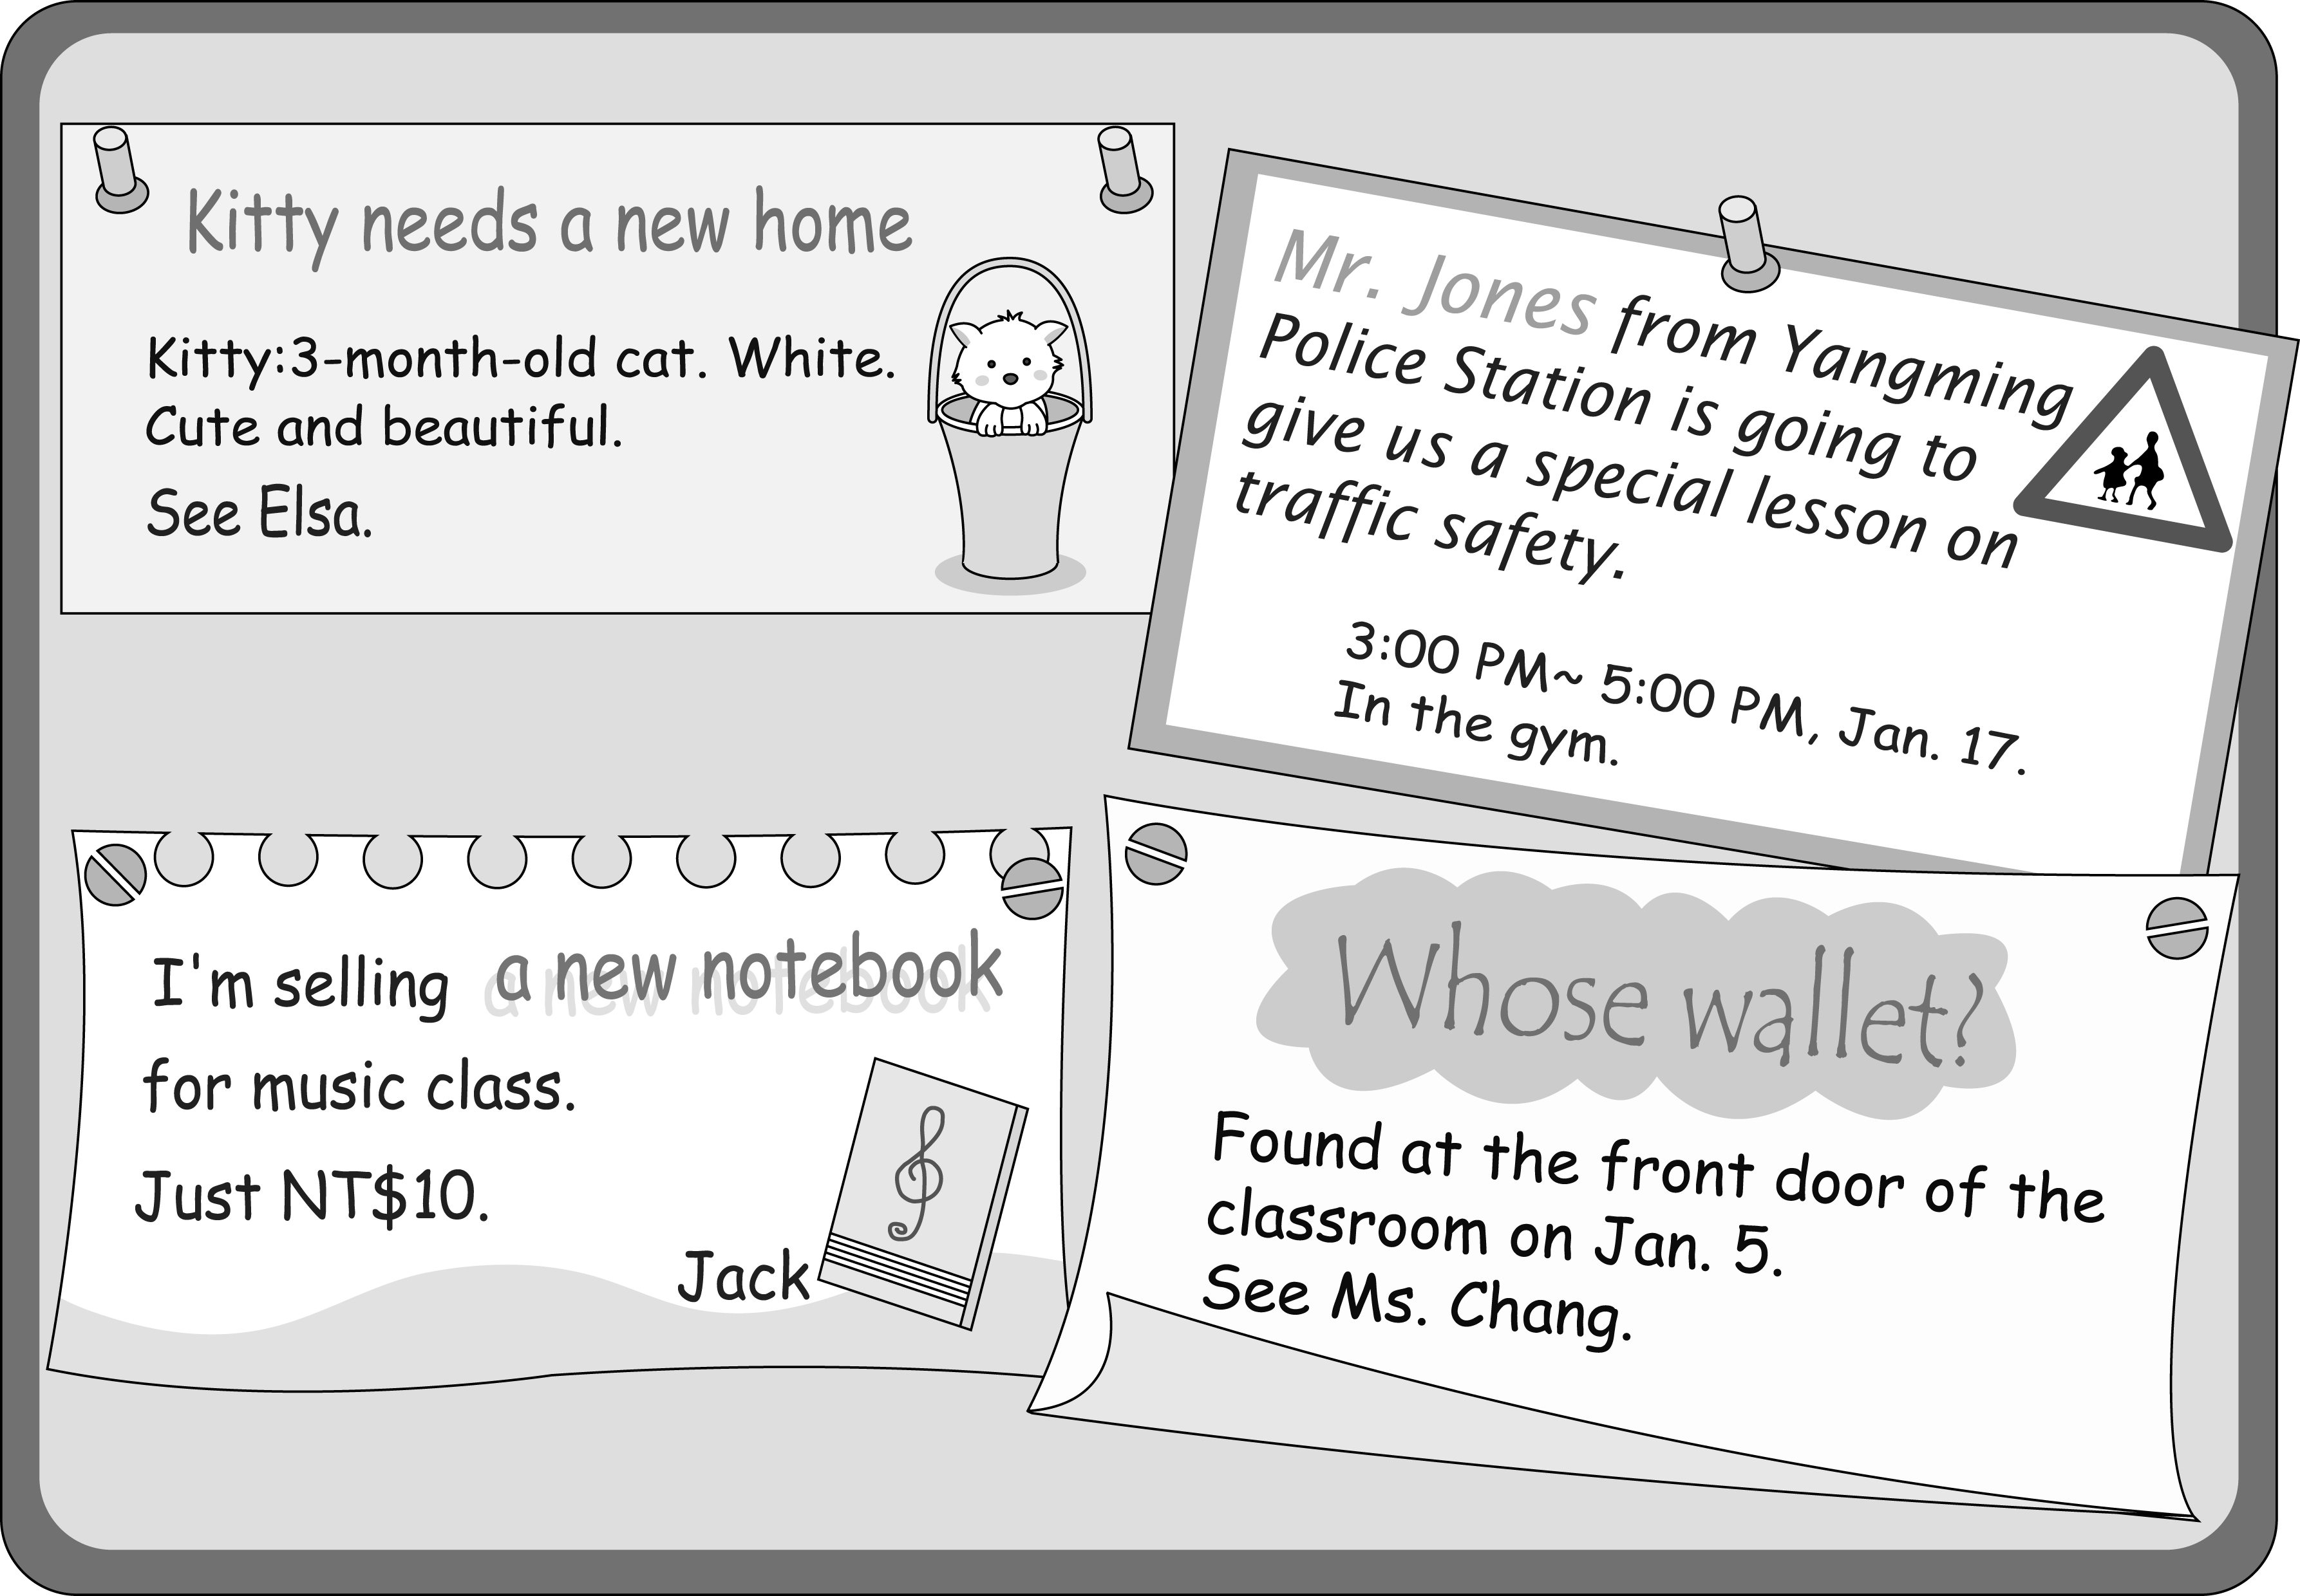
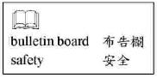
（Ｃ）27.What does Elsa want?
(A) To find a cute cat.
(B) To buy a good house.
(C) To give a cat to a classmate.
(D) To make friends with someone who has a cat.
（Ｂ）28.David cannot find his wallet. What should he do?
(A) Go to the police station.
(B) Ask Ms. Chang about it.
(C) Meet Jack in music class.
(D) Wait at the front door of the classroom on Jan. 5.

（29.～31.）
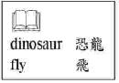
Arnold: Hey, Julie, what's in your hand?
Julie: A book about dinosaurs. My son is a big fan of Brachiosaurus.
Arnold: Brachi… What?
Julie: Brachiosaurus. B-R-A-C-H-I-O-S-A-U-R-U-S.
Arnold: Wow, it must be a BIG animal.
Julie: It is. It's the biggest dinosaur.
Arnold: Then, what does the smallest dinosaur look like?
Julie: Here! The Compsognathus is the smallest in the dinosaur world. It's about the size of a chicken!
Arnold: Well, I'm starting to fell interested in these animals. How many kinds of dinosaurs are there?
Julie: Oh, there are so many kinds of them. For example, the Tyrannosaurus rex is very terrible because it eats other dinosaurs. And the Pterodactylus can fly like a bird! Some people say it's not a dinosaur, but it's my favorite.
Arnold: Ha! It looks very funny. What would the world look like with so many interesting dinosaurs?
Julie: Interesting? You should feel lucky that they can be seen only in the museum, not on the streets!
（Ａ）29.What is the biggest dinosaur in the world?
(A) Brachiosaurus. (B) Compsognathus.
(C) Pterodactylus. (D) Tyrannosaurus rex.
（Ｃ）30.What is true about Arnold?
(A) His son is a dinosaur fan.
(B) He sells books about dinosaurs.
(C) He is interested in knowing more kinds of dinosaurs.
(D) He invites Julie to go to a dinosaur museum with him.
（Ａ）31.What might the Pterodactylus look like?
(A) 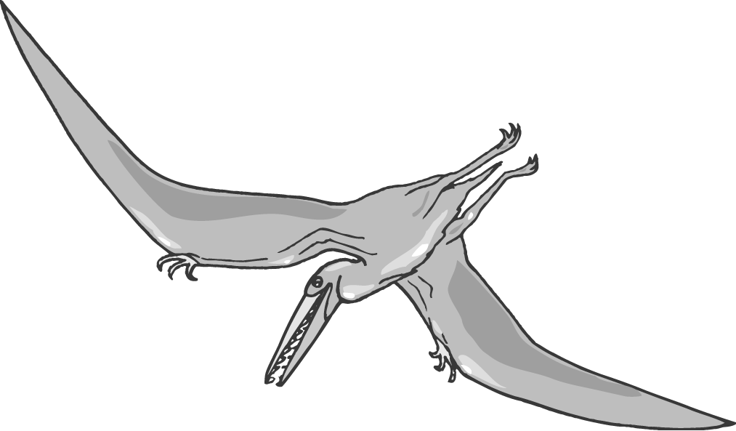 (B) 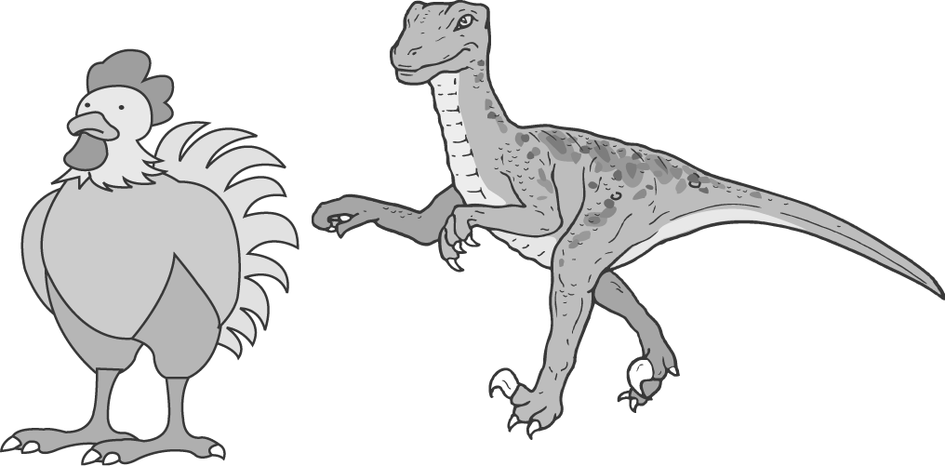
(C)  (D) 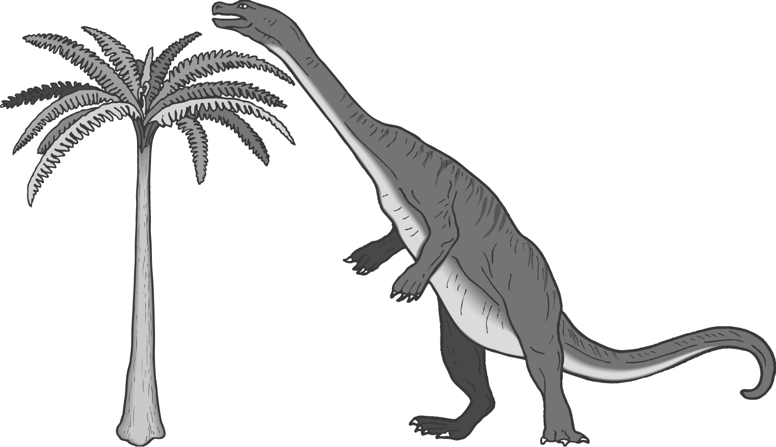
（32.～33.）
Read the poster and answer the questions.
A Nice Day in Garden Town
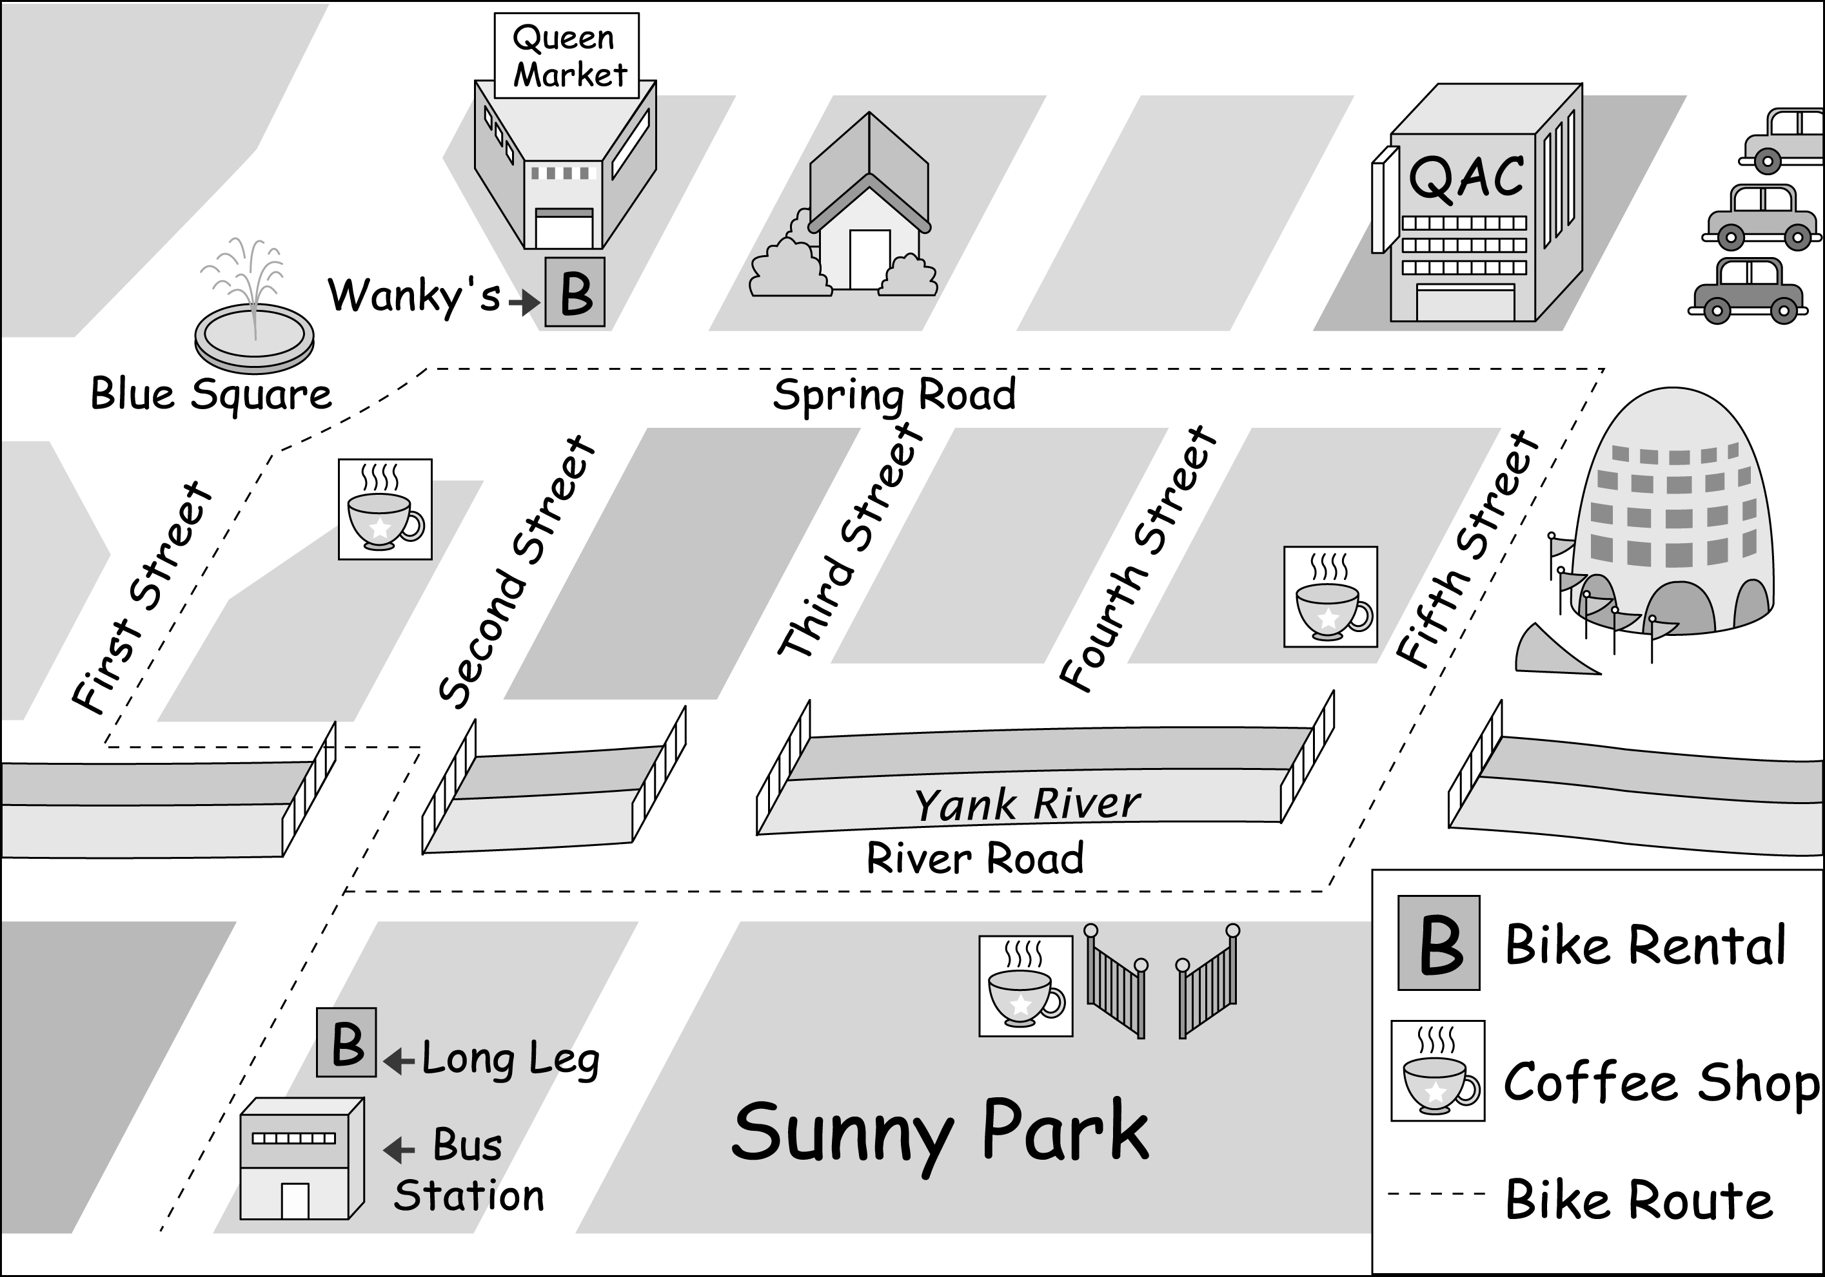
There are two bicycle rental shops on Second Street. One is at Blue Square, and the other is next to the Bus Station. The bike routes are beautiful roads. Along the routes, you can find the most famous places of the town. For example, you can see many street artists at Blue Square; you can stop to do some shopping in Queen Market or QAC Department Store; or you can enjoy the fresh air in Sunny Park or by the Yank River.

（Ａ）32.What does the poster want people to do?
(A) To enjoy the town by bike.
(B) To build a beautiful bike route.
(C) To work in Garden Town as an artist.
(D) To follow the traffic rules to avoid accidents.
（Ｃ）33.After a nice afternoon tea in Sunny Park, Howard wants to take the bicycle back to Long Leg. What is the shortest route for him?
(A) Go along Fifth Street, and turn left at QAC corner.
(B) Go along First Street, and turn right at Blue Square.
(C) Go along River Road, and turn left on Second Street.
(D) Go along Spring Road for three blocks, and turn right on Fifth Street.

（34.～36.）
Here is an examination notice Mrs. Dickson gave to her students last week. Read it and answer the questions.
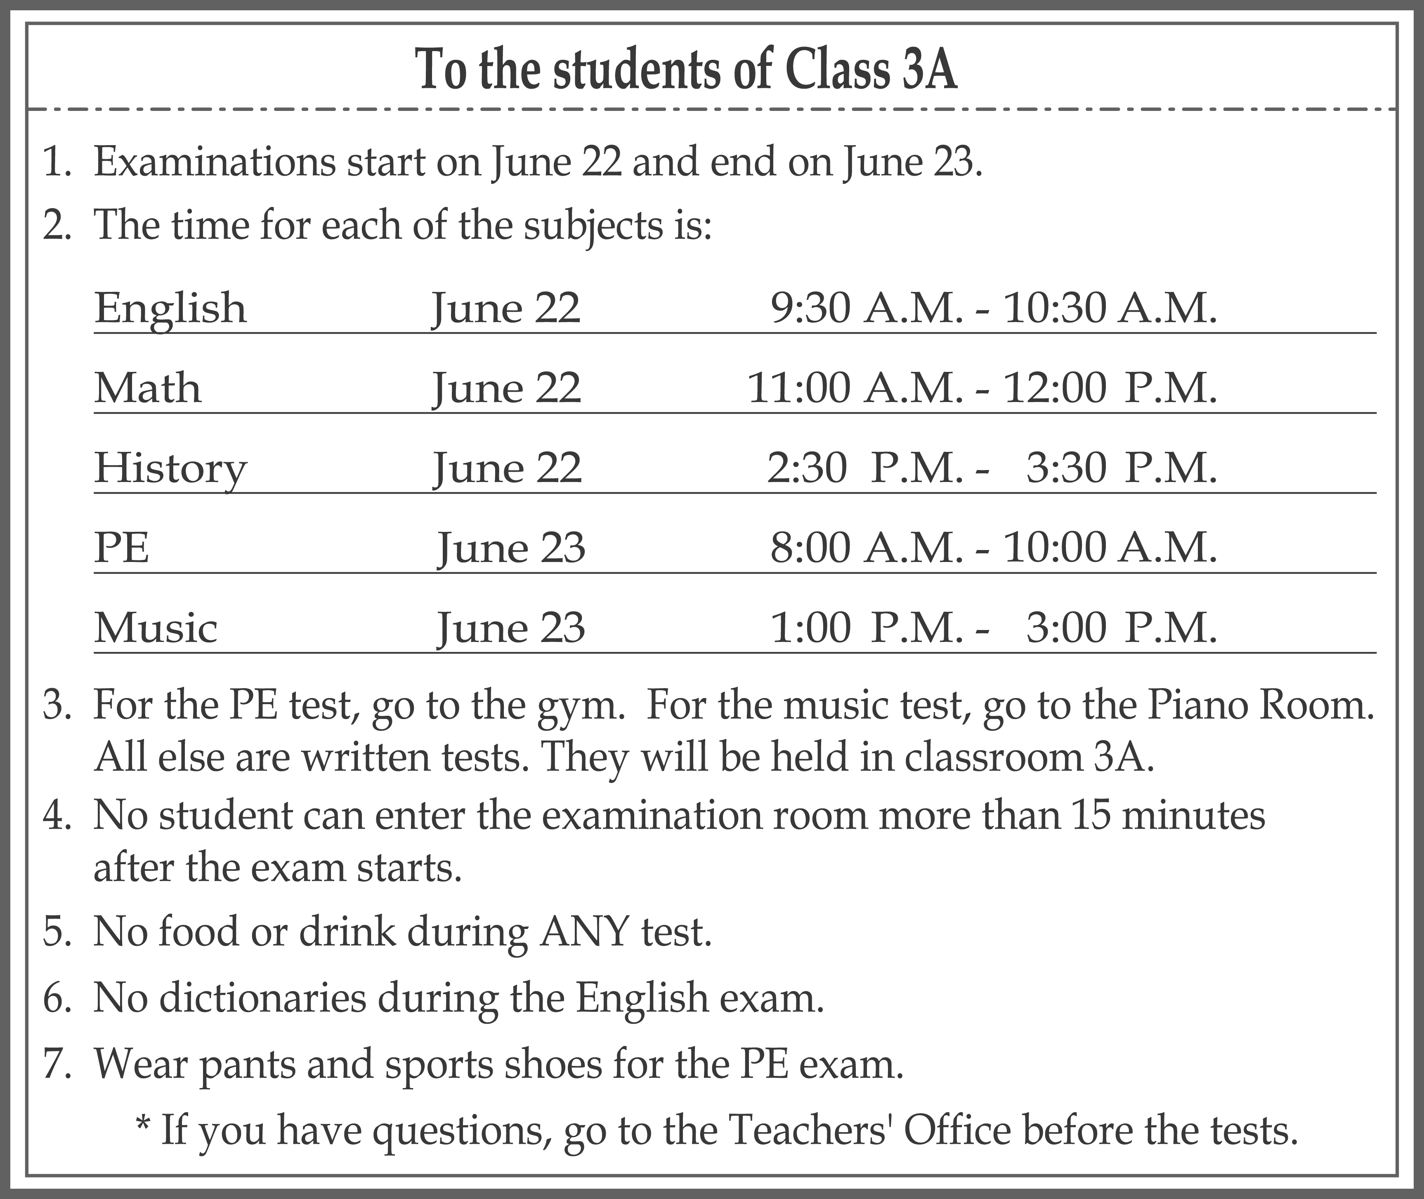
（Ｄ）34.Who could not take the English exam?
(A) Nancy. She wore her sports shoes on June 22.
(B) Richard. He did not have breakfast before the exam.
(C) Wendy. She forgot to take an English dictionary with her.
(D) Tony. He went to school at 9:50 on the morning of June 22.
（Ａ）35.Where was Class 3A at 8:30 A.M., June 23?
(A) In the gym.
(B) In their classroom.
(C) In the Piano Room.
(D) At the Teachers' Office.
（Ｃ）36.When were the written tests held?
(A) Only on the morning of June 22.
(B) Only on the morning of June 23.
(C) On the morning and afternoon of June 22.
(D) On the morning and afternoon of June 23.
（37.～39.）
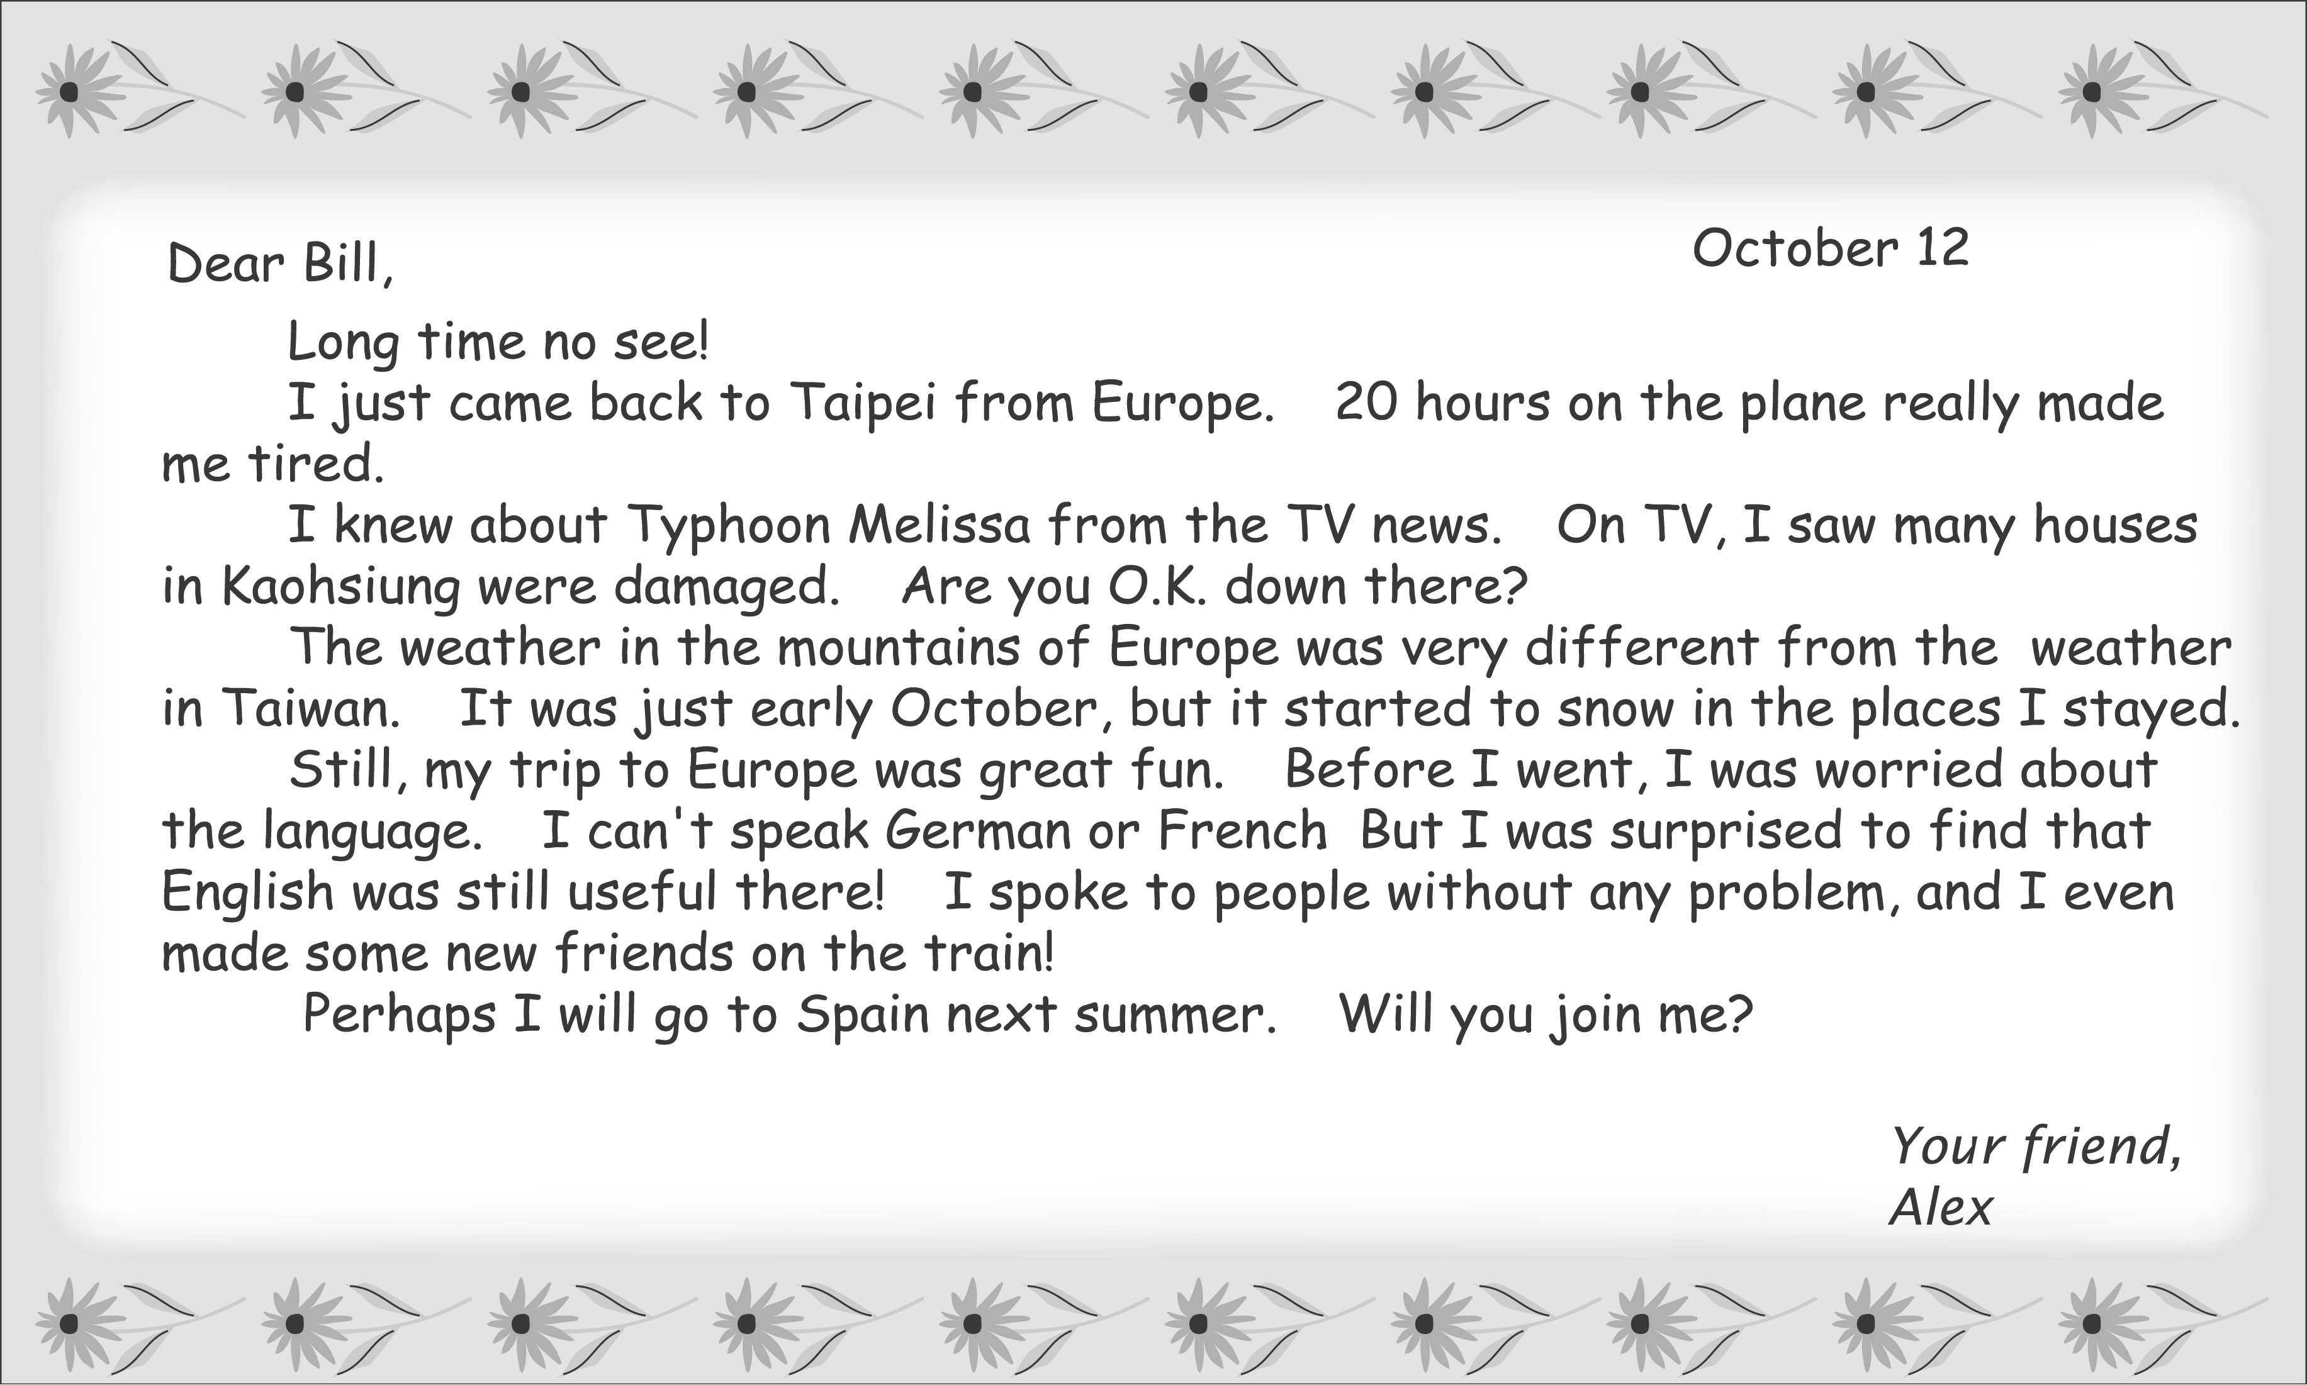
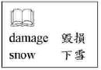
（Ｄ）37.Where does Bill live?
(A) In Spain. (B) In Taipei.
(C) In Germany. (D) In Kaohsiung.
（Ｃ）38.What was the weather like in the mountains when Alex was there?
(A) It rained a lot.
(B) It changes a lot.
(C) It was winter already.
(D) There was a terrible typhoon.
（Ｂ）39.What is true about Alex's experience in Europe?
(A) He was always worried about the weather.
(B) He enjoyed it and would like to go there again.
(C) He was invited to the homes of his new foreign friends.
(D) He learned some English from a language school there.

（40.～42.）
Reading is an activity people enjoy a lot in their free time. Some like reading newspapers, and others enjoy novels or comic books. I like reading about the lives of great people. This always gives me a lot of ideas on how to make my own life better.
Great people are remembered not because they were handsome or beautiful, but because they did not give up when their lives were difficult. They used every opportunity to change their lives and make the world better.
One good example is Orville and Wilbur Wright, the two brothers who invented the airplane. The plane has made the world into a small village. Hard work, not good luck, is the reason why the Wright Brothers could invent this convenient machine and become remarkable people. Today we still remember them when we see planes in the sky.
When I feel sad, stories of great people always help me feel better. This is why I enjoy reading about great people's live.
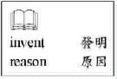

（Ｃ）40.What does“This”mean in the first paragraph?
(A) Being a great person.
(B) Living in a special way.
(C) Reading about the lives of great people.
(D) Reading newspapers, novels, or comic books.
（Ｄ）41.Which book might the writer be most interested in?
(A) How to Build a Strong Plane
(B) Ten Books That Have Made Our World Better
(C) Use Every Opportunity to Read in Your Free Time
(D) Michael Jordan: The Man Who Changed Basketball History
（Ｃ）42.What does“remarkable”mean in the third paragraph?
(A) Nice and polite. (B) Tall and handsome.
(C) Special and famous. (D) Lucky and interesting.
（43.～45.）
Karen Finley was born in the U.S. in 1956. When she was only fourteen, she became interested in performing. She graduated from a performing arts school in 1981 and then began to perform in theaters. In her performances, she showed people some of the problems in the world.
Karen's The Constant State of Desire was first performed at The Kitchen in New York City in 1986. In this performance she wanted people to notice some of the difficult experiences women have because of men. It soon became controversial. Many people did not feel comfortable with the performance. They thought that Karen hated men too much and was out of control. She was strongly criticized by the newspapers. But some other people thought differently and spoke for her. They said that they felt the experiences Karen showed in this performance were true to life.
Karen hoped that people would think about the sad stories that happen every day. She believed people would understand her and learn some lessons if they could“read”her performances more carefully.
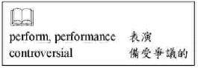
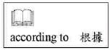
（Ａ）43.According to the reading, what might“The Kitchen”be?
(A) A theater.
(B) A restaurant.
(C) A newspaper.
(D) A performance.
（Ａ）44.According to the reading, why would The Constant State of Desire be controversial?
(A) It seriously criticized men.
(B) Karen was not well prepared.
(C) The women who performed with Karen were out of control.
(D) Karen said something bad about newspapers during the performance.
（Ｃ）45.What did Karen Finley want to do by performing?
(A) To make more friends. (B) To become a superstar.
(C) To show people her ideas. (D) To make money for poor women.

