91學年度國中第二次基本學力測驗 英文領域

第一部分：下列各題（題號1.～16.），請依文意選出一個正確或最佳的答案。
（Ｂ）1. John and Susan gave a nice jacket as a Christmas present.
(A) I (B) me (C) mine (D) myself
（Ｄ）2. Mr. Huang is a ; he sells a lot of things in his supermarket.
(A) driver (B) singer (C) police officer (D) businessman
（Ｂ）3. Young boys really grow fast. Both my sons are already than I am.
(A) tall (B) taller (C) tallest (D) the tallest
（Ａ）4. When it is going to rain, the gets dark.
(A) sky (B) day (C) wind (D) weather
（Ａ）5. There is serious pollution here. I cannot that there were fish in the water before.
(A) imagine (B) examine (C) link (D) criticize
（Ｃ）6. Cindy never got good grades on math tests before, but she did today. Her teacher and classmates were very .
(A) scared (B) strange (C) surprised (D) strict
（Ｄ）7. You have been in front of the computer for more than five hours. It's time for you to and relax.
(A) get up early (B) show off
(C) shut up (D) get some exercise
（Ｄ）8. The teacher his students vacuum the floor of the classroom after the party.
(A) asked (B) wanted (C) found (D) had
（Ｃ）9. Jane always does well on English tests, but her sisters .
(A) doesn't (B) aren't (C) don't (D) didn't
（Ｄ）10.Paula: Is that big toy store Mr. and Mrs. Chen's?
Kelly: Yes, it's . My daughter loves going there.
(A) his (B) hers (C) ours (D) theirs
（Ｃ）11. Yu-chen: Mom, I'm . Can I have a coke?
Mrs. Lee: Why not drink some water?
(A) thin (B) cool (C) thirsty (D) hungry
（Ｃ）12.Daisy: Are you sure Mr. Johnson is home? He might still be in his office.
Helen: Let's ring the .
(A) voice (B) watch
(C) doorbell (D) answer
（Ｂ）13.Alice: How often do you wash your hair?
Betty:
(A) One day. (B) Twice a week.
(C) Since yesterday. (D) Three days ago.
（Ｃ）14.Tina: The bread looks delicious! You want to buy some?
Carl: I'd love to, but I don't have money with me now.
(A) no (B) all (C) any (D) some
（Ｂ）15.Cary: When you go shopping, do you usually with your credit card?
Tony: No, I don't have a credit card.
(A) use (B) pay (C) spend (D) waste
（Ｃ）16.James: Do you see the street vendor over there?
Philip: Which one?
James: The one is wearing a hat.
(A) it (B) he (C) who (D) which

第二部分：下列十一個題組，共有29題（題號17.～45.），請依據所附選文或圖表資料，選出一個正確或最佳的答案。

（17.～19.）
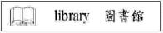
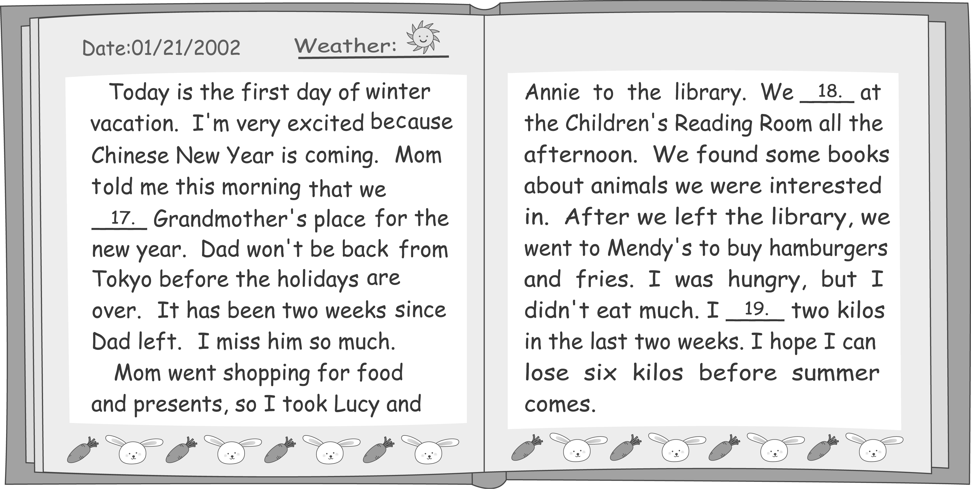
（Ｄ）17.(A) go to (B) went to (C) have gone to (D) are going to
（Ａ）18.(A) stayed (B) will stay
(C) have stayed (D) were going to stay
（Ｂ）19.(A) lose (B) have lost (C) am losing (D) was going to lose

（20.～22.）

Kidland
Welcome to Kidland.com. This is a place for you to have fun with your friends and family. Please read and 20. when you visit us.
1. NEVER give out your name, telephone number, pictures, or the name of your school
without your parents' permission.
2. NEVER say yes to anyone who invites you to go out alone with him / her.
3. 21. if you get an e-mail from a stranger. Do not open it; tell your parents first.
4. ALWAYS tell your parents when you see words that make you fell bad.
5. NEVER buy anything online or give out a credit card number without your parents' permission.
Thank you again for visiting Kidland.com. We hope you will feel 22. . Have a good time online!
（Ｃ）20.(A) stay in touch (B) give up trying
(C) follow these tips (D) understand grownups better
（Ａ）21.(A) BE CAREFUL (B) ALWAYS feel happy
(C) NEVER talk to your friends online
(D) DON'T FORGET to answer questions
（Ｄ）22.(A) young and pretty (B) warm and strong
(C) lucky and proud (D) safe and comfortable

（23.～25.）
Andrew: Good morning, may I help you?
Gordon: I'd like to buy some milk.
Andrew: O.K. 23. Which one would you like?
Gordon: I'm not sure. 24.
Andrew: Well, some kinds are for children, some are for women, and some are for old people.
Gordon: I see. It's for my daughter. She's three years old.
Andrew: Then these two are popular brands, but 25. .
Gordon: Oh? Is Angel Face really better than Super Star?
Andrew: Well, their prices are different because Angel Face is a foreign brand, and Super Star
is made in Taiwan.
（Ｂ）23.(A) I have three daughters.
(B) We have many brands.
(C) We have coffee, tea, and coke.
(D) There are two supermarkets near here.
（Ａ）24.(A) What's the difference?
(B) Why do people drink milk?
(C) How much money do you have?
(D) Do people buy milk for their family?
（Ｃ）25.(A) Super Star is more popular than Angel Face
(B) Angel Face and Super Star have the same price
(C) Angel Face is more expensive than Super Star
(D) both Angel Face and Super Star are from New Zealand

（26.～27.）
Tom found a note on his desk when he came back from his PE class.
Tom,
I'm so happy! Remember that beautiful girl we saw at the party last Saturday? Her name is Emily. She's a student in Class 3A. She's Nancy's cousin, and I talked to her this morning. She said yes when I invited her to a movie. I can't believe it!
Can you give me some advice after school?
Brian
2:10 p.m.
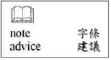

（Ａ）26.According to the note, what could be a question that Brian asks Tom after school?
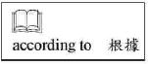
(A)“What should I wear when I go out with her?”
(B)“Would you like to go to a movie with me?”
(C)“Who was that beautiful girl at the party?”
(D)“How can I get better grades in English?”
（Ｄ）27.Which is true about Emily?
(A) She is Tom's cousin. (B) She is Brian's classmate.
(C) She went to the party with Tom. (D) She will go to a movie with Brian.

（28.～29.）
October 31 is Halloween. It is the end of summer and the start of the long, cold winter. Two thousand years ago, people believed that the spirits of dead people would come back to the living world on this day. They also believed that these spirits could help the living people see their future.
The day after Halloween, November 1, was known as“All-hallows.”On this day people went to church to remember the great people who died for their religion. The night before
“All-hallows”was called“All-hallows' Eve.”The name later became“Halloween.”
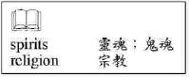
（Ａ）28.What is the reading mainly about?
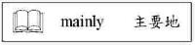
(A) The history of Halloween.
(B) The terrible spirits on Halloween.
(C) The different ways to celebrate Halloween.
(D) The famous people who died on Halloween.
（Ｄ）29.According to the reading, which is true about Halloween?
(A) It is also called“All-hallows.”
(B) It is the first day of November.
(C) It is celebrated at the end of winter.
(D) It is about dead people and their spirits.

（30.～31.）
Karen: I'd like to take a trip to a foreign country again this spring vacation. Could you give me
some advice?
Larry: I just came back from Sunnyland. It was a business trip, but I had a great time there.
Karen: I heard they have beautiful beaches.
Larry: You're right. And there're also many nice coffee shops along the beaches.
Karen: Are the people in Sunnyland friendly?
Larry: Don't worry. People there are very nice to foreign visitors. Don't feel embarrassed to
ask for help. They're always ready to tell you anything you need to know.
Karen: Did you spend a lot of money there?
Larry: No, not really. I stayed for five days and spent only ten thousand dollars.
Karen: That's great. I don't think I can find a better place.
Larry: Enjoy yourself!
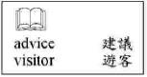
（Ｃ）30.According to the dialogue, why does Larry think Sunnyland is a good place to visit?
(A) It is good for doing business.
(B) The coffee there is very cheap.
(C) People there like to help visitors.
(D) There are many beautiful girls on the beaches.
（Ｄ）31.Which is true about Karen?
(A) She has many friends in Sunnyland.
(B) She has never been to a foreign country.
(C) She is going to spend her spring vacation with Larry.
(D) She thinks that it is a good idea to take a trip to Sunnyland.

（32.～34.）
Welcome to Formosa Zoo!
Our beloved llama, Wally, will be 5 years old on Nov. 14.
Come and join us to celebrate his birthday.
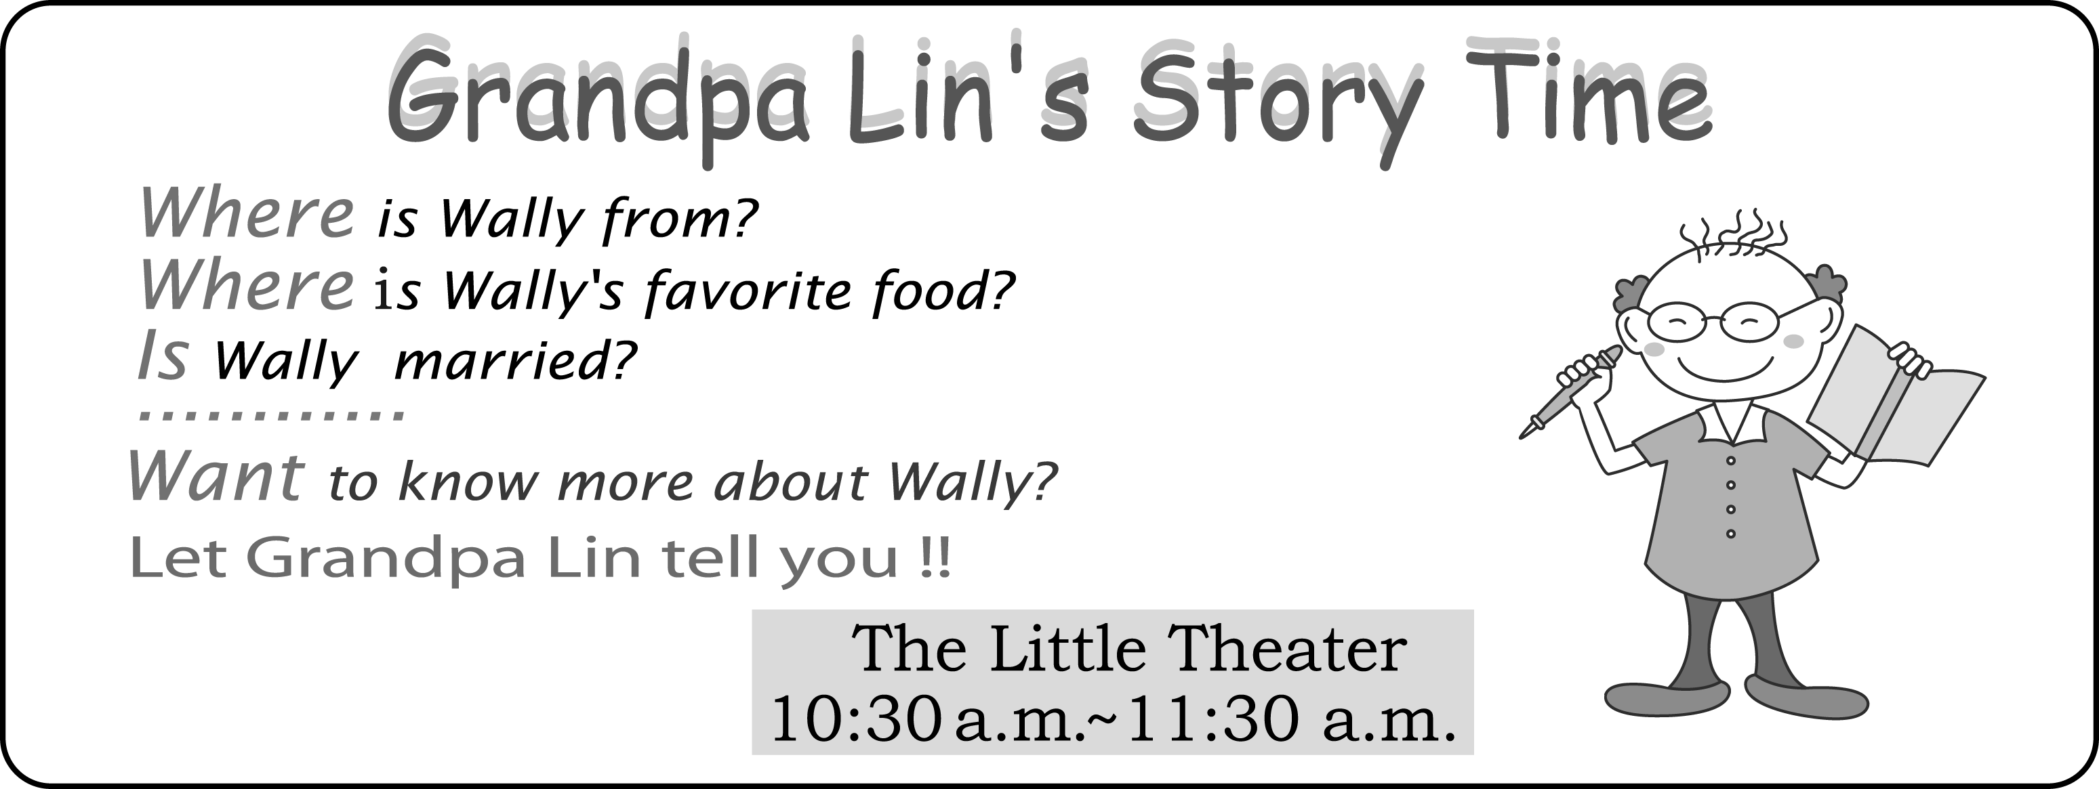
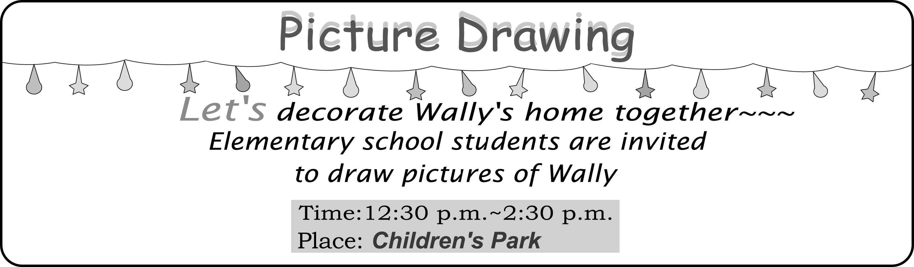
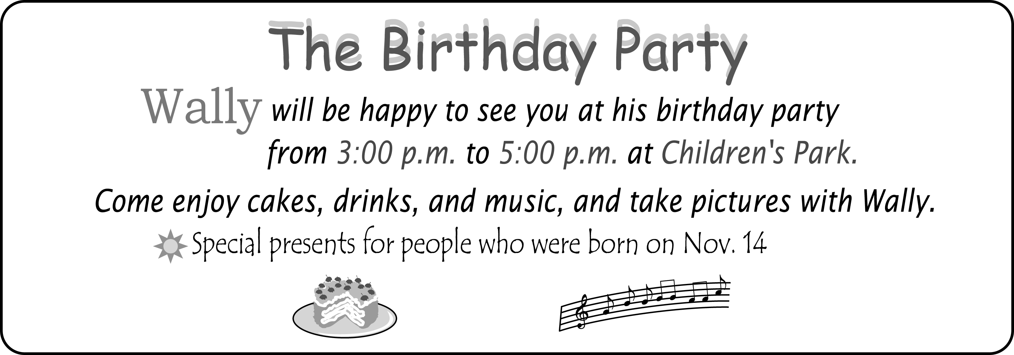
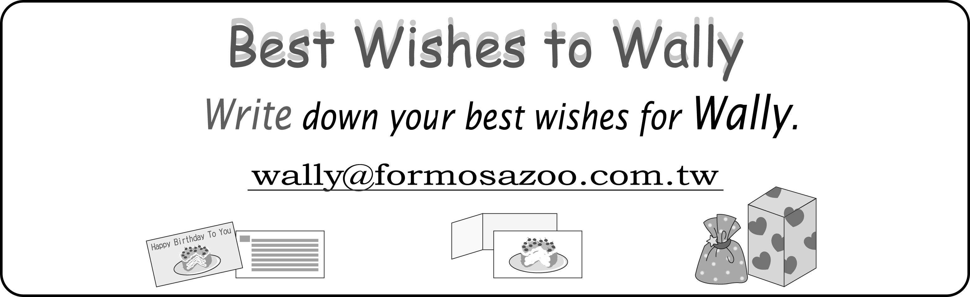
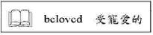
（Ｃ）32.What is a“llama”?
(A) A zoo.
(B) A boy.
(C) An animal.
(D) An important day.
（Ｄ）33.Ted's family visited Formosa Zoo on Nov. 14. In his family, who could get a special present from the zoo?
(A) Ted. He drew a picture of Wally at the Children's Park.
(B) Ted's brother. He sent an e-mail to Formosa Zoo.
(C) Ted's mother. She helped make cakes for Wally's party.
(D) Ted's father. He and Wally have the same birthday.
（Ａ）34.Stella learned a lot about Wally's life and history on Nov. 14. Which activity did she join?
(A)“Grandpa Lin's Story Time.”
(B)“Picture Drawing.”
(C)“The Birthday Party.”
(D)“Best Wishes to Wally.”

（35.～37.）
John Keats is one of the greatest English poets. He was born in London in 1795 and started studying to be a doctor when he was only fifteen. But after he finished his studies, he gave up the idea of becoming a doctor and decided to be a poet. He wrote and soon became an important poet.
Keats spent the last three years of his life writing a lot of beautiful poems. But he did not have a happy life at that time. In fact, he got seriously sick, and could not get married to the girl he loved. Still, he wrote about love and beautiful things in his poems. These poems have made many sad people happy. One of his famous poems is about fall. In this poem Keats showed his love for this world even in his bad health. Keats died at the young age of twenty-five, but both the poet and his poems will always be remembered.
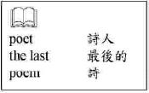

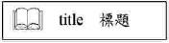
（Ａ）35.What is the best title for the reading?
(A) Keats' Life and His Poems.
(B) How to Read Keats' Poems.
(C) Beautiful Poems about Love.
(D) Great Poets Who Died Young.
（Ｂ）36.What did Keats give up when he decided to write?
(A) Getting married.
(B) Being a doctor.
(C) Helping sad people.
(D) Becoming famous.
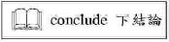
（Ａ）37.What can we conclude from the reading?
(A) Life could be short but art is long.
(B) Everyone should learn to read poems.
(C) Being a doctor is better than being a poet.
(D) A poet usually becomes famous after he dies.

（38.～40.）
Read Allen's diary and answer the questions.
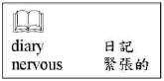
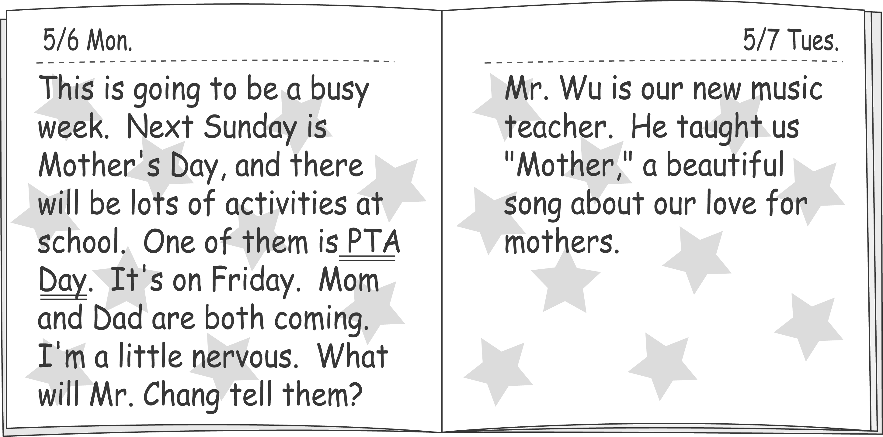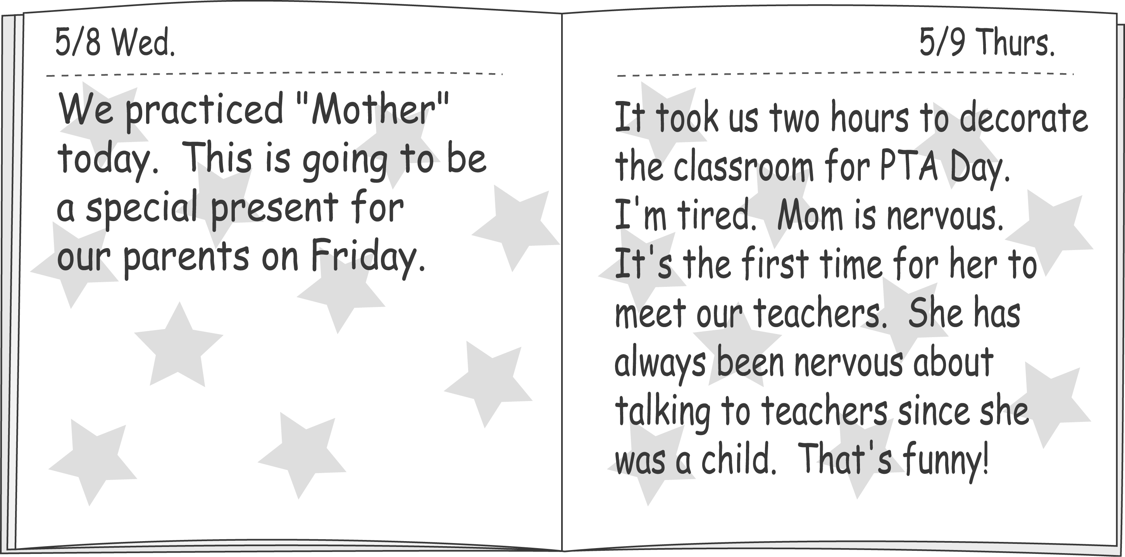
（Ｃ）38.What does“PTA Day”mean?
(A) The day for students to take music tests.
(B) The day for teachers to practice teaching.
(C) The day for parents to meet teachers at school.
(D) The day for students to ask questions about music.
（Ｂ）39.According to Allen's diary, what will the class do on Friday?
(A) They will decorate their classroom.
(B) They will sing to thank their mothers.
(C) The will buy presents for their parents.
(D) The will welcome a new music teacher.
（Ｂ）40.Why does Allen's mother feel nervous?
(A) Allen does not do well at school.
(B) She is afraid of talking to teachers.
(C) Allen's father is going to school too.
(D) She has to sing a song in front of the class.

（41.～42.）

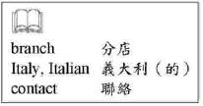
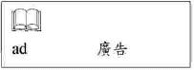
（Ｄ）41.What does the word“assistant”mean in the ad?
(A) An opportunity to learn making pizza.
(B) A kind of vegetable for making pizza.
(C) A famous pizza restaurant in Italy.
(D) A person who helps make pizza.
（Ｃ）42.What can we learn about Puccini Pizza from the ad?
(A) It gives lessons to anyone who is interested in making pizza.
(B) It will buy an Italian restaurant as its branch store.
(C) It is going to have a new store in Taichung.
(D) It helps people open their own pizza stores.

（43.～45.）
During the past one hundred years, there have been many inventions that make our life much easier and more interesting. TV is one of them . Many people enjoy watching TV for fun. Some even believe that TV has made their children smarter because there are all kinds of information on it－news, science, sports, music, and language. Children can learn a lot from TV in a short time without going out. Many parents are happy about this because they themselves are too busy to spend time with their children.
But we have found that more and more children today have problems with reading, thinking, and concentrating even though they have watched a lot of TV. In fact, getting much information from TV does not mean real learning. Children who watch too much TV do not have enough time to think or to communicate with people. Besides, it takes time and love for children to grow up. What children need most is their parents. Parents give children love, and help them solve problems in the right way. We should teach our children what real life is without TV. After all, machines should not be more important than people.
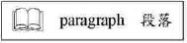
（Ｃ）43.What does“this”mean in the first paragraph?
(A) Watching TV to relax.
(B) Doing well on school tests.
(C) Learning quickly from TV.
(D) Spending time with children.
（Ａ）44.What does the writer think of TV?
(A) It takes away children's opportunity to think.
(B) It gives useful tips for becoming better parents.
(C) It does not give enough information to people today.
(D) It is the most important invention of the past one hundred years.
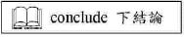
（Ｂ）45.What can we conclude from the reading?
(A) People in the future will enjoy more new inventions.
(B) Children should learn more from their parents than from TV.
(C) Students who watch TV are smarter than students who do not.
(D) Watching TV is a good way for children to understand real life.

