92學年度國中第一次基本學力測驗 英文領域

第一部分：下列各題（題號1.～20.），請依文意選出一個正確或最佳的答案。

（Ｄ）1. It is to use fake credit cards.
(A) boring (B) foreign (C) ideal (D) illegal
（Ｃ）2. In Taiwan, the first of a school year usually begins in September.
(A) example (B) rule (C) semester (D) system
（Ａ）3. Frank always thinks about too many things, so he cannot in class.
(A) concentrate (B) imagine (C) preview (D) remember
（Ｃ）4. Mr. Wang is a . He sells food and drinks outside the park every day.
(A) PE teacher (B) police officer
(C) street vendor (D) taxi driver
（Ａ）5. In summer it is to stay in my parents' room because it is air-conditioned.
(A) comfortable (B) gentle (C) impossible (D) serious
（Ｃ）6. The old man is looking at this granddaughter . He has not seen her for a long time.
(A) happy (B) happier (C) happily (D) the happiest
（Ｄ）7. Fred has a for languages. He can speak Japanese, French and Russian.
(A) brand (B) joke (C) report (D) talent
（Ｃ）8. Yuki loves wearing strange hats because she wants people to her.
(A) believe (B) control (C) notice (D) visit
（Ｂ）9. Mr. Chen has a loud voice. His voice can clearly even in that big classroom.
(A) hear (B) be heard
(C) be hearing (D) have heard
（Ａ）10.Mother makes me my homework every day before I can play video games.
(A) finish (B) finished
(C) finishing (D) to finish
（Ｄ）11. carefully before you buy a new house.
(A) Thinking (B) To think
(C) Thinks (D) Think
（Ｃ）12.Brian: How do you usually go back to Hualien?
Peter: By . There are many flights a day.
(A) bus (B) car
(C) plane (D) train
（Ｂ）13.Ms. Li: How much is this pencil?
Albert: It's 15 dollars.
Ms. Li: Sorry, but I don't have any now. Here's 1,000 dollars.
Albert: That's all right.
(A) bill (B) change (C) money (D) wallet
（Ｄ）14.Jenny: How many countries in Europe?
Betty: I'm not sure.
(A) is it (B) is there (C) are they (D) are there
（Ｃ）15.Elsa: Did Eric buy any vegetables in the market?
Bob: No, he didn't, but he bought fish.
(A) no (B) any (C) some (D) both
（Ｄ）16.Allen: George looks strong. Has he ever been sick?
Doris: He's a superman! He goes to the doctor.
(A) already (B) even (C) often (D) seldom
（Ａ）17.Becky: Do you like watching cooking programs on TV?
Diana: No, I don't, but my twin brother . He's very fond of cooking.
(A) does (B) do (C) is (D) are
（Ｂ）18.Jane: I heard you went to Yangmingshan last spring vacation.
Dick: We not only visited the park took a hot-spring bath. It was a great trip.
(A) by the way (B) but also (C) after (D) and
（Ｄ）19.Nancy: We want to invite everyone at school to the party, but there are so many cards to
write.
Jimmy: Why not put some on the walls of our school? Everyone will get the
news very soon!
(A) clocks (B) e-mails
(C) envelopes (D) posters
（Ｂ）20.Rose: It's time to go to bed. You have to get up early tomorrow,
?
Nina: Yes, my class is going hiking tomorrow.
(A) can't you (B) don't you
(C) aren't you (D) haven't you

第二部分：下列九個題組，共有25題（題號21.～45.），請依據所附選文或圖表資料，選出一個正確或最佳的答案。

（21.～24.）
Dear Mr. Help:
Daniel was my best friend in high school. I 21. him for the first time on the school bus. He was nice, and most important of all, we both were interested in sports. We soon became good friends. I 22. basketball with him after school in the gym. High school was a great time for us, and we enjoyed the“men's talk”between us.
But things 23. since we graduated. Daniel can't see me very often because he's got a girlfriend. I try to talk to him, but he keeps avoiding me. Daniel 24. me several times that he needs more time to be with his dear Gloria. How can a girlfriend be more important than a best friend? Do you think I should find a new friend? Or should I get a girlfriend, too?
Johnny
（Ａ）21.(A) met (B) have met
(C) used to meet (D) was going to meet
（Ｃ）22.(A) play (B) have played
(C) used to play (D) was going to play
（Ｂ）23.(A) changed (B) have changed
(C) were changing (D) are going to change
（Ｃ）24.(A) is telling (B) will tell (C) has told (D) used to tell

（25.～27.）
Clerk: Good afternoon. Can I help you?
Mr. Lai: I would like to pick up a present for my son.
Clerk: 25.
Mr. Lai: Eighteen. He's a student.
Clerk: I think he'd love a cell phone. We have all the fashionable colors.
Mr. Lai: Well, but I don't want him to use a cell phone too early.
Clerk: Or you can buy one for yourself. 26. See? This was 5,000 dollars last week but only 3,000 today. It's the best price you can get!
Mr. Lai: 27. I don't think I need a cell phone now.
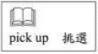
（Ａ）25.(A) How old is he?
(B) How tall is he?
(C) How much money do you have?
(D) What would you like to give him?
（Ｂ）26.(A) You have spent a lot of money.
(B) Cell phones are very cheap now.
(C) It's the best present for your son.
(D) They will become more and more expensive.
（Ｃ）27.(A) Of course. (B) That's true.
(C) No, thanks. (D) You're welcome.

（28.～29.）
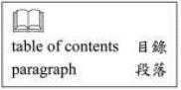
Read the table of contents of this book and answer the questions.
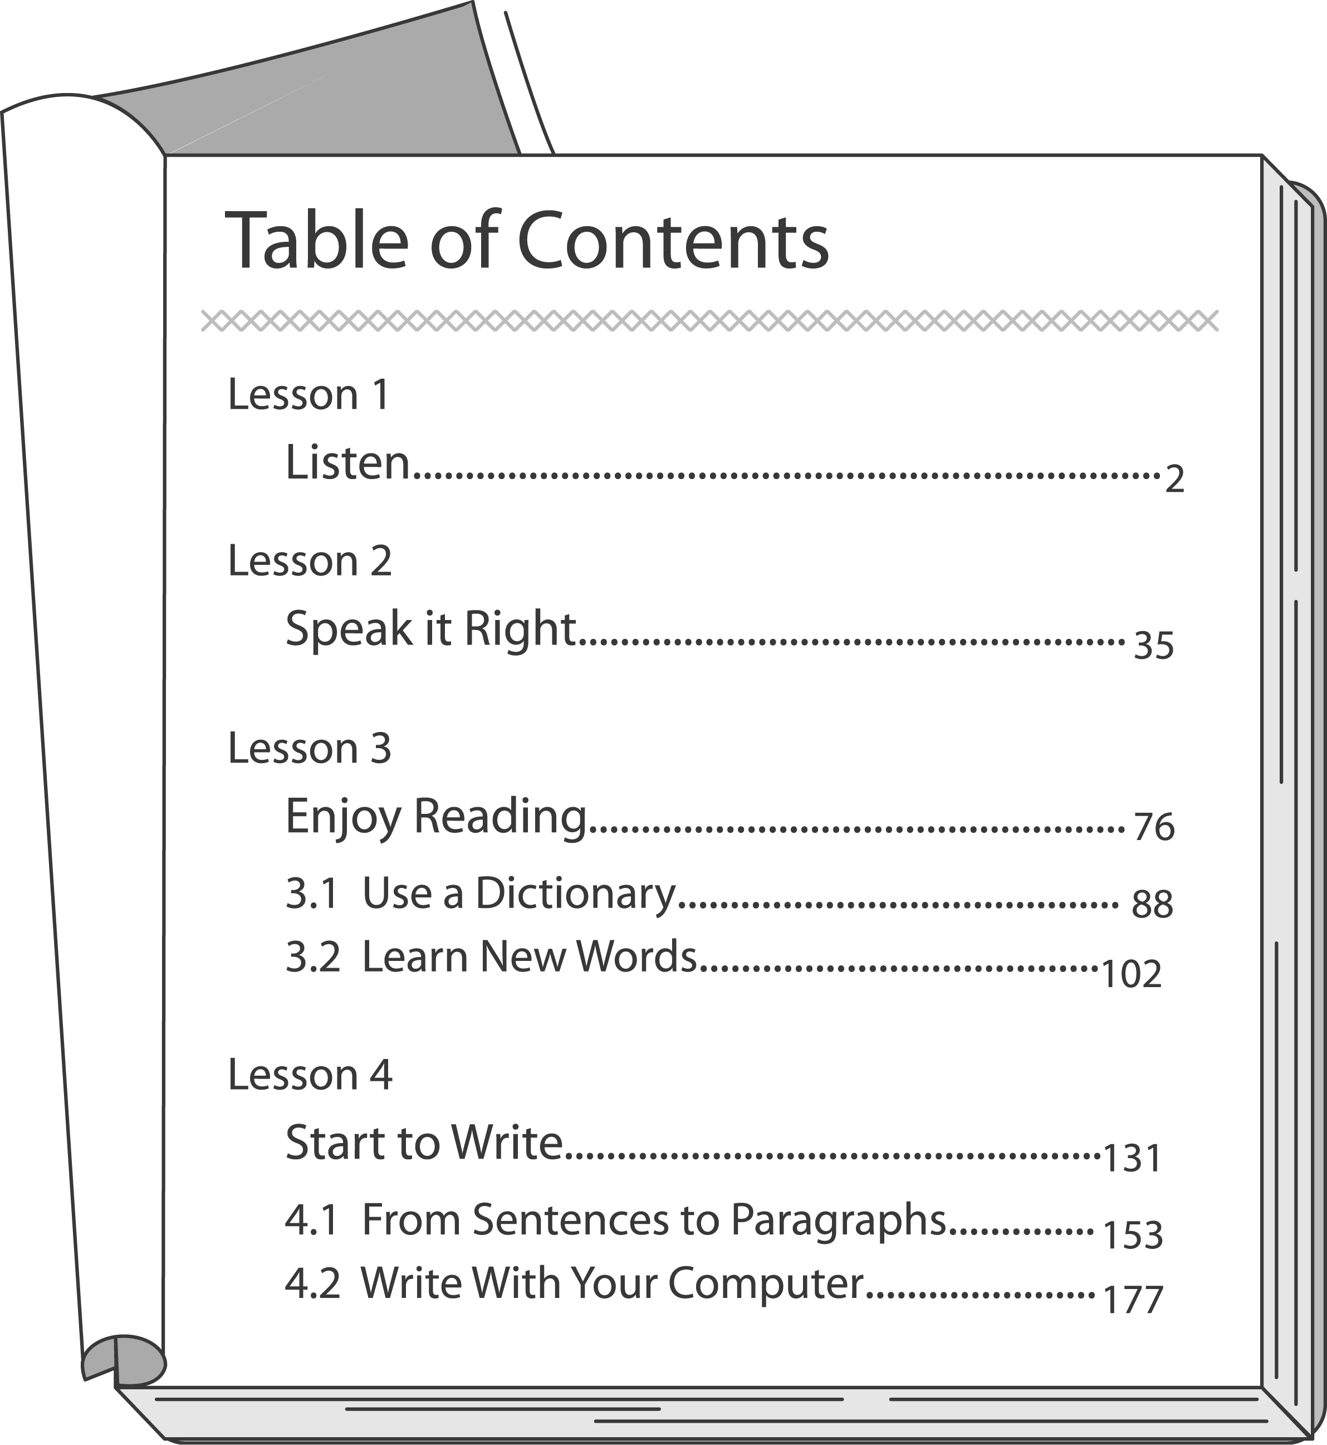

（Ｄ）28.What is this book about?
(A) Taking a trip with your family. (B) Solving computer problems.
(C) Telling stories to children. (D) Learning a language.
（Ｃ）29.
You can understand a story without knowing every word. You can even learn what the new words mean from other sentences.”
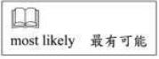
In which lesson will you most likely find these two sentences?
(A) Lesson 1.
(B) Lesson 2.
(C) Lesson 3.
(D) Lesson 4.

（30.～31.）

Welcome to Nocsafari
Under the night sky
you'll be surprised at what you can find.
Beautiful and special animals will
give you a really wonderful time.
Over 90％ of animals here are most active at night.
That's why we are open at this time.
Different things you've never seen during the daytime
are all here waiting for you to say hi.
Newly Opened!

（Ｄ）30.What may Nocsafari be?
(A) A restaurant. (B) A hospital. (C) A theater. (D) A zoo.
（Ａ）31.When is Nocsafari open?
(A) At night. (B) Day and night. (C) During the day. (D) In the afternoon.

（32.～34.）
One evening, my dad asked me to buy some bread for dinner. It was dark and cold outside. I rode a bike to a store near my school. When I left the store, it got even darker, so I got on my bike right away. Then I found a woman in a white dress riding a motorcycle after me. She followed me for a long time. I rode very fast and started to cry for help, but no one was there. I was too scared and too tired to ride any faster. At last, I gave up. The woman stopped in front of me and said,“Why were you riding so fast, Ken? It's dangerous!”I looked at the woman.“Oh! It's you, Mom! You really scared me. Dad said you wouldn't be back for dinner tonight!”
（Ｂ）32.Why did Ken go out that night?
(A) To ride a bike. (B) To buy some food.
(C) To go to cram school. (D) To look for his mother.
（Ｂ）33.Why was Ken riding fast on his way home?
(A) He was hungry. (B) Someone was following him.
(C) It was getting darker and colder.
(D) His father asked him to go home soon.
（Ｄ）34.Who was the motorcyclist?
(A) A stranger. (B) A policeman.
(A) Ken's father. (C) Ken's mother.

（35.～37.）
Dear Cindy,
I enjoyed the dinner at your place last night.
Everything was great: the food, the wine, the music, and the dancing. I was impressed with the delicious cake you made. Would you give me the recipe?
I also enjoyed meeting your friends and family. I had a very interesting talk with your cousin, Joe White. He was a lot of fun and very friendly.
I really had a good time. Thank you so much.
Tina
P.S. May I have Joe's telephone number? Thanks again.
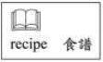
（Ｃ）35.Who gave the dinner party?
(A) Joe. (B) Tina. (C) Cindy. (D) Tina's cousin.
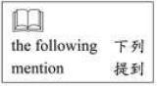
（Ａ）36.Which of the following was not mentioned in the letter?
(A) Saying hello to Joe.
(B) Saying thanks to Cindy.
(C) Asking for Cindy's cake recipe.
(D) Asking for Joe's telephone number.
（Ｃ）37.Which of the following did Tina do at the party?
(A) Calling Joe. (B) Helping make a cake.
(C) Talking with Cindy's family. (D) Playing music for her friends.

（38.～40.）
Look at the map. Harry and Paul are in front of Da Da Theater. Read their dialogue and answer the questions.
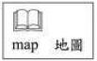
Harry: Excuse me, how can I get to Green Park?
Paul: Well, if you want to take a bus, there's a bus stop over there. But it's faster if you take the subway. The subway station is two blocks away from here.
Harry: I think I'll take the subway. How much is a student ticket?
Paul: Twenty-five dollars from here to Green Park.
Harry: Thanks. By the way, any supermarket near here? I need to buy a drink.
Paul: Yes, there's one on the way to the subway station. It's just down the street.
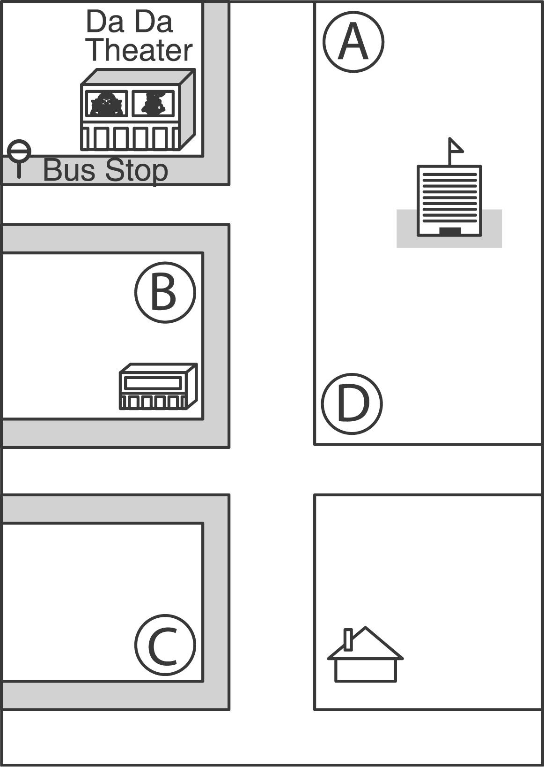
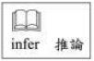
（Ｄ）38.What can we infer from the dialogue?
(A) Harry will go to Green Park with Paul.
(B) Harry will take a bus to the subway station.
(C) Harry will buy a coke at the subway station.
(D) Harry will pay twenty-five dollars for the subway ticket.
（Ｂ）39.What does one mean in dialogue?
(A) A subway ticket. (B) A supermarket.
(C) A bus stop. (D) A drink.
（Ｃ）40.Where is the subway station?
(A) At ○. (B) At ○. (C) At ○. (D) At ○.

（41.～42.）
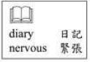
Read Amy's diary and answer the questions.
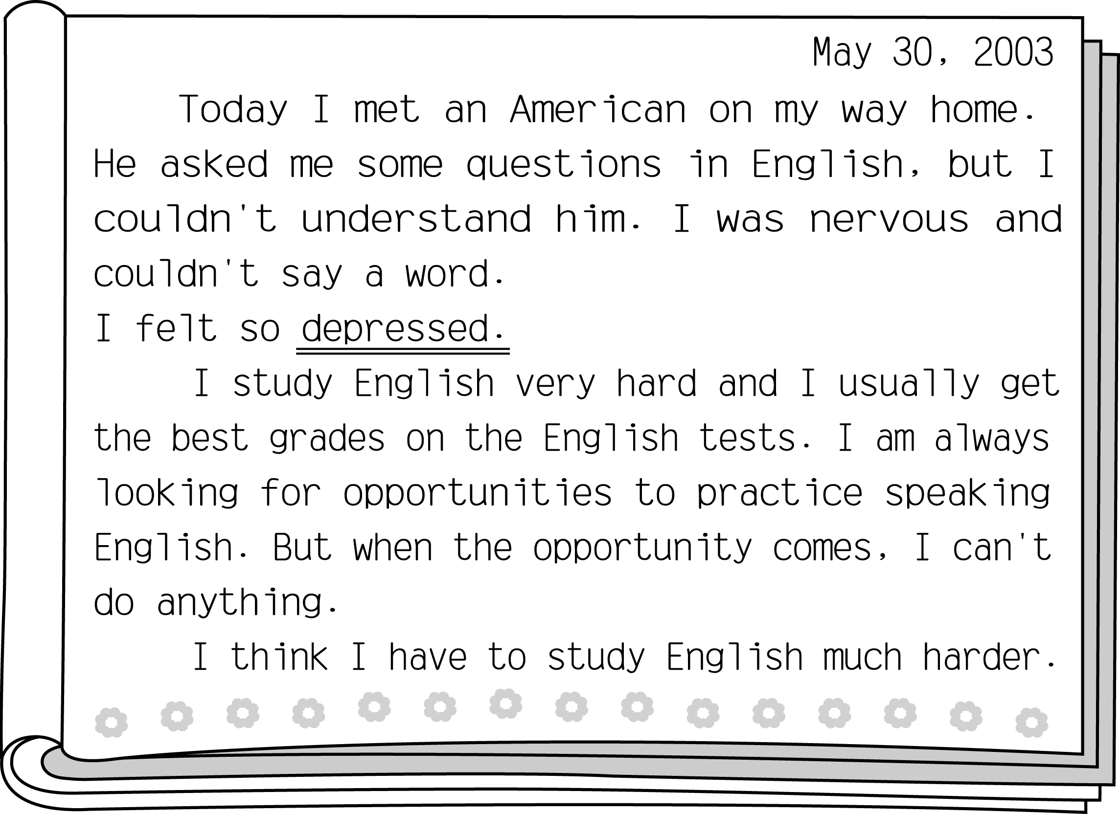
（Ａ）41.What does depressed mean in the letter?
(A) Sad. (B) Bored. (C) Lucky. (D) Excited.
（Ｄ）42.What can we learn from Amy's experience?
(A) It is dangerous to talk to strangers on the streets.
(B) English is the most difficult subject for most students.
(C) People who get nervous easily cannot get good grades in English.
(D) Getting good grades in English does not mean we can use English well.

（43.～45.）
When I was little girl, my family lived in a small village. There was a very beautiful river near my home. The water was clean and cool. I liked to go fishing there with my mom. We would catch fish, look for clams and play in the water. There were also a lot of birds near the river. We would spend all day watching the birds. Life was beautiful and wonderful in the old days.
Now my family lives in the city. Last Sunday my daughter asked me to take her to see the beautiful river I was always talking about.“I want so much to go fishing there with you and Grandma,”she said.
When we went to the river, we only saw a factory and a mountain of garbage. My mom was surprised, my daughter was disappointed, and I was sad ─ the river was my best friend; I grew up with it. Now there are no fish in it; the birds are gone, too. I hear it crying for help. But what can I do?
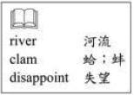
（Ａ）43.When the writer went back to see the river, what did she find?
(A) The pollution in the river was very serious.
(B) The river was a good place for children to play.
(C) Bird-watching was more and more popular along the river.
(D) There were no fish in the river because too many people went fishing.
（Ｂ）44.Who is the Grandma in the reading?
(A) The writer. (B) The writer's mom.
(C) The writer's daughter. (D) The writer's grandmother.
（Ｂ）45.What did the writer mean when she said,“I grew up with it”?
(A) She helped clean the garbage out of the river.
(B) She spent much time playing around the river.
(C) She had many friends who lived near the river.
(D) She grew well by eating fish and clams from the river.

