92學年度國中第二次基本學力測驗 英文領域

第一部分：下列各題（題號1.～20.），請依文意選出一個正確或最佳的答案。
（Ａ）1. Glen is a very TV star; even children know his name.
(A) famous (B) hungry (C) serious (D) weak
（Ｃ）2. Students should always a new lesson before class so they can understand better in class.
(A) attend (B) create (C) preview (D) produce
（Ｃ）3. My son's shoes are too small. I am going to buy him a new
.
(A) mate (B) number (C) pair (D) price
（Ｂ）4. Mr. Lin usually his restaurant with lights and flowers before the New Year.
(A) celebrates (B) decorates (C) examines (D) notices
（Ｄ）5. I have no in cooking so I always ask my brother to cook for me.
(A) rule (B) point (C) example (D) interest
（Ａ）6. Many people in big cities go to work by subway. Millions of come in and out of the subway stations every day.
(A) passengers (B) systems (C) tunnels (D) waiters
（Ｃ）7. My grandfather spends of his free time reading newspapers.
(A) one (B) both (C) most (D) many
（Ｃ）8. Willy has changed a lot. He get up early to do exercise. But now he wakes up late and is late for school every day.
(A) forgot to (B) hated to (C) used to (D) volunteered to
（Ｄ）9. To avoid accidents, we have to drive all the time.
(A) heavily (B) quickly (C) clearly (D) carefully
（Ａ）10.Watching American movies one of the activities we enjoy most in our English class.
(A) is (B) are (C) to be (D) being
（Ｄ）11.Sue is very sick and has to stop working for several weeks. But she feels better, she will get back to work.
(A) so far (B) since then (C) because (D) as soon as
（Ａ）12.Jenny plays the piano very well. Her mother makes her two hours every day.
(A) practice (B) practiced
(C) practicing (D) to practice
（Ｄ）13.David: Yesterday a woman bumped into Allen and after that, he couldn't find his .
Walter: Poor Allen! How much did her lose?
David: Not much, but he's worried about the credit cards in it!
(A) computer (B) letter (C) ticket (D) wallet
（Ｂ）14.Kate: Earl, is that tall boy your brother? Earl: Yes, .
Kate: But you two look so different!
(A) it is (B) he is (C) that is (D) you are
（Ｂ）15.Ally: What happened to your ?
John: Nothing. It always looks terrible after I go swimming.
Ally: Well, I think it will look better if you wear a hat.
(A) eye (B) hair (C) hand (D) leg
（Ｄ）16.Bill: Have you ever been to Hong Kong?
Ted: Yes, . It's really a fun place to go.
(A) five days (B) for three years
(C) in one month (D) twice already
（Ｂ）17.Lisa: What this morning?
Tina: Well, it's Sunday. I think I'll go to church with my father.
(A) have you done (B) are you going to do
(C) did you do (D) were you doing
（Ｄ）18.A-wei: This typhoon is so terrible!
A-fen: Yes, I'm not sure we can still go fishing tomorrow.
(A) who (B) what (C) which (D) whether
（Ａ）19.Jack: There is going to a dance show on Saturday. Would you like to go with
me?
Nina: Sure. I can't wait for it.
(A) be (B) do (C) get (D) have
（Ｃ）20.Cathy: I'm going out. How will the weather be this evening?
Eddie: Well, it's fall already, you know. I think it will be to take a jacket.
(A) cooler (B) heavier (C) safer (D) stronger

第二部分：下列十個題組，共有25題（題號21.～45.），請依據所附選文或圖表資料，選出一個正確或最佳的答案。

（21.～23.）
Billy is one of my classmates in junior high school. Three years ago, he was very heavy, but he looks wonderful now. Here is his story about how he lost weight.
Billy 21. a lot of snacks and fast food in his elementary school days. Besides, he did not do much exercise. So he kept putting on weight. He became so heavy that one day he broke the chair he was sitting on when he was in class.
After this experience, Billy decided to lose some kilos. First, he went to see a doctor and 22. to avoid fast food. Also, the doctor said he should start exercising. Billy followed the doctor's advice: he 23. away from fast food and snacks for one year, and most important of all, he jogged every day.
That is how Billy lost 20 kilos before he entered junior high school.

（Ｃ）21.(A) eats (B) has eaten (C) ate (D) was going to eat
（Ｂ）22.(A) is asked (B) was asked
(C) will be asked (D) would be asked
（Ｄ）23.(A) has stayed (B) is staying (C) will stay (D) stayed

（24.～26.）
Dear Lily Brown,
During my first two years in junior high school, I never met any girls I liked. 24. －a girl came into my life. Diana is a new student in my class. She is not only beautiful but also nice to people. Almost all the boys in my class like her, and 25. . She often talks to us happily, and I am worried that she may like other boys.
Last Thursday, I decided to ask her to be my girlfriend. But before I spoke, my nose started bleeding! It was so embarrassing. I wished 26. .
Dear Lily, do you think she still wants to talk to me after that? What should I do?
Very worried boy,
Nick
（Ｃ）24.(A) So I won't have a wife
(B) And I have many classmates
(C) But things are different now
(D) Because Mom told me not to
（Ａ）25.(A) I am one of them (B) I am happy with it
(C) she is afraid of them (D) she finally makes up her mind
（Ａ）26.(A) I could die (B) she would love it
(C) everyone could see it (D) I could get married soon

（27.～28.）
Pearl is going to take her son, Mark, to see an eye doctor, but Mark has school in the morning and writing classes on Monday and Friday afternoons. Pearl is free only in the afternoon.
Here are the doctor's office hours

Office Hours
 | Mon. | Tues. | Wed. | Thurs. | Fri. | Sat. | Sun.
A.M.
P.M.
□closed □open

（Ｂ）27.When will be the best time for Pearl to take Mark to see the eye doctor?
(A) Monday. (B) Tuesday. (C) Wednesday. (D) Friday.
（Ｃ）28.How many days a week does the doctor work in the morning?
(A) Two days. (B) Three days. (C) Four days. (D) Five days.

（29.～30.）
Look at the map and answer the questions.
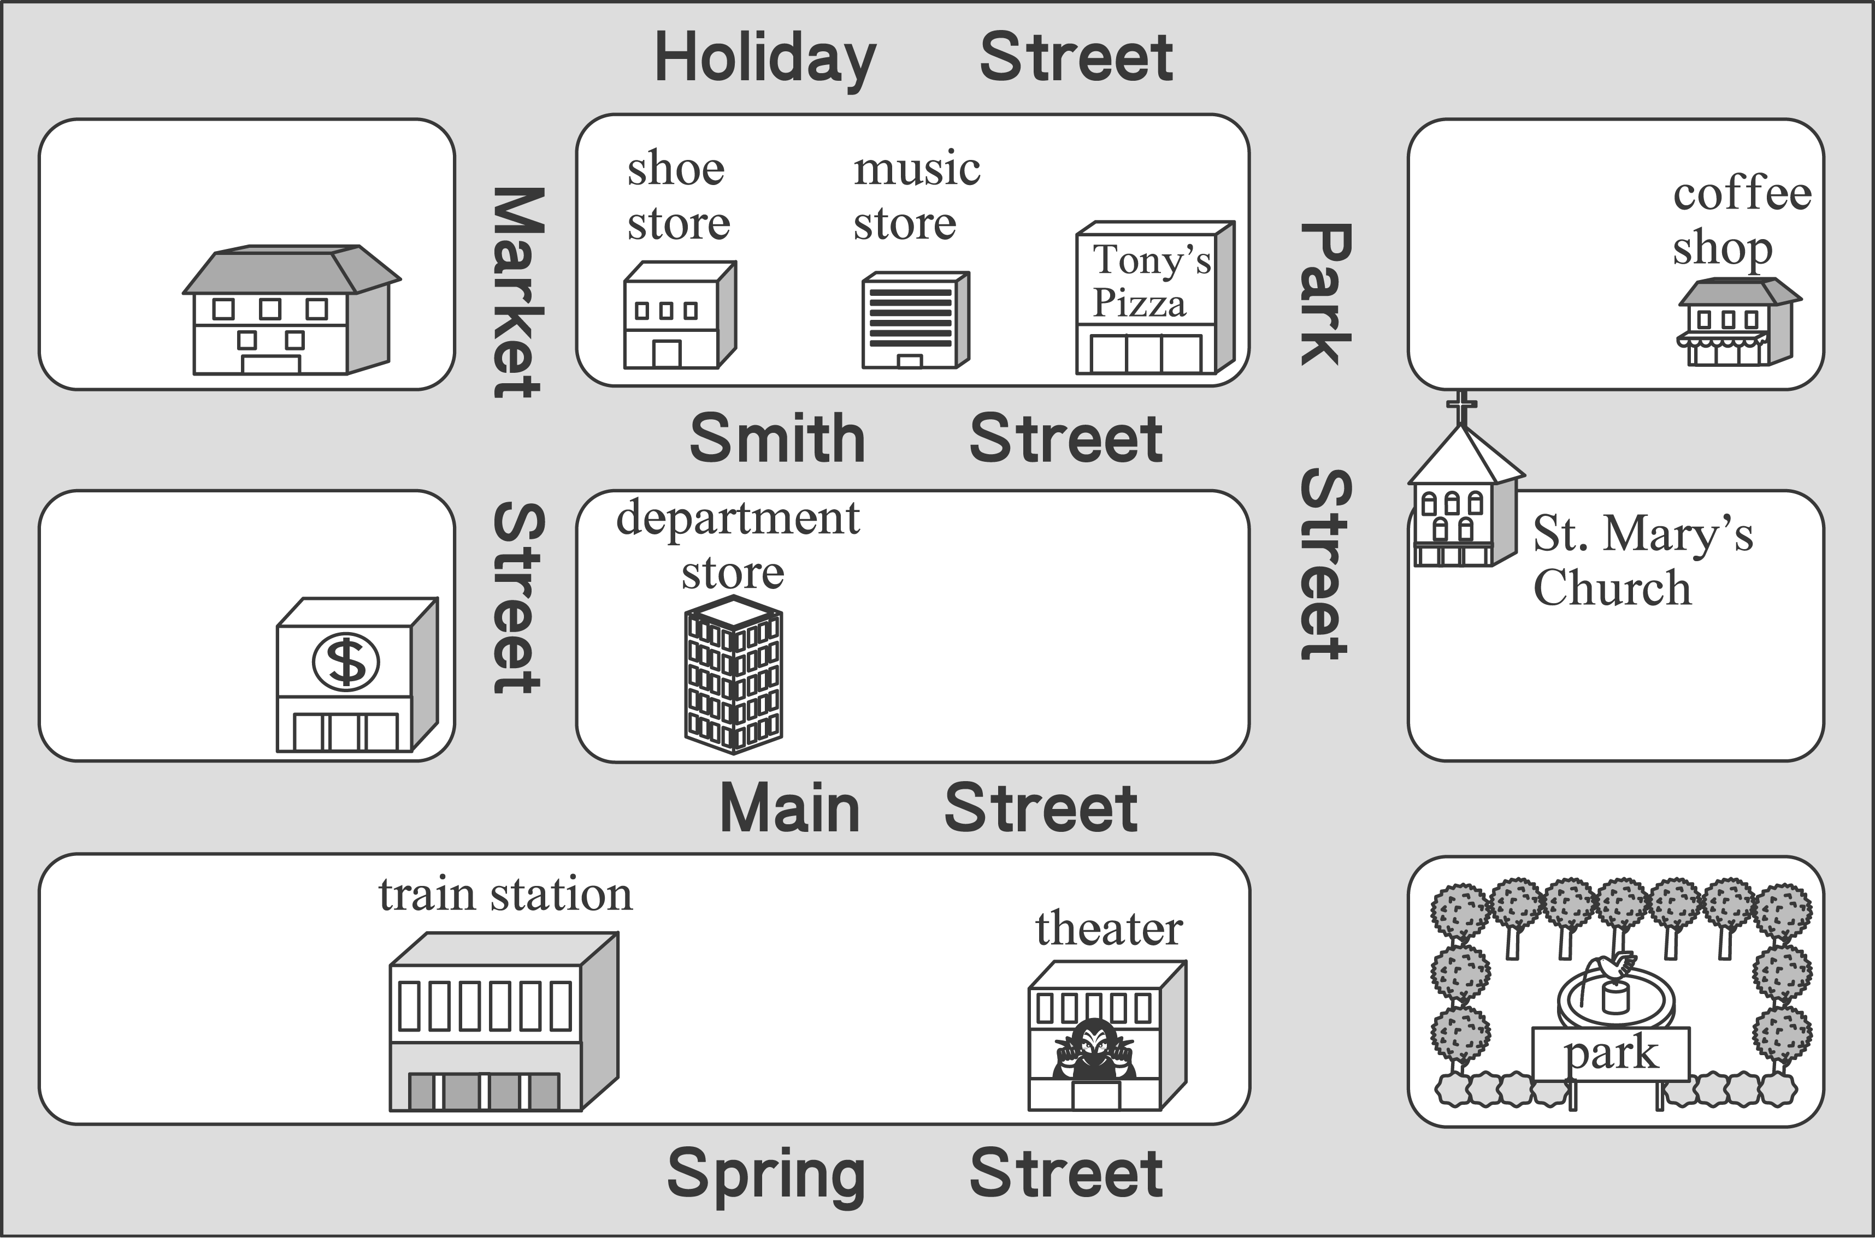

（Ｄ）29.Where is Tony's Pizza?
(A) It is on Holiday Street.
(B) It is next to the coffee shop.
(C) It is between the music store and the shoe store.
(D) It is on the corner of Park Street and Smith Street.
（Ｃ）30.A-ding just got off the train and wanted to see St. Mary's Church. How can he get there?
(A) Go down Park Street and turn left to Main Street.
(B) Go down Market Street for two blocks and turn left. It is on the left.
(C) Go down Spring Street and turn left to Park Street. Walk along Park Street for two blocks.
(D) Go down Main Street and turn right to Market Street. Walk along Market Street for two blocks.

（31.～32.）

Emily: Hey, Frank, did you watch the basketball game yesterday?
Frank: Yes, I did. The Elephants won, 85－73.
Emily: Really? That's great! They are my favorite team.
Frank: Didn't you watch it? It was the most important game of the season.
Emily: My mom wouldn't let me. She said today's English test was more important than a basketball game.
Frank: But it was really an exciting game.
Emily: I know. I wanted so much to watch it.
Frank: You can watch the rerun this evening.
Emily: No, I can't. I have to go to cram school at five o'clock.

（Ｂ）31.Why didn't Emily watch the game yesterday?
(A) She hates the Elephants.
(B) She had to study English.
(C) She had to do the housework.
(D) She had to go to cram school.
（Ａ）32.What can we learn from the dialogue?
(A) Emily is a basketball fan.
(B) Frank thinks going to cram school is a waste of time.
(C) Frank feels sorry that he didn't tell Emily about the game.
(D) Emily usually watches an important basketball game twice.

（33.～34.）
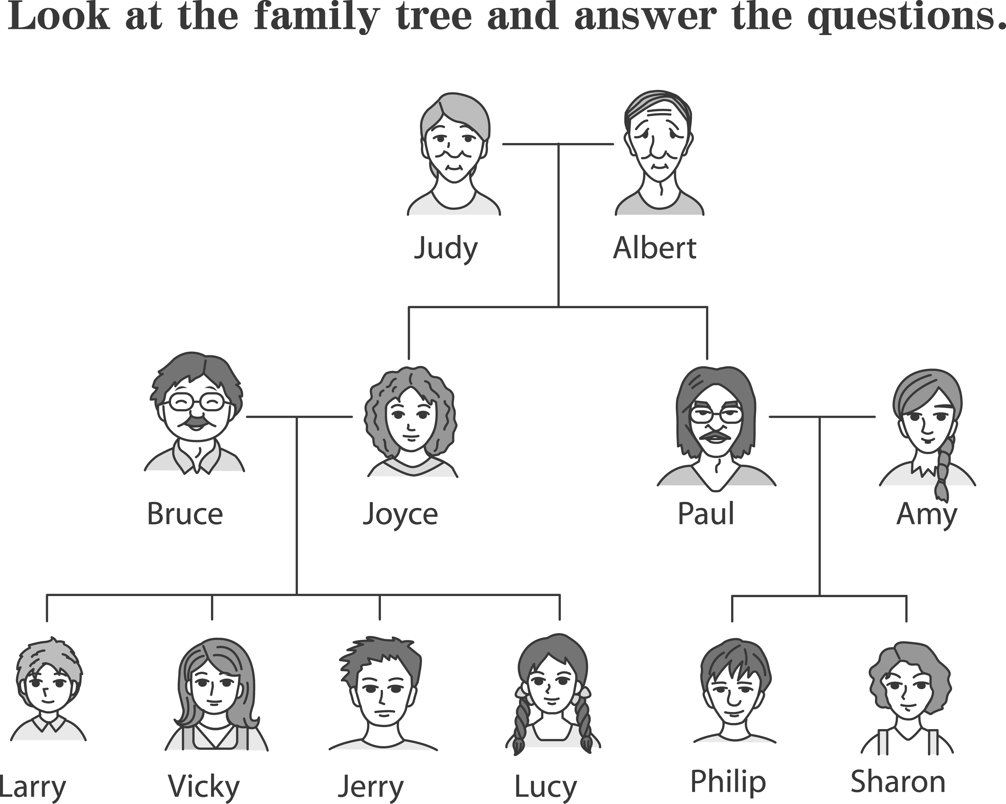


（Ｃ）33.Which of the following is Sharon's cousin?
(A) Albert. (B) Joyce. (C) Vicky. (D) Philip.

（Ｂ）34.“My father is a Chinese teacher. He is tall and wears glasses. My mother is a businesswoman. They both are busy, so we children have to do the housework. Sometimes my sisters cook, and I help wash the dishes and vacuum the floor. My younger brother is only three years old. The only things he does are eating and playing.”Who wrote the paragraph?
(A) Judy. (B) Jerry. (C) Philip. (D) Sharon.

（35.～36.）
Welcome 2004
All Anne's Fans Invited!
Date: Dec. 31, 2003
Time: 8:00 p.m.
Place: Ginny's Hall
Join us at“Welcome 2004.”Come and listen to Anne's new songs when we count down for the New Year. Her beautiful voice will give you a wonderful night. Free CDs, pictures, and posters will be given to those who can answer some questions about Anne. Come and see if you are one of the lucky ones! You can even sing a song with her if you are one of the first ten to come.
Call Lucy at 0900200201

（Ｂ）35.What may Welcome 2004 be?
(A) A song.
(B) A party.
(C) A movie.
(D) A video game.
（Ａ）36.What can we learn from the poster?
(A) Anne is a singer.
(B) Anne is good at taking pictures.
(C) Lucy is going to sell Anne's posters.
(D) CDs and posters will be given to the first ten people to come.

（37.～38.）
Pam: Wow! You look great today! Is that a new dress?
Else: Yeah! My dad bought it for me.
Pam: Well, it's pretty. It shows good taste.
Elsa: Thank you. Virgos are famous for their taste.
Pam: Oh? Is your dad a Virgo?
Elsa: No, I am a Virgo. I love the dress; he just paid the bill. And he said the dress looked strange.

（Ｃ）37.What does Pam think about Elsa's dress?
(A) It is strange.
(B) It is too large.
(C) It is beautiful.
(D) It is good for Virgos.
（Ｄ）38.Which is true about Elsa and her father?
(A) They are both Virgos.
(B) They both enjoy shopping.
(C) They both love strange dresses.
(D) They have different tastes in women's dresses.

（39.～41.）
 | TODAY'S MOVIES
 | Red Room |  | Blue Room |  | Green Room |  | White Room
 | Black Tiger  （only for people older than 18）  9:00  11:30  14:00  16:30  19:00  21:30 |  | Boys in Love  9:30  11:30  13:30  15:30  17:30  19:30  ★21:30  ★only shown on weekends |  | Summer Beach  11:30  13:30  15:30  17:30  19:30  21:30 |  | The Doll's House  12:20  14:50  17:20  19:50
 | June 1～Jun 17 |  | June 1～June 20 |  | June 10～June 25 |  | June 10～June 21


（Ｃ）39.June 23 is Mrs. Wu's birthday. Her husband is going to take her to see a movie. Which
movie can they see?
(A) Black Tiger (B) Boys In Love
(C) Summer Beach (D) The Doll's House
（Ｂ）40.Mary, a junior high school student, went to a movie with her classmates. After the movie, they had lunch at a restaurant near the theater at 11: 40. Which movie did they see?
(A) Black Tiger (B) Boys In Love
(C) Summer Beach (D) The Doll's House
（Ｂ）41.Which is true about the movies in the poster?
(A) People cannot see Black Tiger on weekends.
(B) The Doll's House is not shown in the morning.
(C) Boys in Love is shown six times on weekends.
(D) Of all the movies, Summer Beach is shown the most days.

（42.～45.）
Wonderland is the hometown of minifishers. Because the winter there is cold, they go to warmer places for the winter and go back home the next spring to have their babies. Every year, hundreds of minifishers visit Starland. They stay there with their families for several months. They usually sleep during the daytime and wake up in the evening to look for food. Small fish are their favorite.
Minifishers were first found in Starland one hundred years ago. Now Starland has become their most important stopping place for the winter. But this could change soon because people in Starland are thinking of building factories near the minifishers' winter home. Minifishers are shy and do not easily change the way they live. Can we do something to help these friends from the sky? Though making money is important, people in Starland should know the lives of other animals are important, too. Let's work together to help them.
（Ｄ）42.What many a minifisher be?
(A) A factory worker. (B) A food vendor.
(C) A fish. (D) A bird.
（Ａ）43.Why do minifishers come to Starland?
(A) The winter in Starland is warm.
(B) Their babies are born in Starland.
(C) They cannot find their way home.
(D) They enjoy meeting people in Starland.

（Ｂ）44.What does this mean in the second paragraph?
(A) The winter home of minifishers will be moved.
(B) Starland is a good place for minifishers to spend the winter.
(C) Minifishers were first found in Starland one hundred years ago.
(D) Building factories near Starland will scare away the minifishers.
（Ｄ）45.What does the writer think of the idea of building factories?
(A) It takes too much money to build factories.
(B) The new factories will not be good for the people in Starland.
(C) The minifishers' winter home is a good place for new factories.
(D) People should think about other living things before building factories.

