93學年度國中第一次基本學力測驗 英文領域

第一部分：下列各題（題號1.～18.），請依據題意選出一個正確或最佳的答案。
（Ｄ）1. Frank plays basketball well. He’s quick and makes good .
(A) desserts (B) music (C) shoes (D) shots
（Ｄ）2. We enjoy working with Pauline because she always to help.
(A) begins (B) forgets (C) hates (D) volunteers
（Ａ）3. Good learners are not afraid of . In fact, they learn more from looking for the answers.
(A) asking questions (B) avoiding problems
(C) copying ideas (D) criticizing others
（Ｄ）4. The last week scared a lot of people. Its strong winds and heavy rains took fifty lives.
(A) air pollution (B) soccer game
(C) system (D) typhoon
（Ｂ）5. It is the bus driver’s job to make sure that every is safe.
(A) motorcyclist (B) passenger (C) stranger (D) vendor
（Ａ）6. My grandmother believes that young children in big cities get sick easily the air is dirty.
(A) because (B) before (C) but (D) whether
（Ｂ）7. Andy is very found of having parties, so he often his friends to his house on the weekend.
(A) follows (B) invites (C) remembers (D) visits
（Ｄ）8. I sent Lucy two e-mails last week, but she has not answered me .
(A) already (B) also (C) either (D) yet
（Ｃ）9. Henry does well at school and is always polite to his teachers. His friends like him, and his parents are him.
(A) good at (B) interesting to
(C) proud of (D) worried about
（Ｃ）10.I love sports and enjoy playing baseball with friends the school team.
(A) about (B) at (C) on (D) to
（Ｄ）11. the lesson before class gives me a better idea about what the teacher is going to teach.
(A) Preview (B) Previews (C) Previewed (D) Previewing
（Ｄ）12.I need someone his work to take out the garbage for me.
(A) finish (B) finished
(C) has finished (D) who has finished
（Ｂ）13.My mother me send a letter yesterday.
(A) asked (B) had (C) told (D) wanted
（Ｂ）14.Mr. Su: Sorry, I don’t have enough money now. Can I pay with my ?
Waiter: Sure.
(A) birthday card (B) credit card (C) name card (D) phone card
（Ｃ）15.Cathy: What are these flowers for?
Oscar: We’re going to use them to the Christmas tree. Would you please help us
put them in the tree?
(A) celebrate (B) create (C) decorate (D) produce
（Ｃ）16.Jane: Did you get up early this morning?
Tina: No, I didn’t, but my brother . He gets up early every day..
(A) does (B) is (C) did (D) was
（Ａ）17.Lucy: is Ted doing in the kitchen?
Ryan: He’s cooking dinner for us.
(A) What (B) Where (C) Who (D) Why
（Ａ）18.Grace: How many pencils in your pencil box?
Allen: Only one.
(A) are there (B) are they (C) is there (D) is it

第二部分：下列十個題組，共有27題（題號19.～45.），請依據選文或所附圖表資料，選出一個正確或最佳的答案。
（19～21）
(Doris sees Carol on her way to school.)
Doris: Hi, Carol. Would you like to go to the movie The Doll World with me tonight?
Carol: I’d love to, but I have to take care of my sister Kelly. My parents 19 home tonight.
Doris: You can take her to the movie with us.
Carol: I don’t think so. I 20 taking her to a movie with me once. She kept talking during the movie, and even cried loudly. I was so embarrassed.
Doris: That’s too bad. But I’ve heard this movie is really popular with young children. Maybe she 21 it.
Carol: Well, let me think about it. I’ll tell you later when I see you at lunch.
Doris: Sure. See you then.
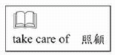
（Ｃ）19.(A) don’t be
(B) weren’t
(C) won’t be
(D) haven’t been
（Ｂ）20.(A) try
(B) tried
(C) will try
(D) am trying
（Ｃ）21.(A) loves
(B) loved
(C) will love
(D) was going to love

（22～25）
Three years ago, my family moved from Hualien to keeling. Mom and Dad came to Keelung because there were more 22 here. But it was still very difficult for them to find jobs.
Finally Mom found a job in a factory near the beach. She had to 23 in the morning to clean the fish that were sent to the factory during the night. It was no an easy job. Mom usually became very tried after a long day’s work.
Dad became a construction worker. He usually came home only twice a week, so we did not see him very often. One day he 24 when he was at work. He broke his leg and had to stay in bed in our small house. He has been very weak since then.
I will soon 25 junior high school. Should I go to senior high school in September? Or should I quit school and get a job to help my family? What should I do?

（Ｃ）22.(A) spring rains
(B) delicious snacks
(C) job opportunities
(D) senior high schools
（Ｄ）23.(A) go swimming
(B) take us to school
(C) vacuum the house
(D) get up at four or five
（Ｂ）24.(A) solved a problem
(B) got seriously hurt
(C) saw a car accident
(D) wore a warm jacket
（Ｃ）25.(A) return to
(B) prepare for
(C) graduate from
(D) start a new life in
（26～27）
There are 22 boys and 22 girls in Ms. Wang’s class. The bar chart shows the ways they use to go to school. Look at it and answer the questions.
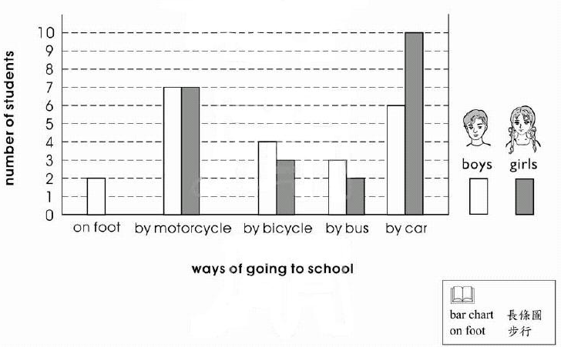
（Ｃ）26. How many different ways do the girls use to go to school?
(A) Two.
(B) Three.
(C) Four.
(D) Five.
（Ｄ）27. How many students go to school by bus?
(A) Two.
(B) Three.
(C) Four.
(D) Five.
（28～29）
Jeffrey: Excuse me, are you ready to order?
Mr. Wu: Yes, but… Well, what’s “ohenstri”?
Jeffrey: Oh, it’s a bird from Botaland. It tastes like… chicken! You can try it. It’s very delicious.
Mr. Wu: But I’m afraid of new things. I think I’ll just have some chicken soup.
Jeffery: That’s a great idea, sir, but the soup tastes just like ohenstri!
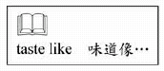
（Ｄ）28. Where is Mr. Wu?
(A) At home.
(B) In a zoo.
(C) In a hospital.
(D) In a restaurant.
（Ｂ）29. Why doesn’t Mr. Wu want to have ohenstri?
(A) It is not fresh.
(B) It is strange to him.
(C) It is from Botaland.
(D) It tastes like chicken.
（30～32）
Daphne got an e-mail from her brother, Steven.
Daphne,
You’re very busy these days. I called you several times, but no one answered. Are you still working at your office at 10 o’clock at night?
Next Sunday is Dad’s birthday. I want to give him a fantastic present, but fantastic things are usually too expensive for a poor student like me. I’ll be very happy if you can help me. I think Dad will be glad to get a radio as a birthday present, and the kind of radio I’d like to give him is the most fashionable one, Mini 3388. it is very small, convenient and will be very useful for Dad. What do you think?
I know you don’t have time to find a good present for Dad. So I’ll go to buy the radio, and you just pay the bill next weekend when you come back home.
Steven

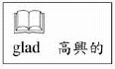

（Ｄ）30. Why does Steven write this e-mail to his sister?
(A) He wants her to call their dad.
(B) He wants to say happy birthday to his sister.
(C) He needs to buy a new cell phone for himself.
(D) He needs money to buy a present for their dad.
（Ｃ）31. What does fantastic mean in the e-mail?
(A) Cheap.
(B) Heavy.
(C) Wonderful..
(D) Second-hand.
（Ａ）32. what does one mean?
(A) A radio.
(B) A student.
(C) An office.
(D) An e-mail.

（33.～34.）
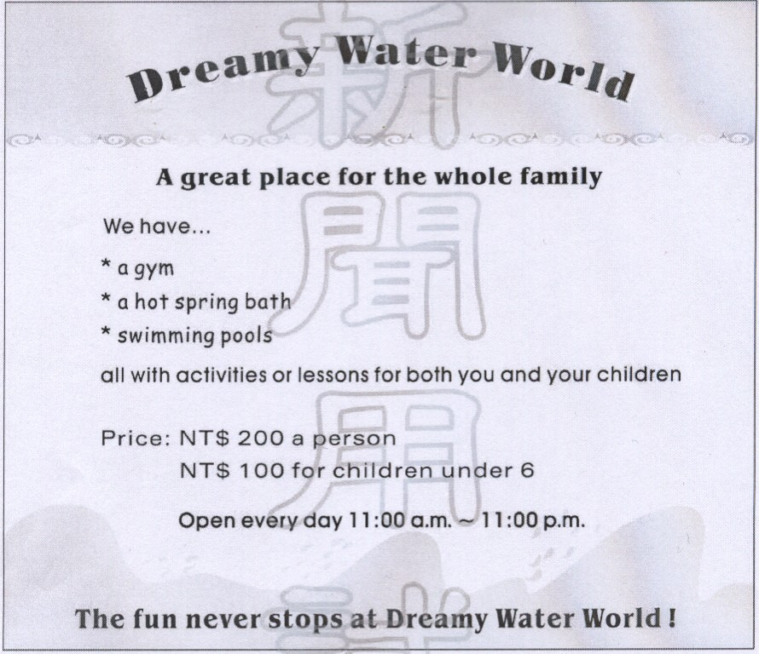
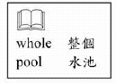
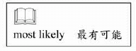
（Ａ）33.Who would most likely go to Dreamy Water World often?
(A) Mr. Zhang; he loves taking a hot spring bath.
(B) Miss Chen; she is looking for a place to go fishing.
(C) Mr. Luo; he enjoys swimming in the early morning.
(D) Mrs. Guo; she needs a quiet place to talk about business.
（Ｂ）34. Mr. Lin wants to go to Dreamy Water World with his five-year-old twin daughters this Saturday. How much will the have to pay?
(A) NT$ 300. (B) NT$ 400.
(C) NT$ 500. (D) NT$ 600.

（35.～36.）
It was late. I was too hungry to sleep, so I put on my jacket and went downstairs to coffee shop to get some food. A cute little dog was standing at the door. It looked friendly. I stopped to play with it and I though it like me. “Does it have a home?” I wondered. So I decided to ask the clerk whose dog it was. I thought if the dog didn’t have an owner, I might take it home and take care of it. “It’s my dog,” said the young girl.” “She’s waiting for me to finish my work. She worries and barks a lot if she doesn’t see me at night, so I let her stay here with me.”
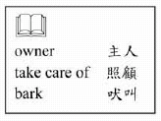
（Ｂ）35.Which is true about the cute little dog?
(A) it felt cold and hungry.
(B) It liked to be with its owner.
(C) It needed a quiet place to sleep.
(D) It would go home with the writer.
（Ａ）36.What was the young girl doing in the coffee shop?
(A) She was working.
(B) She was buying food.
(C) She was waiting for friends.
(D) She was looking for her dog.

（37～39）
April 12, 2000
Hi, Minglong:
How’s everything?
My brothers and I have been very busy since we came back to Japan. School here started last week. I have many interesting classes this semester. Japanese history is my favorite. I’ve learned a lot in that class.
Our house in Japan is comfortable. I hope you can come and visit us this summer. My parents will be very happy to see you, and you can also meet some of my friends here.
I had a great time in Taiwan and I miss our classmates very much. Please send my best wishes to them and stay in touch!
your Friend.
Sadako
（Ａ）37.Whick is true about Sadako?
(A) He enjoyed his life in Taiwan.
(B) He has found a new job in Japan.
(C) He is bored with Japanese history.
(D) He is going to Taiwan this summer.

（Ｃ）38.When did Sadako’s school most likely begin?
(A) February 22.
(B) March 12.
(C) April 7.
(D) September 1.
（Ｄ）39.What does them mean in the letter?
(A) Sadako’s parents.
(B) Sadako’s brothers.
(C) Sadako’s friends in Japan.
(D) Sadako’s classmates in Taiwan.

（40～42）
Weight control is very popular these days. People hope to become thin quickly. Some even take medicine without a doctor’s prescription. But reports show that although many of them do lose weight, they soon gain it back or gain even more.
So how can you safely control your weight? Diet and exercise are the answers. Eat only when you are hungry and eat only food that is good for your health. Never just stop eating; doing so can make you feel even hungrier, and you will eat more. Also, it is better to prepare your own food instead of eating out. And think about changing your lifestyle. For example, turn off the TV and the computer and get some exercise every day. But remember: Don’t be too strict with yourself. Give yourself some time to find the best way to control your weight.
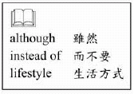

（Ｄ）40.Which is the best title for the reading?
(A) Medicine for Losing Weight.
(B) Tips for Losing Weight Quickly.
(C) Why People Need Weight control.
(D) Safe Ways to Control One’s Weight.
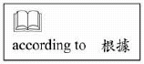
（Ｂ）41.According to the writer, what happens to people who take medicine to lose weight?
(A) The feel unhappy about eating.
(B) Many of them put on weight again.
(C) They cannot concentrate on their work.
(D) Most of them lose too much weight and get sick.
（Ｂ）42.What does Don’t be too strict with yourself mean in the reading?
(A) Eat anything you like when you feel unhappy.
(B) Never try to lose weight in a way that is too difficult.
(C) Try to relax by watching TV or playing computer games.
(D) Don’t feel bad if you have spent a lot of money trying to lose weight.

（43～45）
Here are four ads from newspaper. Read them and answer the questions.
Newly
Opened
Marsha’s House’
Come and enjoy home on your trips.
We offer rooms of different sizes and
Delicious food.
No. 5 Park Road
:543-002

Country Life Market
Our fruits and vegetables
Come in fresh every morning.
Special prices
for the first mouth
Opening hours:10:00 a.m.~10:00 p.m.
No. 3 Clinton Street
Tel: 544-996
Wawa Village
The best school for your dog.
They learn everything here.
＊ Also a nice home them
When you are out of town.
Call 544-471 24 hours
Next Wave Music Store
After 10 years of teaching piano,
Arnold Swenson has made his first CD!
Come and meet him this weekend.
Special presents for the first50 people.
Sat. 7:00 p.m.
Call Diana 543-616

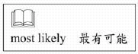
（Ａ）43.Selina’s grandparents are visiting Selina for three days next week. They cannots stay at her place because it is not big enough. Selina is looking for a place for them. Which place will she most likely call?
(A) Marsha’s House.
(B) Country Life Market.
(C) Wawa village.
(D) Next Wave Music Store.
（Ａ）44.Which is true about Arnold Swenson?
(A) He has been a music teacher.
(B) He has sold pianos for ten years.
(C) Most of his piano CDs are popular.
(D) He will give all his fans special presents this weekend.

（Ｃ）45.According to the four ads, which is true?
(A) Wawa village is open only at night.
(B) Marsha’s House does not offer food.
(C) Country Life Market has fresh fruits and vegetables every day.
(D) Next Wave Music Store is going to sell Arnold Swenson’s CD at a special price.

