93學年度國中第二次基本學力測驗 英文領域

第一部分：下列各題（題號1.～20.），請依據題意選出一個正確或最佳的答案。
（Ｂ）1. This sweater looks pretty, but I don’t like its . Do you have a black one?
(A) brand (B) color (C) price (D) size
（Ｄ）2. You’ve studied English for a long time, ?
(A) did you (B) didn’t you (C) have you (D) haven’t you
（Ａ）3. I saw a traffic on my way to school. Many people got hurt.
(A) accident (B) jam (C) light (D) rule
（Ａ）4. My mom asked me several times to send an e-mail to my cousin in England,
but I always to do it.
(A) forget (B) learn (C) try (D) volunteer
（Ａ）5. I like to go shopping in that department store because the there are very polite and nice.
(A) clerks (B) doctors (C) fans (D) passengers
（Ｂ）6. Gina has always been writing. In fact, she likes writing so much that she has decided to be a writer.
(A) embarrassed by (B) found of
(C) safe in (D) worried about
（Ｂ）7. If you are not afraid of talking to strangers, you’ll have more to make friends.
(A) languages (B) opportunities
(C) prescriptions (D) problems
（Ｃ）8. of the students in my school do not have the experience of going to a foreign country. Only a few do.
(A) Any (B) Both (C) Most (D) One
（Ｃ）9. Simon is an interesting person. He gets excited .
(A) easy (B) easier (C) easily (D) easiest
（Ｄ）10.John felt much better he took the medicine the doctor gave him.
(A) if (B) so (C) than (D) after
（Ｄ）11. Mary got two dolls from her grandfather on her birthday, and she liked very much..
(A) her (B) it (C) ones (D) them
（Ｂ）12.Judy moved to France and has lived there two years. I miss her very much.
(A) before (B) for (C) in (D) since
（Ｃ）13.My dog hates to take a bath. It usually me one hour to make him clean.
(A) needs (B) spends (C) takes (D) uses
（Ｂ）14.The singer sings beautifully. I cannot think of anyone with a voice.
(A) best (B) better (C) more (D) most
（Ａ）15.Wily found the novel he bought last week was under is bed.
(A) that (B) where (C) whether (D) which
（Ａ）16.Cindy cried out when she saw a motorcycle into her cat.
(A) bump (B) bumped (C) to bump (D) has bumped
（Ａ）17.Mrs. Li: I think you should take a jacket with you, A-fang. It will get this afternoon.
A-fang: OK, Mom, but where’s my jacket?
(A) cold (B) dark (C) dry (D) fine
（Ｄ）18.George: do you practice playing the piano?
Tommy: When my mom is at home, I have to practice EVERY DAY, but she’s away on a business trip this week!
(A) How about (B) How long
(C) How much (D) How often
（Ｂ）19.Lisa: I hate washing these pants by hand.
Jane: Perhaps we should get a to do it for us. Let’s buy one tomorrow.
(A) factory (B) machine (C) supermarket (D) towel

（Ｄ）20.A-ming: Dad, can I go dancing tomorrow?
Mr. Wu: your homework and we’ll talk about it.
(A) Finishes (B) Finishing (C) To finish (D) Finish

第二部分：下列十個題組，共有25題（題號 21.～45.），請依據選文或所附圖表資料，選出一個正確或最佳的答案。

（21～23）
Last Saturday, I decided to go to a movie in the evening. My little sister said that she wanted to go with me because she was bored at home. When we got to the theater, a lot of people 21 there to buy tickets. I saw a friend in the crowd, so I walked up and talked to him for a while. When we finished talking, I found my sister was gone! I 22 her name loudly and looked for her for thirty minutes. Everyone was looking at me. Finally, I found my sister in a toyshop near the theater. She was playing happily there.
We 23 the movie that night and went home early. I have learned from this experience to be more careful if I have to take my sister out with me again.
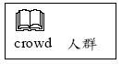
（Ｄ）21.(A) wait
(B) have waited
(C) will wait
(D) were waiting
（Ｃ）22.(A) have called
(B) will call
(C) called
(D) was calling
（Ｃ）23.(A) have not seen
(B) will not see
(C) did not see
(D) were not seeing

（24～26）
Karen was a good basketball player. She was the star of the school team and she was very proud of herself. One day a new student, Linda, came to Karen’s school. Linda was also good at playing basketball, so she was asked to 24 .
Two months later their team was playing an important game. The new student, Linda, kept making good shots. Karen felt unhappy. She wanted people to know 25 ; she wanted to be noticed. So she tried very hard to score baskets.
The coach stopped the game and told Karen that if a player only wants to show off, she might 26 . Karen did not listen. After she went back to the game, she did score several baskets. But their team lost the game in the end.
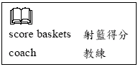
（Ｂ）24.(A) study harder
(B) join the school team
(C) give up her own interest
(D) teach Karen how to swim
（Ｂ）25.(A) she was Linda’s best friend
(B) she could make good shots too
(C) she could follow the game rules
(D) she was paid well to play the game
（Ａ）26.(A) hurt the team
(B) solve a lot of problems
(C) waste too much money
(D) become popular with the fans

（27～28）
There are four classes in Albert Language School. Here are the numbers of students in every class.
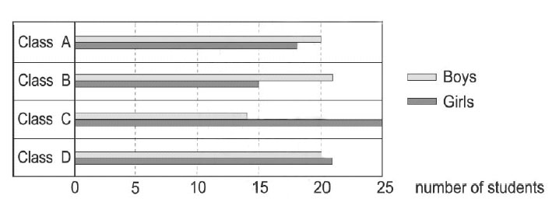
（Ｃ）27. Which class has the most girls?
(A) Class A. (B) Class B.
(C) Class C. (D) Class D.
（Ａ）28. Which classes have more boys than girls?
(A) Class A and Class B.
(B) Class C and Class D.
(C) Class A and Class C.
(D) Class B and Class D.

（29～30）
What do you think is beautiful? Some people believe that long necks are pretty, and some people think full lips look good. Being heavy is thought to be beautiful, too, by some people who do not have enough food. And now it is very popular to be thin. But remember, people are born with differences and everyone is special in some way. Lose weight if you are too heavy, but do not lose yourself at the same time.
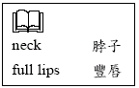
（Ｂ）29. What can we learn from the reading?
(A) It takes a lot of money to lose weight.
(B) Different people have different ideas about what is beautiful.
(C) People who have unusual talents may become popular some day.
(D) More and more people today understand the importance of health.
（Ｃ）30. What does lose yourself mean in the reading?
(A) Stop going on a diet.
(B) Criticize other people.
(C) Forget that you are special.
(D) Fall asleep in your exercise classes.

（31～32）
(It’s December 23. Roger and Terry are talking about the Christmas Eve party.)
Roger: What are you going to wear to the party, Terry?
Terry: I haven’t decided yet. How about you?
Roger: My father has given me a hat. I’ll be a cowboy.
Terry: That’s a good idea. You’ll be the most handsome boy at the party.
Roger: Thank you. Well…do you think Sophie is coming, too?
Terry: Of course! It’s the most important party of the year! Everyone is coming.
Roger: Then, do you think she will notice me?
Terry: I’m sure she’ll want to dance with you, Cowboy!
（Ｂ）31. Who will be a cowboy at the party?
(A) Terry. (B) Roger.
(C) Sophie. (D) Roger’s father.
（Ａ）32. What can we learn from the dialogue?
(A) Roger likes Sophie.
(B) Roger and Terry are brothers.
(C) Terry will not go to the party.
(D) Sophie will not notice roger at the party.

（33～34）
Dear Dad,
I know you are unhappy about the poor grades on my tests this semester. I’m sorry for that. I promise I will study harder next time. But Dad, please, could I study at home by myself? I don’t want to go to the cram school any more. I don’t think it can help me. I promise I won’t spend so much time watching TV and playing computer games. I’ll do my homework every day and use my time well to preview and review every lesson.
Let me try, Dad. I’m sure I’ll do better.
your son,
Fred
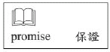

（Ｂ）33.Why did Fred write the letter to his father?
(A) He does not like his teachers at school.
(B) He does not want to go to cram school.
(C) He needs a computer to do his homework.
(D) He hopes his father can spend more time at home.
（Ａ）34. What does that mean in the letter?
(A) Fred did not do well on tests.
(B) Fred did not use his time well.
(C) Fred felt unhappy about his father.
(D) Fred could not promise anything to his father.

（35～36）
Read the poster and answer the questions.

Wu Ma Ma Kitchen

Taiwanese Home-cooked food
Different Dishes Every Day
Your Second Home in Town

8:00 A.M. – 9:00 P.M. Mon.-Fri.
9:00 A.M. – 10:00 P.M. Sat.
(after 8:00 P.M. soup and dessert only)
Closed on the second Monday of every month.

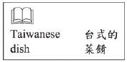
（Ｄ）35.Why would Wu Ma Ma Kitchen be Your Second Home?
(A) It is decorated like your home.
(B) Your can sleep there after dinner.
(C) It can be bought as a second home.
(D) You can relax and enjoy the food just like at home.
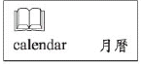
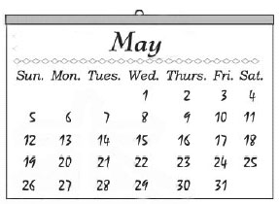
（Ｄ）36.Wu Ma Ma is thinking of taking a trip for two days. She wants to go when her restaurant is not open. Look at the calendar. When will be the best time for her?
(A) May 4 and 5.
(B) May 5 and 6.
(C) May 11 and 12.
(D) May 12 and 13.

（37～40）
Kelly is very special student in my class. Her father is an American, and her mother is a Chinese from Hong Kong. Kelly was born in New York and finished elementary school there. Then the family decided to move to Taiwan because Kelly’s father found a new job in Taipei. Kelly could speak only English, but her parents did not send her to a special school for foreign children. They wanted her to study in a regular junior high school and to make friends with the local students.
Kelly has to work very hard at school. English is easy for her, of course. Math is OK, too. But Chinese and History are big headaches for her because she cannot read the books in Chinese. She often comes to me, her English teacher, to ask questions about Chinese and History. She is trying very hard, and I believe she will do well in Taiwan.
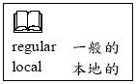
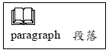
（Ｃ）37.Who wrote the two paragraphs?
(A) Kelly herself.
(B) Kelly’s mother.
(C) Kelly’s teacher.
(D) Kelly’s classmate.
（Ａ）38.Why did Kelly’s family move to Taiwan?
(A) Kelly’s father changed his job.
(B) Kelly wanted to study in foreign country.
(C) Kelly’s parents had many friends in Taiwan.
(D) Kelly’s mother needed to learn Chinese to do business.
（Ａ）39.Who are They in the first paragraph?
(A) Kelly’s parents.
(B) Kelly’s teachers.
(C) Foreign children.
(D) Kelly’s American friends.
（Ｄ）40.What does big headaches mean in the second paragraph?
(A) Useful tips.
(B) Strict rules.
(C) Expensive books.
(D) Difficult subjects.

（41～42）
Read the evening TV schedule and answer the questions.
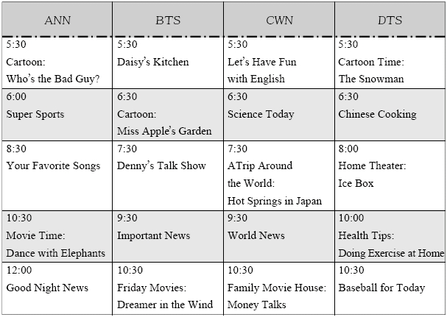
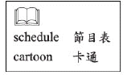
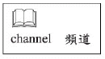
（Ｂ）41.Scott Rossi enjoys watching cartoons. Today he has a math class for one hour at five o’clock. On which TV channel can he watch a cartoon after his math class?
(A) ANN. (B) BTS.
(C) CWN. (D) DTS.
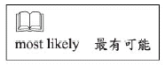
（Ｄ）42.Marian Rossi would like to relax and watch a movie on TV this evening. But she has to go to bed before 10:30 tonight. Which movie will she most likely watch?
(A) Dance with Elephants.
(B) Dreamer in the Wind.
(C) Money Talks.
(D) Ice Box.

（43～45）
Welcome to your favorite radio show, “Music Wonder land”! March 21 will be the 300th birthday of Bach, the Father of Music. So this month we are going to have several special programs on this great man of music.
Johann Sebastian Bach was born in Germany in 1685. During his lifetime, Bach wrote a lot of music for the church and for his students, but he himself did not keep his own works carefully. Luckily, his second wife copied them and saved them for him. So today we can still remember Bach through his music.
Bach married twice in his life and had 20 children altogether. He was a man who loved his family very much. When his first wife planned to learn the piano, he wrote two music books for her. And he also wrote music for one of his daughters to tell her that too much coffee was bad for her health. I am now going to play a song for you from this interesting Coffee Cantata. And we will hear more about Bach after the song.
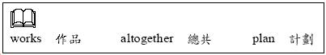
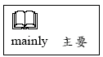
（Ｄ）43.So far, what is this radio show mainly about?
(A) The Bach family history.
(B) Bach’s great church music.
(C) Ways to learn Bach’s music.
(D) Stories about Bach and his music.
（Ａ）44.Why is Bach’s second wife important to his music?
(A) She helped Bach keep his works.
(B) Many of Bach’s works were written for her.
(C) She gave Bach a lot of good ideas about music.
(D) Her money helped Bach concentrate on writing music.
（Ｃ）45.Why did Bach write the Coffee Cantata?
(A) To celebrate his birthday.
(B) To show people his love of coffee.
(C) To tell his child not to drink so much coffee.
(D) To create a new kind of music for the church.
試題結束

