94學年度國中第一次基本學力測驗 英文領域

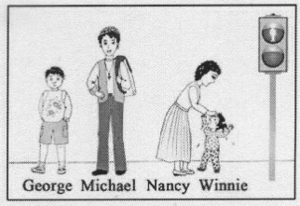
第一部分：下列各題（題號1.～19.），請依據題意選出一個正確或最佳的答案。
（Ｃ）1. Look at the picture. Nancy is .
(A) the tallest
(B) the shortest
(C) taller than Winnie
(D) shorter than George
（Ａ）2. Da-fa is cleaning the house some of his friends are coming for dinner.
(A) because (B) but (C) if (D) so
（Ｂ）3. Don’t forget to your teeth before you go to bed. It’s important to clean them every night.
(A) bite (B) brush (C) count (D) pull
（Ａ）4. My sister does not like the jacket, and I don’t, .
(A) either (B) so (C) too (D) yet
（Ａ）5. I like bread very much and I usually buy my breakfast at the
near my home.
(A) bakery (B) bank (C) fire station (D) post office
（Ｃ）6. She’s going to Europe, she?
(A) doesn’t (B) hasn’t (C) isn’t (D) won’t
（Ａ）7. The of the house is too high. My parents do not have enough money to buy it.
(A) price (B) size (C) space (D) wall
（Ｂ）8. People in this small town are quite to strangers; they always try to help out when strangers are trouble.
(A) careful (B) friendly (C) honest (D) successful
（Ｂ）9. The movie is about a true story happened in Korea in 1945.
(A) it (B) that (C) what (D) when
（Ａ）10.Tina is getting married to a man she has known only a month.
(A) for (B) in (C) on (D) since
（Ｃ）11. There are five stories in this book. The one about a shy police officer is the most to me.
(A) interest (B) interested (C) interesting (D) interestingly
（Ｂ）12.If Frank to the office tonight, give this package to him.
(A) came (B) comes (C) has come (D) will come
（Ｃ）13.It is very dangerous to play . The train may come at any time.
(A) in the airport (B) on the playground
(C) on the railway (D) on the sidewalk
（Ｄ）14. of the books on the desk is about the famous writers of our country.
(A) A lot (B) A few (C) Both (D) One
（Ｂ）15. will be a welcome party next week for the new students. Will you come with me?
(A) It (B) There (C) They (D) We
（Ｄ）16.Sally got angry because her little brother the fan when she was still working on the computer.
(A) cheated (B) closed (C) got off (D) turned off
（Ｄ）17.Susan: It’s getting cloudy
Jamie: I think it’s going to rain.
Susan: I’m glad we have an with us.
(A) airplane (B) eraser (C) example (D) umbrella
（Ａ）18.Tim: Aren’t you hungry?
Emi: No, I’m not. I’m still from lunch.
(A) full (B) strong (C) thirsty (D) tired
（Ａ）19.Judy: The ball game will be on TV tomorrow at six in the morning.
Lucy: up early and you won’t miss it.
(A) Get (B) To get (C) Getting (D) Gets

第二部分：下列十一個題組，共有26題（題號 20.～45.），請依據選文或所附圖表資料，選出一個正確或最佳的答案。

（20～22）
Last night I had a bad dream. In my dream, I 20 to a room by three strange-looking people. They talked to each other in a language I didn’t understand. I didn’t know what they 21 to me. Would they do anything bad? I was so afraid that I started to cry. Suddenly, one of them came up to me and tried to hurt me with a knife. I cried out loudly and then I 22 up. Luckily, there were no people around-I was in my own bed!
（Ｂ）20.(A) am taken
(B) was taken
(C) have been taken
(D) would be taken
（Ｄ）21.(A) are doing
(B) did
(C) have done
(D) would do
（Ｂ）22.(A) wake
(B) woke
(C) was waking
(D) was going to wake

（23～25）
October 25, 2000
Dear Hong-min,
How have you been? It’s been a long time since you wrote me a letter. I miss you a lot.
I started going to 23 in September. My classes begin at 7:00 every evening from Monday to Friday. So far I have studied very hard in every subject. Of all the subjects, math is the most useful to me. Other subjects, like History and Chinese Art, are difficult. 24 is much easier. I’m having a lot of fun with the new language. Maybe I can talk to your American friends some day.
I enjoy my life so much! I almost forget that I am a 60-year old woman, I feel that I am 25 than before.
Best wishes,
Mom

（Ｂ）23.(A) church
(B) high school
(C) a birthday party
(D) a computer class
（Ｂ）24.(A) Math
(B) English
(C) History
(D) Chinese Art
（Ｄ）25.(A) lazier
(B) quieter
(C) thinner
(D) younger

（26～27）
Roger,
Mom and Dad called several times from Tainan when you went to the movies last night. They were very worried because they couldn’t reach you by calling your cell phone. The said you shouldn’t stay out so late. Please call them when you wake up.
I’m going to the library with my classmates and will be home at five.
p.s. Mom and Dad will be back home this Thursday afternoon.
Elva
8:00 a.m. 5/16

（Ｄ）26. Where was Roger when his parents called?
(A) At home.
(B) In Tainan.

(C) In the library.
(D) In the theater.
（Ｃ）27. Look at the calendar. When will Elva’s parents com home?
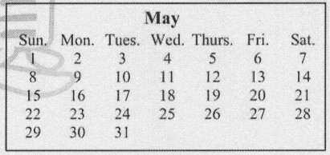
(A) On May 12.
(B) On May 16.
(C) On May 19.
(D) On May 26.

（28～29）
Allen: Every body is talking about Burt’s Dream. Let’s go see the movie n Friday.
Jason: We can’t see the movie. We need to be eighteen to see it.
Allen: Oh… that’s too bad.
Jason: But we can watch White Star.
Allen: I saw it last month. It’s boring.
Jason: Really? How about A cat’s Life or The Roses? I heard they’re good.
Allen: A Cat’s Life? It sounds like fun. O.K. Let’s go see it on Friday.
Jason: The I’ll ask my mom if she is free that day.
Allen: Your mom? Why?
Jason: She said I can’t go to the movies without her before I’m fifteen.
Allen: What? So we’re going to the movie with your mother?
Jason: Or with my dad, you know.
Allen: Oh, no!
（Ｃ）28. Why does Jason’s mother want to go to the movies with him?
(A) She loves watching movies.
(B) She wants to meet Jason’s friends.
(C) She does not think Jason is old enough.
(D) She likes to go shopping near the theater.
（Ｃ）29. If Allen and Jason are going to the movies together on Friday, which movie will they see?
(A) Burt’s Dream.
(B) White Star.
(C) A cat’s Life.
(D) The Roses.

（30～31）
Have Fun & Learn in Little Rabbit
We pick up your children at school
and give them a safe place to play, do
homework, and learn after school.
Experienced Teachers / Lunch & Snacks / Toys & Books
Ages 6 to 12
Our Programs:
＊ Languages ＊Math ＊Computer ＊Music
Open 11:00 a.m. to 7:00 p.m., Mon. to Fri.
26 Market Road , Star City
(between First Street and Second Street, next to the Flower Market)
TEL: 8765-4321
The Most Excellent After-School Programs for Your Children!

（Ｄ）30. What is Little Rabbit?
(A) A children’s zoo.
(B) A children’s library.
(C) An elementary school.
(D) A children’s learning center.

（Ｃ）31. Look at the map. Where is Little Rabbit?
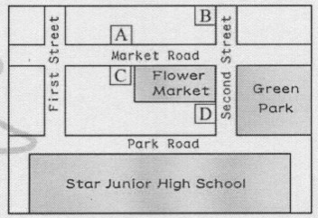
(A) A.
(B) B.
(C) C.
(D) D.

（32～33）
Olivia: Hi, Daniel. I have something to tell you. My brother can’t drive us to sunny City on Saturday. He has to work.
Daniel: Then we’ll have to go by ourselves. Let me check the train schedule. How about if we take the 9:00 train?
Olivia: That’s too early. I don’t want to get up before nine on Saturday morning.
Daniel: Well, then, how about the one at eleven o’clock?
Olivia: I think that would be better. We could have lunch somewhere near the Sunny City Tran Station before we go to the Art Museum.
Daniel: Don’t you think that might make us a little late? We need to be back before five so that we can go to Alice’s party.
Olivia: Oh, I forgot about that. Well, let’s take some sandwiches with us. We can have our lunch on the train.
Daniel: Good idea.

（Ｂ）32. Why are Olivia and Daniel going to Sunny City?
(A) To have lunch.
(B) To go to a museum.
(C) To go to Alice’s party.
(D) To visit Olivia’s brother.
（Ｃ）33.Which train do Olivia and Daniel decide to take to Sunny City?
(A) The five o’clock train.
(B) The nine o’clock train.
(C) The eleven o’clock train.
(D) The twelve o’clock train.

（34～35）
Dear Wendy,
You asked me to send you a picture of my family. Here it is.
The picture was taken in our garden by my cousin. It took me some time to get everyone together. My younger sister, Gigi, was so excited about taking pictures. She made my mom stand between my two brothers, and made my dad walk to the back and then to the front. Finally, she had him sit down under the tree. She even made our dog, Rover, move three times, but Rover did not like the idea of taking pictures, so he ran into doghouse. I am the one behind the doghouse. As for Gigi, can you see where she is?
Karen

（Ａ）34. Which is the picture that Karen sent Wendy?
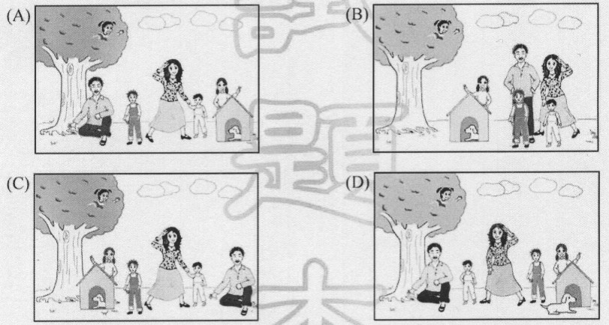

（Ｄ）35.Who is she in the second paragraph?
(A) Karen’s mother.
(B) Wendy.
(C) Karen.
(D) Gigi.


（36～38）
There are some popular singers these days. Many of their fans enjoy getting together to share their love for the stars. My younger sister, Mei-ling, is one of these fans.
Mei-ling is crazy about Rye Kim. She has been in one of his fan clubs since last year. Mei-ling did not have any close friends before, and she always felt lost and lonely. But she has made many friends with the same interests since she joined the club. Now Mei-ling and her friends are planning a big party for Kim’s birthday. Mei-ling is happy, but my dad is not. In fact, he is very worried. Rye Kim is a total stranger to him, and he cannot understand why a man who sings crazy songs can be so important to his daughter. He really hopes that Mei-ling can love her family as much as she loves Rye Kim.
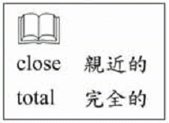
（Ａ）36.Who is Rye Kim?
(A) A singer.
(B) A crazy fan.
(C) Mei-ling’s father.
(D) Mei-ling’s brother.
（Ｄ）37.Which is true about Mei-ling?
(A) She is proud of her beautiful voice.
(B) She always wants to be a movie star.
(C) She is going to have a party on her birthday.
(D) She has changed a lot since she joined a fan club.
（Ｄ）38.Why is Mei-ling’s father NOT happy?
(A) Mei-ling does not have any friends.
(B) Mei-ling is not doing well at school.
(C) Mei-ling is crazy about playing computer games.
(D) Mei-ling is spending too much time on a stranger.

（39～40）
Mr. Adams works from six in the evening to three in the morning, so he cannot see his daughter Cindy very often. He sometimes writes letters to her. Here is a letter he wrote.
Dear Cindy,
I know you like chatting on the Internet. But many people don’t use
their real names on the Internet. Some of them even make up stories about
themselves. Your Internet friends may be very different from what you
think they are. So it could be dangerous for you to go out with them. If, in the future, any of your Internet friends ask you to meet with them, you are welcome to invite them to have dinner with us in our house.
Your mom and I have been very busy these days. We really should
spend more time together. How about if we go to Kenting next weekend?
Love,
Dad



（Ｄ）39.What is the main reason that Mr. Adams wrote this letter? 
(A) To ask Cindy not to get on the Internet.
(B) To invite Cindy’s friends to have dinner at home.
(C) To tell Cindy why he has been so busy these days.
(D) To tell Cindy to be careful about people she meets on the Internet.
（Ｃ）40.Which is true about Mr. Adams?
(A) He knows noting about the Internet.
(B) He usually spends the evening with Cindy.
(C) He is thinking about taking a trip with his family.
(D) He thinks that computers are very useful for students.

（41～42）
Read the first page of the table of contents in this book and answer the questions.

CONTENTS
PREFACE
About This Book ………………………………..1
How to Use This book ………………………….3
PART I Christmas
1. The History of Christmas……………………..8
2. The First Santa Claus…………………………18
PART II Mother’s Day
3. Eng I land’s Mothering Sunday ……………...28
4. The First Mother’s Day……………………….30
PART III Father’s Day
5. How Did Father’s Day Begin? ……………….36
6. Father’s Day in Different Countries…………..43

（Ｂ）41.What is the best title for the book? 
(A) Food for Holidays.
(B) The History of Holidays.
(C) Places to Go on Holidays.
(D) Different Ways to celebrate Holidays.
（Ｄ）42.
“….We don’t know when people started to celebrate it for the first
time. But it is clear that this holiday began a few years after the first Mother’s Day. Some say the idea came from Mrs. Sonora Smart
Dodd. Her father took good care of the six children in her family
after her mother died young. So Mrs. Dodd wanted to show thanks
to her father in the same way people celebrated Mother’s Day….”


In which party of the book would you most likely find these sentences?
(A) PREFACE.
(B) PART I.
(C) PART II.
(D) PART III.

（43～45）
Heartland is a beautiful town in which cars and motorcycles are
not allowed. The town is famous for its blue sky and fresh air. The
weather there is nice and warm all the year, so trees and flowers grow
well in all seasons.
I went to Heartland last month and stayed there for five days.
Every morning I woke up to the songs of birds. Then I would take a
walk or ride a bicycle along the country roads. Orchards and gardens
were everywhere. Flower shops and coffee houses were also on the
way. Every night from my window I could see bright stars in the sky,
and I would go to sleep with the smell of grass.
The five-day holiday in Heartland gave me a lot of surprises. I
hope I can go there again some day and spend more time there.
（Ｂ）43.Why did the writer go to Heartland?
(A) To build a house. (B) To spend a vacation.
(C) To work as a farmer. (D) To give a surprise party.
（Ａ）44.If the writer is talking to friends about Heartland, what will she/he say?
(A) The sky in Heartland is very clear.
(B) Life in Heartland is fast and modern.
(C) Taxis in Heartland are very convenient.
(D) The Christmas snow in Heartland is beautiful.

（Ｃ）45.Which is most UNLIKELY to be found in Heartland?
(A) A shop that fixes bicycles.
(B) A market that sells fresh fruit.
(C) A factory that makes motorcycles.
(D) A coffee shop that also sells flowers.
試題結束

