94學年度國中第二次基本學力測驗 英文領域

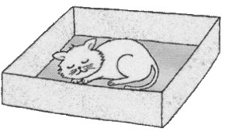
第一部分：下列各題（題號1.～16.），請依據題意選出一個正確或最佳的答案。
（Ｃ）1. Look at the picture. The cat is sleeping the box.
(A) behind
(B) beside
(C) inside
(D) under
（Ｄ）2. The soup is not sweet enough. Can you put some in it?
(A) ice (B) oil (C) salt (D) sugar
（Ｂ）3. When I am hungry, and food looks to me.
(A) common (B) delicious (C) honest (D) simple
（Ｄ）4. The poor man’s wife was very sick. We did not know how to tell him the bad .
(A) example (B) health (C) idea (D) news
（Ｂ）5. There are many trees in the park. of them are over fifty years old.
(A) Both (B) Most (C) Much (D) One
（Ｄ）6. When the teacher was not in the classroom, the students talked loudly and made a lot of she?
(A) excuses (B) heat (C) languages (D) noise
（Ａ）7. Stella is a baseball fan. She more than one hundred pictures of famous baseball players.
(A) has (B) has been (C) is (D) is having
（Ｄ）8. It was very this morning. My hat was blown away when I was walking on the street.
(A) cloudy (B) dry (C) warm (D) windy
（Ａ）9. If finish my homework before eight o’clock, my parents will let me TV for one hour.
(A) watch (B) watching (C) to watch (D) have watched
（Ａ）10.The students got when they saw their favorite movie star eating at the next table.
(A) excited (B) excitedly (C) exciting (D) excitingly
（Ｂ）11. Asking questions Henna learn more and better.
(A) help (B) helps (C) helping (D) to help
（Ａ）12.Our dog always hides food under the ground. She it out when she needs it.
(A) digs (B) hands (C) knocks (D) packs
（Ｄ）13.Sarah: does your little sister get up?
Willy: About six.
(A) How often (B) How old (C) What day (D) What time
（Ｄ）14. Yi-fen: My doesn’t feel very well.
Maria: Maybe you ate too much for breakfast.
(A) computer (B) future (C) hobby (D) stomach
（Ｂ）15.Paul: Shelly’s father a businessman?
Carl: I don’t think so. I remember he teaches English.
(A) Are (B) Is (C) Do (D) Does
（Ｃ）16.Ryan: Would you like to play tennis with me?
Dara: No, thanks. it for three hours already. I’m tired now.
(A) I play (B) I’m playing
(C) I’ve played (D) I’ll play

第二部分：下列十一個題組，共有29題（題號 17.～45.），請依據選文或所附圖表資料，選出一個正確或最佳的答案。
（17～19）
Ms. Li: A-fu, why were you late every day this week?
A-fu: I’m sorry, Ms. Li, but there 17 a traffic jam on Monday morning.
Ms. Li: How about Tuesday and Wednesday?
A-fu: I missed the bus.
Ms. Li: Why did you miss the bus?
A-fu: I 18 very hard and went to bed late.
Ms. Li: If you keep being late, I 19 you dump garbage for the class for one
month!
A-fu: But Ms. Li, I was NOT late this morning!
Ms. Li: No, you weren’t. But why are you still wearing your slippers?
A-fu: What? I…!?
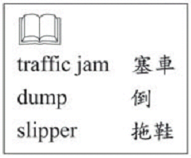
（Ａ）17.(A) was
(B) is
(C) has been
(D) will be
（Ａ）18.(A) studied
(B) am studying
(C) have studied
(D) will study
（Ｄ）19.(A) was making
(B) make
(C) have made
(D) will make
（20～22）
Last Sunday, at about 4 o’clock in the morning, my family and I were woken up by our dog. We were 20 to see smoke every where. Dad ran to the bathroom to get everyone a wet towel, and Mom told us to crawl on the floor. It was hard to see clearly in the dark, but we were very lucky to be able to 21 and get out quickly.
We lost everything in the house. I was very sad. But Mom and Dad said that they were thankful because 22 . Maybe they were right: I did not lose my family-the most important thing in my life. 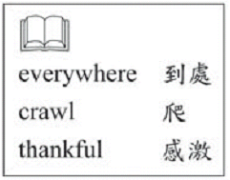
（Ｄ）20.(A) bored
(B) proud
(C) ready
(D) surprised
（Ａ）21.(A) get to the door
(B) check the e-mail
(C) turn off the light
(D) answer the phone
（Ｂ）22.(A) nothing was burned
(B) no one got hurt in the fire
(C) we kept all our money at home
(D) our house was big and comfortable
（23～24）
Dec. 15, 2000
Dear Jenny,
I love Christmas. It’s a season
of giving and getting beautiful cards.
This card was made by my daughter
Julie. Do you like it?
This winter we have a lot of snow
here, but a friend called yesterday and
said that you are still wearing T-shirts
down there.
How will you celebrate Christmas?
Are you going to visit Amy this year?
If so, please say hello to her for me and
Tell her that I miss her wonderful cakes!
Love,
Wendy

（Ａ）23. What should This card look liet?
(A) (B) (C) (D)
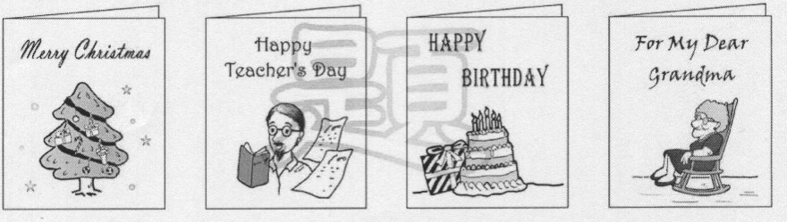

（Ｃ）24. Who makes good cakes?
(A) Jenny.
(B) Julie.
(C) Amy.
(D) Wendy.
（25～26）
Here is a map. Look at it and answer the questions.
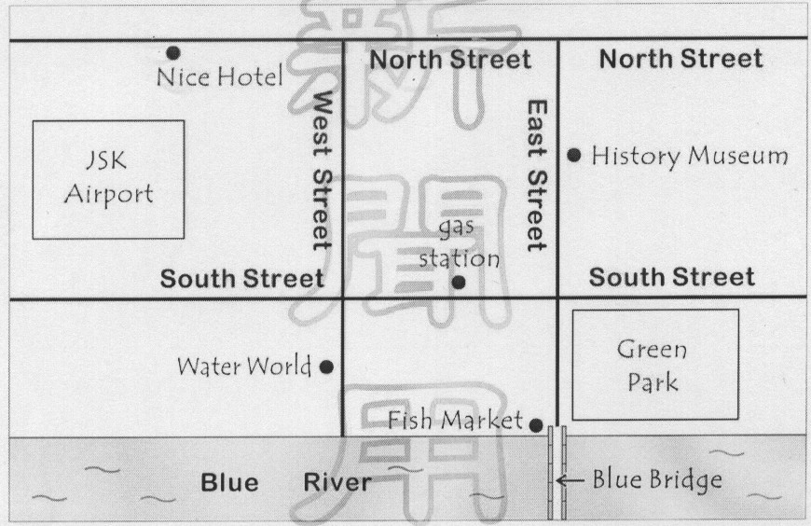

（Ｃ）25. Where is the Fish Market?
(A) It is in the middle of Green Park.
(B) It is on South Street, near the river.
(C) It is on the river bank, next to the bridge.
(D) It is between Nice Hotel and Water World.
（Ｂ）26. Albert is going to drive to the History Museum from the airport, but he needs to go to the gas station first. Which way will he most likely take?

(A) North Street → East Street.
(B) South Street → East Street.
(C) North Street → East Street → South Street.
(D) South Street → East Street → North Street.
（27～28）
(Thomas is visiting Randy.)
Randy: Here’s my room, Thomas.
Thomas: Wow! It’s like a toy store. I bet this really cost a lot of money!
Randy: No, it didn’t.
Thomas: It didn’t? Then, does your father sell toys?
Randy: No, it’s my grandpa. He works in a toy factory. His boss always gives him toys with some defects. Look at this singing doll. It’s pretty, but it can’t sing.
Thomas: How about this truck?
Randy: See the driver in it? His hat is missing.
Thomas: I see. But I still like it. I love toys. I’ve always dreamed about having a room with lost of toys. You’re so lucky.
Randy: If you like, you can come any time to play with them.
Thomas: Really? That’s wonderful!

（Ｄ）27. What does Randy’s grandfather do?
(A) He is a singer.
(B) He is a shopkeeper.
(C) He is a truck driver.
(D) He is a factory worker.
（Ｃ）28. Which is true about Thomas?
(A) He is Randy’s cousin.
(B) He needs a new house.
(C) He loves Randy’s room.
(D) He is too old to enjoy toys.
（30～31）
Read the poster and answer the questions.
Stay at Green Square
100 comfortable rooms / beautiful garden
TV, refrigerator and Internet in every room
parking, breakfast, coffee and tea
Only two minutes’ walk to the beach
Ten minute’s to Rainbow Lake
Enjoy a wonderful vacation at the beach
swimming fishing boating
50 Green Road
Rainbow Town
TEL:888-4545

FREE



（Ａ）29. What is Green Square?
(A) A hotel. (B) A park.
(C) A restaurant. (D) A department store.
（Ｃ）30. Look at the map. Where is Green Square?
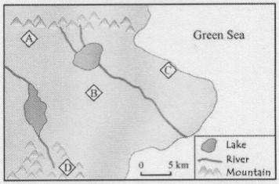
(A) A.
(B) B.
(C) C.
(D) D.

（31～32）
Dear Sir,
I ordered a shirt from you last month. But there are some
problems with it. First, the color is not as read as it shown in the
catalogue. I understand that the picture does not always show the
real color, but it should not be that different. Second, I asked for a
medium size because it is the size I usually wear. But your medium
is so small that I have to give it to my younger brother.
I think you should be more serious about your business.
Truly,
Adam Rosen

Dear Mr. Rosen,
Thank you for telling us the problems with your order. We
hope we can give you better service. We are sending you another
shirt with this letter. It is size large, and its red color is brighter than
the one you had. We hope you like it.
Our office hours are 9:00 a.m. – 5:00 p.m. Please call us if you have any more questions.
Yours truly,
Victor Smith


（Ｃ）31. Why does Adam Rosen write the letter?
(A) To say sorry to his brother.
(B) To talk about his problems with a friend.
(C) To show how he feels about what he bought.
(D) To find out the business hours of a new store.
（Ｂ）32. What does Victor Smith do for Adam Rosen?
(A) He finds a job for him. (B) He mails him a new shirt.
(C) He gives him a camera. (D) He draws a picture for him.

（33～35）
Susan was a woman who hated animals. She never wanted to keep any pets at home. To her, all animals were dirty and boring. Susan could never understand why people would like to have cats or dogs in the house. It was so stupid!
Last month Susan’s daughter, Penny, came home from school with a mouse in a box. Susan was very angry. But Penny said that it was her homework. Her teacher asked each student to take care of an animal and learn to get along with it. Susan had to say yes.
It was fun for Penny at the beginning, but then she got lazy and forgot to do her homework. It became Susan’s homework. She gave it food and water every day and found that the mouse was in fact not dirty. She even talked to it! It was not boring or stupid! Now Susan is having a good time with “her” mouse. She named it Nini. And she is going to buy another one to make a pair.
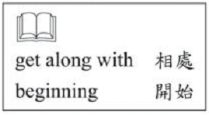
（Ｃ）33.Why was Susan so angry when she first saw the mouse?
(A) The mouse bit her.
(B) She like cats better.
(C) She did not want any animals in her house.
(D) The mouse was the animal she hated most.
（Ｃ）34.What happened to the mouse in the end?
(A) It got sick.
(B) It had a baby.
(C) It became Susan’s pet.
(D) It was sent to a pet shop.

（Ｂ）35.What does her mean in the second paragraph?
(A) Susan’s.
(B) Penny’s.
(C) Penny’s teacher’s.
(D) Penny’s Classmate’s.

（36～38）
Diana: Here we are at the Grand Shopping Center.
Bruce: Great! There are so many things I’d like to see.
Diana: It will be fun for you, but not for me.
Bruce: Come on. I’m sure you can enjoy yourself when I’m shopping.
Diana: OK, OK. I’ll wait for you at Jones’ Coffee House. Is three hours enough for you?
Bruce: I think so. But where’s the coffee shop?
Diana: just go along this hallway and you will see a snack shop. Take a right turn, and the coffee shop is at the end of the hallway. Remember to come meet me at 4 p.m., please.
Bruce: Sure! Grand shopping Center, here I come!
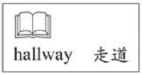

（Ｂ）36.What can we learn from the conversation?
(A) Bruce works at the snack shop.
(B) Diana does not want to go shopping.
(C) Bruce and Diana are brother and sister.
(D) Diana drinks three cups of coffee every day.
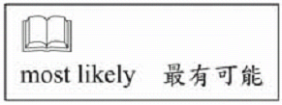
（Ａ）37.At what time did Diana and Bruce most likely arrive at the shopping center?
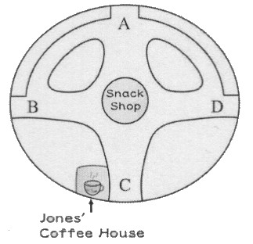
(A) 1 p.m.
(B) 3 p.m.
(C) 4 p.m.
(D) 7 p.m.
（Ｂ）38.Look at the map. Where were Diana and Bruce standing when they were having this conversation?
(A) A.
(B) B.
(C) C.
(D) D.

（39～41）
I was jogging with my dog this morning when I saw John Archer at a street corner. He was sitting on a bike with one of his feet on the ground. “He’s waiting for someone,” I thought. John and I were both in the ninth grade. He was a basketball player on our school team and was very popular with many girls. But I never talked to him before. He was not my type.
John saw me, too. He smiled. For a moment I thought he was smiling at someone else. But he was not. “Hi, Mary Jones,” he said to me. “You have a cute little dog.” I smiled but did not say anything, because I did not know what to say. “I’m here waiting for you. Would you…would you like to go to the movies with me?” he asked. I was very surprised. I never thought he would do this, and I never thought about going out with him.
I said “no,” of course. But he seemed nice and friendly. Maybe I would go to watch him play basketball some day. 
（Ｄ）39.What was John doing on the street when Mary saw him?
(A) Jogging.
(B) Talking to a girl.
(C) Riding a bicycle.
(D) Waiting for someone.
（Ｄ）40.What does this mean in the second paragraph?
(A) Smiling at Mary’s dog.
(B) Being surprised to see Mary.
(C) Playing basketball with Mary.
(D) Asking Mary to go to a movie.

（Ａ）41.What do we know about John and Mary from the reading?
(A) They are in the same school.
(B) They like each other very much.
(C) They are both interested in movies.
(D) They both enjoy jogging in the morning.
（42～45）
Read the first page of the table of contents in this book and answer the questions.
Tony and Peter Coming Back
Remember Tony and Peter, the twin brothers who started singing at the age of five? The little boys are now twenty-five years old and will come back home for the first time since they left ten years ago. They will be singing to celebrate the 100th birthday of our beautiful town.
Tony and Peter are famous for their wonderful voices. They
are popular with both young and old people. Three years ago the brothers organized the Garbage Can with their three cousins.
The five of them stated to write their own their own songs and
have become successful. In the coming concert in Greentown,
the Garbage Can is going to sing their best-loved songs and several new ones.
The concert will be at Apple Park at 7 p.m. on October 10.
Fans who do not want to miss it should get to the park as early as possible.


（Ｃ）42.How old were Tony and Peter when they left Greentown?
(A) 5. (B) 10. (C) 15. (D) 25.
（Ｄ）43.What is Garbage Can?
(A) A song. (B) A town. (C) A music show. (D) A singing group.
（Ｃ）44.What does ones mean?
(A) Fans. (B) Parks. (C) Songs. (D) Voices.
（Ｄ）45.Which is NOT true about Tony and Peter?
(A) They sing with their cousins.
(B) They are going to sing at Apple Park.
(C) They began to sing when they were very young.
(D) They are celebrating their birthday in Greentown.
試題結束

