95學年度國中第一次基本學力測驗 英文領域

第一部分：下列各題（題號1.～20.），請依據題意選出一個正確或最佳的答案。
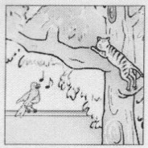
（Ｂ）1. Look at the picture. What is the cat doing?
(A) Singing.
(B) Climbing a tree.
(C) Playing with a toy.
(D) Jumping down the wall.
（Ａ）2. This water is to hot to drink. Let’s put some in it?
(A) ice (B) oil (C) salt (D) sugar
（Ｃ）3. Lucy looks in pants than in a dress.
(A) pretty (B) prettily (C) prettier (D) the prettiest
（Ｄ）4. Spring is a wonderful season because is usually warm and sunny.
(A) which (B) this (C) one (D) it
（Ａ）5. Andrew spends long hours studying every night. He is a(n)
student.
(A) hard-working (B) honest (C) lucky (D) polite
（Ｄ）6. There are several in your workbook. You should correct them before you go to bed.
(A) chances (B) erasers (C) groups (D) mistakes
（Ｄ）7. With the new bridge, life in this town will become more
.
(A) useful (B) boring (C) serious (D) convenient
（Ａ）8. Mr. and Mrs. Jones are crazy about dolls. In the past three years. They have more than one hundred dolls.
(A) collected (B) guessed (C) practiced (D) repeated
（Ｂ）9. You’ve had the same food for breakfast for one week. Do you wants something for a change?
(A) bright (B) different (C) helpful (D) round
（Ｃ）10.At first, my bookstore’s business not very good. But now it is doing quite well.
(A) is (B) does (C) was (D) did
（Ｂ）11. This TV program helps us get some of other countries. I’ve learned a lot from it.
(A) exercise (B) knowledge (C) light (D) traffic
（Ｃ）12.Jacky would like to bring that poor dog back home, but he isn’t sure his mother likes dogs.
(A) how (B) what (C) whether (D) which
（Ｂ）13.All the packages are checked at the airport to keep every one safe.
(A) careful (B) carefully
(C) more careful (D) the most careful
（Ｄ）14. My brother doesn’t live with us. He out after he got married.
(A) has moved (B) will move
(C) was moving (D) moved
（Ｄ）15.Susan: Do you know you have talked on the phone? Aren’t you thirsty?
Walter: Oh, come on! I’ve only talked for thirty minutes!
(A) how old (B) how often
(C) how many (D) how long
（Ｃ）16.Tim: Can you see what the word is? The first is not clear.
Ann: Oh, it’s “r.” The word is “ring.”
(A) idea (B) lesson (C) letter (D) sound
（Ｂ）17.Alice: Have you ever been to a baseball game?
Jamie: No, never.
Alice: Sure. Baseball is my favorite sport.
(A) Do you? (B) Have you?
(C) Don’t you? (D) Haven’t you?
（Ｃ）18. Tony: Will you go to Cindy’s party tonight?
Jane: No, I have to do my homework. Don’t you have ?
Tony: Well, I already finished it at school.
(A) you (B) your (C) yours (D) you’re
（Ａ）19.Wendy: do you know where the library is?
Simon: Just going for two more blocks and you’ll see it.
(A) keep (B) to keep (C) keeping (D) keeps
（Ｃ）20.Mike: Oh, no! I my cell phone on the train.
Alan: Let’s call the station and ask if anyone has found it.
(A) broke (B) carried (C) left (D) used

第二部分：下列十個題組，共有25題（題號 21～45），請依據選文或所附圖表資料，選出一個正確或最佳的答案。
（21～23）
Shu-fen is in her third year of junior high school. She has many tests every day, but she does not even want to look at her books. Shu-fen was not like this before. In fact, she 21 studying during her first two years of high school and always got high grades on test. She was happy then.
But these days Shu-fen always feels tired and bored. There 22 so many tests that Shu-fen cannot relax and do the things she likes. But what can she do? She can only tell herself that things 23 better after she starts senior high school
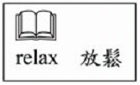
（Ｂ）21.(A) enjoys (B) enjoyed
(C) has enjoyed (D) will enjoy
（Ａ）22.(A) are (B) were
(C) would be (D) are going to be
（Ｄ）22.(A) get (B) got
(C) have got (D) will get

（24～25）
Mrs. Lin: Hong-kai! It’s twelve o’clock already! Are you going to stay in bed all day long?
Hong-kai: Mom, it’s Sunday! And we don’t have any homework this weekend.
Mr. Lin: That’s great! Then you can 24 after lunch, can’t you?
Hong-kai: OK, but I think I should be paid for that. How about ten dollars for cleaning my room and five for taking out the garbage?
Mr. Lin: No problem. But I cleaned your room and took out the garbage yesterday. I think I should 25 , too. Now, come on! Get up!
（Ｃ）24.(A) study English
(B) play the piano
(C) clean the house
(D) go out for a walk
（Ａ）25.(A) get 15 dollars
(B) wait for 15 days
(C) lose 15 kilograms
(D) get up 15 minutes earlier
（26～27）
Here is a map and a train schedule from West Town to South End.
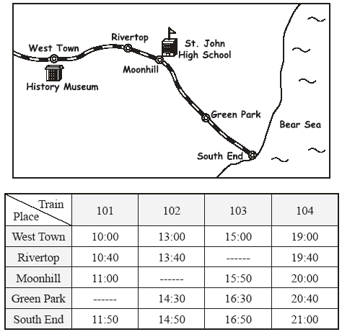
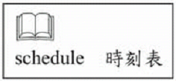
（Ｂ）26. Elsa lives in Green Park. She took the train to the beach and met her friend there at 3:00 p.m. Which train did she take?
(A) 101.
(B) 102.
(C) 103.
(D) 104.
（Ｃ）27. Class 2A of St. John High School went to the History Museum yesterday and spent all morning there. Later, they took the train and got back to school at 4:10 p.m. Which train did they take?
(A) 101.
(B) 102.
(C) 103.
(D) 104.
（28～30）
Mei-ting is from a small village in Nantou. Last week she and her brother came to Kaohsiung to stay with their grandparents. Their house in Nantou fell down in a terrible typhoon. Their parents had to stay in Nantou to take care of their little sister in the hospital. She was seriously hurt when the house fell down.
Mei-ting and her brother now go to a new school in Kaohsiung. Everyone in the school is nice to them, but Mei-ting feels sad because they have to stay in Kaohsiung for a long time, until their new house is built. She misses her classmates in Nantou very much. They are wonderful friends, and their letters have made her feel much better. Mei-ting also misses her parents and her little sister. She hopes she can see them again soon.
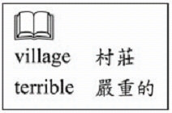
（Ｂ）28. Why did Mei-ting leave her home?
(A) Her parents sold their house.
(B) Her family lost their house in a typhoon.
(C) She got hurt and needed a better doctor.
(D) She wanted to go to a bigger school in the city.
（Ｂ）29. Where are Mei-ting’s parents?
(A) In Taipei.
(B) In Nantou.
(C) In Kaohsiung.
(D) In a foreign country.
（Ｄ）30. Who are They?
(A) Mei-ting’s grandparents.
(B) Me-ting and her brother.
(C) Mei-ting’s friends in Kaohsiung.
(D) Mei-ting’s classmates in Nantou.

（31～32）
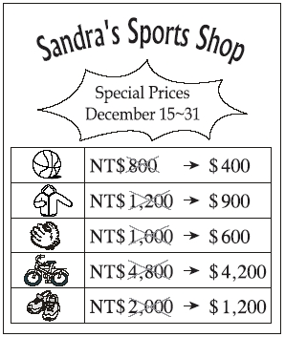
（Ａ）31. Today is December 28. Melody is interested in the things on sale at Sandra’s sports Shop. She has 1,700 NT dollars and she has decided to buy a pair of sports shoes. What else can she buy?
(A) A basketball.
(B) A jacket.
(C) A baseball glove.
(D) A bicycle.
（Ｃ）32. Mr. Chen went to Sandra’s Sports Shop two times in December. He bought a bicycle for his son as a birthday present on December 3. On December 17, he went there again to buy a jacket for his daughter. How much did he spend at Sandra’s Sports Shop in December?
(A) NT$5,100.
(B) NT$5,400.
(C) NT$5,700.
(D) NT$6,000.

（33～35）
Billy: Roger and I are going to have dinner at Silver Hut. Do you want to join us?
Carl: When are you going?
Billy: Saturday.
Carl: I’d like to, but my sister and I are going biking in Rose Park this Saturday. Maybe next time.
Billy: Oh, OK. But you’ve been to Silver Hut, right? I always hear people say good things about it. Is it really that good?
Carl: Oh, yes. They have great tea, great snacks, and great music. Lots of high school students like to go there. Oh, don’t forget to order the nomisini.
Billy: Nomisini? What’s that?
Carl: It’s a bag of chocolate balls with butter inside, and tastes good with tea.
Billy: It sounds great. I can’t wait for Saturday to come.
（Ｄ）33.Which is true about Silver Hunt?
(A) It is inside a park.
(B) It is a bicycle shop.
(C) It is closed on Sundays.
(D) It is popular with teenagers.
（Ｄ）34.What is nomisini?
(A) A song.
(B) A drink.
(C) A game.
(D) A snack.
（Ｃ）35.Why isn’t Carl going to Silver Hut?
(A) He does not like the place.
(B) He has never heard of the place.
(C) He and his sister already have plans.
(D) He does not want to go there with Billy.

（36～38）
Here is an ad. Read it and answer the questions.
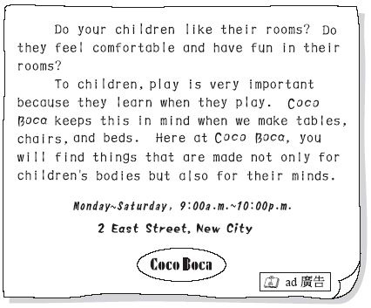
（Ａ）36.What can be bought at Coco Boca?
(A) Beds for children.
(B) Uniforms for students.
(C) Pets that children can play with.
(D) Health food that helps kids grow well.
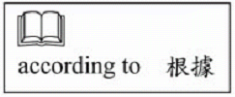
（Ａ）37.According to Coco Boca’s ad, which is true?
(A) Children learn from playing.
(B) Children should sleep in their own rooms.
(C) A large space is good for children’s health.
(D) Parents should spend more time with their children.

（38～40）
A-tong: I’m back.
Mr. Wu: Hi, A-tong. How was your school trip?
A-tong: Great! My teacher took us to Blue Water Zoo. It was so much fun. My classmates and I had a very good time. Dad, do you know what Mola mola is?
Mr. Wu: I have no idea. What is it?
A-tong: It’s the most interesting fish I’ve every seen. It looks like it has a big head but doesn’t have a body. It’s so special. I hope you can see it, too. There are so many interesting fishes and sea animals in the water zoo.
Mr. Wu: It sounds interesting. Maybe we can find time to go there together. We can also take Grandpa and Grandma with us.
A-tong: How about next Friday? It’s a holiday. You don’t have to go to work, right?
Mr. Wu: Right. Call Grandma to see if she and Grandpa have time on Friday.
A-tong: Yeah!
（Ｄ）38.What may Mola mola look like?
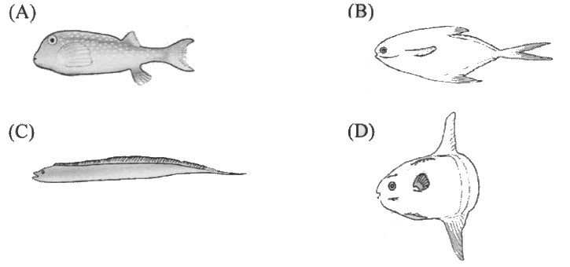
（Ａ）39.Who is Mr. Wu?
(A) A-tong’s father.
(B) A-tong’s friend.
(C) A-tong’s teacher.
(D) a-tong’s grandpa.
（Ｂ）40.What does there mean?
(A) A-tong’s school.
(B) Blue Water Zoo.
(C) Mr. Wu’s office.
(D) Grandparents’ house.
（41～42）
In Andy’s diaries, he wrote about his vacation in July.
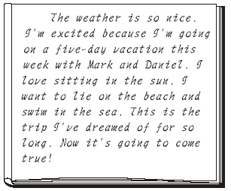
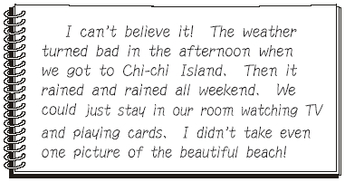
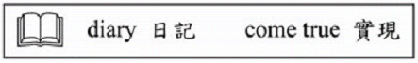
（Ｂ）41.Which is true about Andy’s vacation?
(A) The beach he visited was dirty.
(B) It was different from what he wanted.
(C) He enjoyed playing cards in his room.
(D) The weather was too hot for him to stay outside.
（Ｃ）42.Look at the calendar and the weather of Chi-chi Island for the month of July. According to Andy’s diaries, when did he and his friends get there?
(A) On July 2. (B) On July 4.
(C) On July 16. (D) On July 19. 
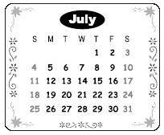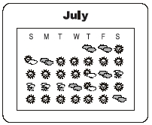

（43～45）
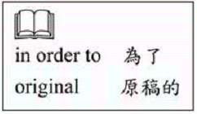
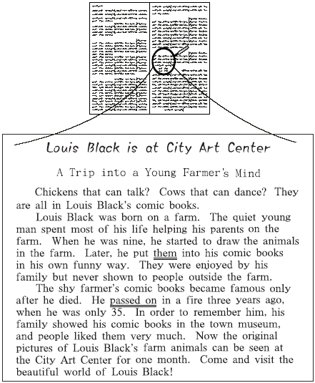
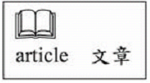
（Ｂ）43.What is this article for?
(A) Planning a trip to visit a farm.
(B) Telling people about an art show.
(C) Celebrating the opening of a museum.
(D) Sharing ideas about how to draw comic books.
（Ａ）44.What does them mean?
(A) Animals in the farm.
(B) Louis Black’s family.
(C) People outside the farm.
(D) Louis black’s comic books.
（Ａ）45.What does passed on mean?
(A) Died.
(B) Grew up.
(C) Got married.
(D) Became a farmer.
試題結束

