95學年度國中第二次基本學力測驗 英文領域

第一部分：下列各題（題號1.～19.），請依據題意選出一個正確或最佳的答案。
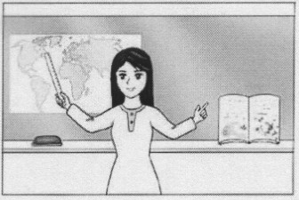
（Ｄ）1. Look at the picture. What is the teacher holding in her had?
(A) A book. (B) An eraser.
(C) A map. (D) A ruler.
（Ｂ）2. I enjoy going swimming. It is my favorite .
(A) group (B) sport (C) excuse (D) dream
（Ａ）3. It’s enough here. I don’t think we need a lamp.
(A) bright (B) clean (C) quiet (D) safe
（Ａ）4. My younger sister likes best of all the animals.
(A) lions (B) oranges (C) spoons (D) tennis
（Ｄ）5. Mr. Thomas gets a lot of cards and flowers from his students on Teacher’s Day every year; he is really a teacher.
(A) careful (B) crazy (C) lonely (D) popular
（Ｃ）6. My grandpa is good at cooking and he always a big meal for us when we visit him.
(A) burns (B) collects (C) prepares (D) welcomes
（Ｂ）7. Mr. Green was very angry with his daughter she always put her dirty socks on the dinning table.
(A) although (B) because (C) but (D) until
（Ｄ）8. Working all day on the computer makes my eyes really
.
(A) bored (B) hard (C) slow (D) tired
（Ａ）9. If we take the 2:00 train, we’ll in Taichung at 4:30.
(A) arrive (B) belong (C) drop (D) park
（Ｂ）10.Tina hamburgers for lunch every day last week.
(A) has (B) had (C) has had (D) was having
（Ｄ）11. Mr. Yang has worked in this factory 1968.
(A) before (B) for (C) in (D) since
（Ｂ）12.The movie star does not like his family to in public places with him; he does not want people to know who they are.
(A) agree (B) appear (C) cheat (D) decide
（Ｂ）13.Most of Jeff’s best books when he was sick and poor.
(A) have written (B) were written (C) would write (D) wrote
（Ｃ）14. I like to read comic books me laugh.
(A) made (B) to have made (C) that make (D) which makes
（Ａ）15.Kevin: sweater looks better on me, the red one or the blue one?
Betty: The red one, I think.
(A) Which (B) How (C) Where (D) What
（Ａ）16.Judy: I’m thirsty. Can we get something to drink?
Terry: Sure. There’s a just one block away from here. Let’s go there and buy some juice.
(A) supermarket (B) restroom
(C) post office (D) fire station
（Ｃ）17.Grace: How many people in the office when the ire happened?
Harry: Five. Luckily, nobody got hurt.
(A) did they (B) had they
(C) were there (D) would there be
（Ｄ）18. Alice: This cake is so delicious! Where did you buy it?
Oscar: I didn’t buy it. I made it !
(A) for me (B) to me (C) mine (D) myself
（Ｂ）19.Sam: you have a good time at Mr. Moore’s house tonight?
Tom: Yes. It was a wonderful party. I’m glad I went.
(A) Do (B) Did (C) Will (D) Would

第二部分：下列十個題組，共有26題（題號 20～45），請依據選文或所附圖表資料，選出一個正確或最佳的答案。
（20～22）
When Marcy was a little girl, her parents were always worried about not having enough money. Their sad faces made her decide to help, so she left school and 20 to work at the age of fifteen. Since then, she has done many different jobs. Most of the jobs did not pay well, but she tried her best in all of them and learned a lot.
Marcy is not thirty years old, and her family has a better life. But Marcy’s friends keep telling her that she should learn to make more money. They 21 her several ways, but she has not tried any of them. She is not interested in anything risky. What she wants most now is to go back to school. She knows she 22 really happy if she can be a student again.
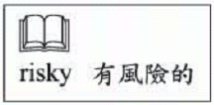
（Ｂ）20.(A) starts
(B) started
(C) has started
(D) will start
（Ｃ）21.(A) are teaching
(B) were teaching
(C) have taught
(D) will teach
（Ｄ）22.(A) is
(B) was
(C) has been
(D) will be

（23～24）
Angela: Excuse me, sir. I think I’m lost. Can you help me?
Mr. Brown: Sure. Where are you going?
Angela: To Animal Star Theater.
Mr. Brown: OK, let’s take a look at your map. Here we are at the bus stop on Meadow Road. See? So you should 23 and turn left on Lake Road. It’s next to Water World.
Angela: And do you know where 24 is? My parents will be waiting for me there late.
Mr. Brown: Oh, it’s also on Lake Road. Walk past Finny School, and you’ll see it.
Angela: Thank you very much!
Mr. Brown: No problem. 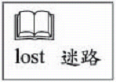
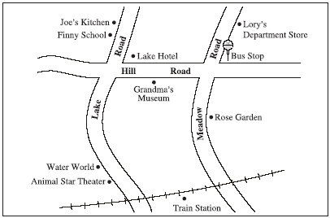
（Ａ）23.(A) go along Hill Road
(B) go to the train station first
(C) walk down Meadow Road
(D) walk to Lory’s Department Store
（Ｃ）24.(A) Lake Hotel
(B) Rose Garden
(C) Joe’s Kitchen
(D) Grandma’s museum

（25～26）
Here is the menu of Yummy Restaurant. Look at it and answer the questions.

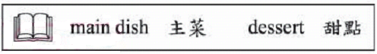
（Ｂ）25. Helen usually orders a fish, a vegetable soup and a cup of coffee for lunch at Yummy Restaurant. If she orders Today’s Special, how much can she save?
(A) NT$30. (B) NT$40. (C) NT$50. (D) NT$60.
（Ｄ）26. Michael loves beef and wants to have only beef for dinner today. If he orders on main dish and one soup, how much does he need to pay?
(A) NT$180. (B) NT$200. (C) NT$210. (D) NT$230.

（27～28）
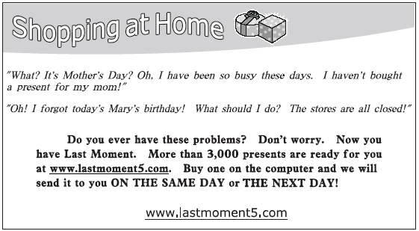
（Ｃ）27. Who may need the service of Las Moment most? 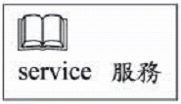
(A) Ian. He plans to buy a new house in the future.
(B) Amy. She enjoys going shopping in department stores.
(C) John. He wants to buy a gift for his wife on the Internet.
(D) Elsa. She is looking for a computer store near her house.
（Ｂ）28. Allen enjoys the service of Last Moment. Which may be the main reason?
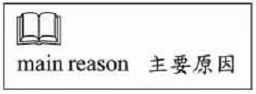
(A) It is old and famous.
(B) It is fast and convenient.
(C) He will have a chance to meet new friends.
(D) He will get a surprise package on his birthday.

（29～30）
Tomorrow’s Weather Forecast for Fishland
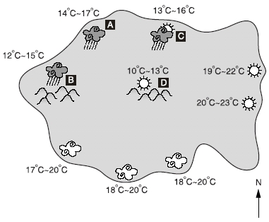
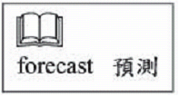
（Ｄ）29. What will the weather be like tomorrow in the south of Fishland?
(A) It will rain.
(B) It will snow.
(C) It will be sunny.
(D) It will be cloudy.
（Ｂ）30. This forecast is for Fishland:
Tomorrow is the first day of this year’s Flower Festival. But
if you are planning on going to the Ru Mountains to enjoy
the flowers, remember to bring an umbrella. Today will be the
last sunny day we have this week. Tomorrow it will start
raining.

Which part of Fishland is the forecast talking about?
(A) A (B) B (C) C (D) D

（31～32）
(Robert and Danny are talking in their office.)
Robert: I’m going on a vacation this summer.
Danny: Where do you plan to go?
Robert: Well, Jenny would like to go to Hawawa.
Danny: It’s a great place for a family trip! And you’re taking the dogs on the trip again?
Robert: Sure, that’s much more fun, isn’t it? Doris and David go everywhere with us. We’ve had great times together.
Danny: How about the hotel? Do you have any idea of where to stay?
Robert: We’ll stay at Hawawa Hotel. It opened this spring, and my parents went there once. It has many large rooms, but it’s not very expensive. And there are beautiful beaches around it. The best thing is that they allow dogs in the room.
Danny: It sounds wonderful. Don’t forget to show me some pictures when you come back.
Robert: No problem! 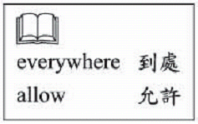
（Ｃ）31. Which is true about Hawawa Hotel?
(A) It is new and expensive.
(B) It is a hotel with hot springs.
(C) It is a hotel with nice beaches.
(D) Its rooms are small but comfortable.
（Ａ）32. Who are Doris and David?
(A) Robert’s dogs.
(B) Robert’s parents.
(C) Robert’s children.
(D) Robert’s friends in Hawawa.
（33～34）
Look at the poster and answer the questions.
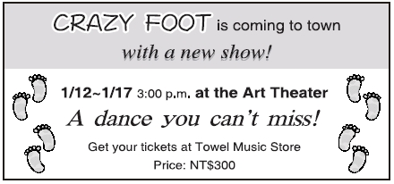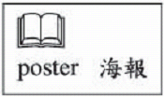
（Ｄ）33.What is CRAZY FOOT?
(A) A movie.
(B) A music band.
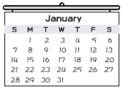
(C) A TV program.
(D) A dance group.
（Ｃ）34.Lina works 9:00 a.m. to 5:00 p.m. every day except Sunday. Look at the calendar.
When can she go to the show?
(A) Jan. 7.
(B) Jan. 13.
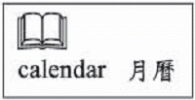
(C) Jan. 14.
(D) Jan. 20.

（35～36）
Rui-yi went to see a doctor and got this one-week prescription:
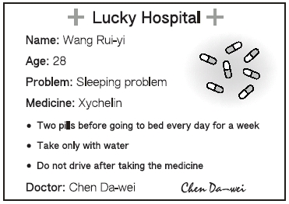
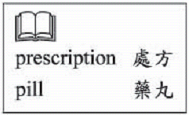
（Ｄ）35.How can Xychelin help Rui-yi?
(A) To eat more.
(B) To see better.
(C) To get thinner.
(D) To sleep better.
（Ｃ）36.How many pills of Xychelin did Rui-yi get?
(A) 2.
(B) 7.
(C) 14.
(D) 28.

（37～39）
(A-hui comes home from work and sees his mother standing at the door.)
A-hui: Hey, Mom. You look worried. Anything wrong?
Mrs. Liu: Your sister hasn’t come back yet. She never comes home later than five-thirty.
A-hui: It’s ten to six now. Did you call the school?
Mrs. Liu: I did. They said Mei-ling left at four-thirty.
A-hui: How about her classmates? We should call them.
Mrs. Liu: I’ve called five of them, and they all have no idea where she is.
A-hui: Let me get my bicycle. I’ll ride around and look for her.
Mrs. Liu: Aren’t you going to have dinner with your girlfriend tonight? You might be
late.
A-hui: Don’t worry, Mom, I’ll call her later. It’s more important to fine Mei-ling. Why don’t you go inside and wait? Mei-ling might call home at any time.
Mrs. Liu: You’re right, and I should call more of her classmates. Ride carefully, OK?
A-hui: I will, Mom.
（Ｂ）37.What is Mrs. Liu worried about?
(A) Her son is riding his bicycle.
(B) Her daughter has not come home.
(C) Her son has not been able to find a job.
(D) Her daughter is not doing well at school.
（Ｄ）38.What has Mrs. Liu done about her problem?
(A) She went biking.
(B) She talked to her friends.
(C) She tried to get more sleep.
(D) She made several phone calls.
（Ｃ）39.Whi is her?
(A) Mei-ling.
(B) Mrs. Liu.
(C) A-hui’s girlfriend.
(D) Mei-ling’s classmate.

（40～42）
My Uncle Jim does not talk much. He is always painting when he is at home. He paints after work and on weekends. Painting is his best friend and his life.
Uncle Jim does not paint for money; he has never sold any of his pictures. There are no people in his pictures. He only draws trees and mountains, but they are not like the ones we see in the real world. They have strange shapes and colors. I do not quite understand Uncle Jim’s pictures, and he never tells us what he is trying to say with them. But I still like them a lot. To me, Uncle Jim has created a different but interesting world.

（Ｃ）40.What kind of person does the writer think Uncle Jim is?
(A) Wise but lazy.
(B) Rich and proud.
(C) Quiet but special.
(D) Young and handsome.
（Ａ）41.What does painting mean to Uncle Jim?
(A) It is a hobby that gives him joy.
(B) It is a chance for him to become famous.
(C) It is a business that makes money for him.
(D) It is the way for him to forget about his bad health.
（Ｄ）42.What does they mean in the reading?
(A) Shapes and colors.
(B) The writer’s family.
(C) Uncle Jim’s friends.
(D) Trees and mountains.

（43～45）
Katie wrote a letter to her English teacher and got a reply from him. Read their letters and answer the questions.
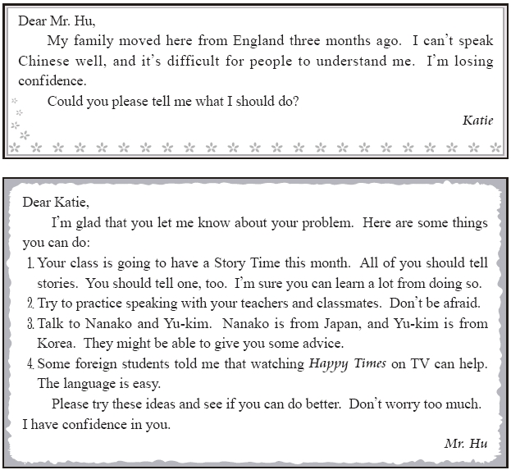
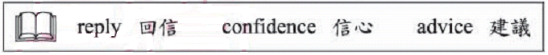
（Ｃ）43.What is Katie’s problem?
(A) She is taking too many classes.
(B) She misses her parents in England.
(C) She is not good at the new language.
(D) She thinks the teachers are too serious.
（Ａ）44.Mr. Hu tries to help Katie in many ways. Which is NOT said in his letter?
(A) Writing a letter every day.
(B) Watching a TV program.
(C) Telling stories in class.
(D) Talking to other foreign students.
（Ａ）45.What language is used in Happy Times?
(A) Chinese.
(B) English.
(C) Japanese.
(D) Korean.
試題結束

