96學年度國中第二次基本學力測驗 英文領域

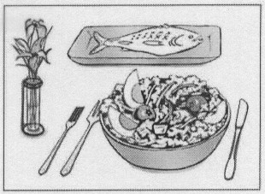
第一部分：下列各題（題號1～18），請依據題意選出一個正確或最佳的答案。
（Ｄ）1. Look at the picture. What is the bowl?
(A) Fish.
(B) Flowers.
(C) Forks.
(D) Salad.
（Ａ）2. The doctor said the woman might become because her eyes were badly hurt.
(A) blind (B) proud (C) strong (D) stupid
（Ｂ）3. Peter and his sister are asked to their parents if they have to go home late.
(A) believe (B) call (C) cheer (D) date
（Ｃ）4. of the gift boxes are already put under the Christmas tree.
(A) One (B) Any (C) All (D) Much
（Ｄ）5. If we want to win the ball game, we’ll have to long hours every day.
(A) celebrate (B) follow (C) grow (D) practice
（Ｂ）6. Different kinds of bears have different colors, but most elephants are .
(A) friendly (B) gray (C) heavy (D) large
（Ａ）7. Tony’s biggest is to be a singer. He has always wanted to sing on TV since he was a child.
(A) dream (B) excuse (C) headache (D) present
（Ｂ）8. The test was very difficult. Only five students in my class it.
(A) crossed (B) passed (C) saved (D) shared
（Ａ）9. My sister told me to clean up our room. She did not want to see any on the floor.
(A) garbage (B) medicine (C) seat (D) space
（Ｂ）10.Joan loves reading but she does not have much money to buy books. She is happy that there is a public right next to her house.
(A) garden (B) library (C) playground (D) restroom

（Ａ）11. When I was a student, I liked to sit in the front of the classroom so that I could see the words better on the .
(A) blackboard (B) desk (C) dictionary (D) postcard
（Ｂ）12.Though Jack was poor and sick, he never any chance to write. That is why he finally became a successful writer.
(A) agreed to (B) gave up (C) looked for (D) thought of
（Ｂ）13.It was important for Kevin his homework quickly because he had to help his parents sell fruit in the night market.
(A) finish (B) to finish (C) finishes (D) finished
（Ｃ）14. When I was walking along the river, I saw some fish out of the water.
(A) jumped (B) to jump (C) jumping (D) are jumping
（Ａ）15.Andy: Did Mary that square watch?
Lucy: Yes, she just bought it.
(A) buy (B) buys (C) bought (D) has bought
（Ｄ）16.Emma: umbrella is it?
Sherry: It’s Ann’s. She forgot to take it home.
(A) What (B) Where (C) Which (D) Whose
（Ｃ）17.Elsa: What does your cousin do?
Paul: She is a and she works in her shoe store for twelve hours every day.
(A) mailman (B) nurse (C) shopkeeper (D) waiter
（Ｃ）18. Robert: Charles wanted to borrow $1,000 from me yesterday.
Mandy: You didn’t lend him the money, ?
(A) would you (B) wouldn’t you
(C) did you (D) didn’t you

第二部分：下列十個題組，共有27題（題號 19～45），請依據選文或所附圖表資料，選出一個正確或最佳的答案。
（19～21）
Dad left us several months ago. He 19 a man who loved his family and his life a lot. He liked to help others, and everyone around him like him very much.
Last year, Dad got very sick and had to stay in the hospital. Mom 20 very busy running between the house and the hospital. Six months later, Dad died. I couldn’t believe I 21 him again.
Today is Dad’s 50th birthday. I really want to tell him how much I miss him…
（Ａ）19.(A) was
(B) is
(C) has been
(D) will be
（Ａ）20.(A) became
(B) becomes
(C) has become
(D) is becoming
（Ｄ）21.(A) did not see
(B) have not seen
(C) am not seeing
(D) would not see

（22～24）

Dear Mark,
How is everyone? I’m now in Cork for 22 . Life
is very busy here. I have 23 hours of English class
a week. From Monday to Friday, there are four classes
every morning for listening, speaking, reading, and writing,
one hour for each. In the afternoon, I have PE classes for
different sports, and I really enjoy my time 24 , running
and laughing with my new friends.
I’m flying back in August. I’ll tell you more about my life
here. See you then.
Best wishes,
Howard

（Ａ）22.(A) a summer school
(B) a special art show
(C) doing some business
(D) visiting a friend of mine
（Ｄ）23.(A) four
(B) five
(C) twelve
(D) twenty
（Ｄ）24.(A) after breakfast
(B) on the Internet
(C) for popular music
(D) outside the classroom

（26～27）
(Fred and Tom are in front of the Sunny Movie Theater.)

Fred: Hey! How about seeing a movie?
Tom: OK. Let’s see Snakes.
Fred: Why? The Blue Star sounds more interesting.
Tom: But didn’t we just see it at school in Mr. Lin’s class last week?
Fred: Oh, is it the same one? Sorry, I didn’t know that. Let’s see Snakes then. Wheat
Time is it now?
Tom: It’s two fifty-five.
Fred: Hurry up! It will start in five minutes. I want to buy some snacks and drinks first.
Tom: We don’t have to hurry. We can see the next show.
Fred: No. My mom will be worried if I’m not home before dinner.
Tom: OK. Then let’s go.
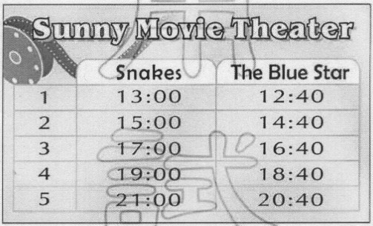

（Ｂ）25. What time is the movie that Fred and Tom decide to see?
(A) 14:40. (B) 15:00.
(C) 16:40. (D) 17:00.
（Ｂ）26. What is the relationship between Fred and Tom? 
(A) Brothers. (B) Classmates.
(C) Father and son. (D) Movie star and fan.

（27～28）
Join us
Lucky’s House offers a warm and safe place for dogs without
a home. It was started by Dr. Joseph Brown in 1995 and has saved
many dogs since then. Join Dr. Brown’s team and help!
We need:
＊ food ＊ towels ＊ part-time workers
＊ money ＊cars ＊animal doctors
You can also take any of our dogs home. It will make them
very happy, because what dogs want most is to have a real home
and family.
Call: Miss White 212-6655

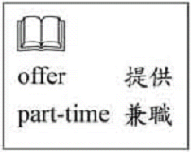

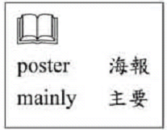
（Ｃ）27. What is the poster mainly about?
(A) Selling dogs.
(B) Looking for dogs.
(C) Asking for help for dogs.
(D) Showing how to build houses for dogs.
（Ａ）28.What does It mean in the poster?
(A) Taking dogs home.
(B) Giving food to dogs.
(C) Being an animal doctor.
(D) Living in Lucky’s House.


（29～30）
Dear May,
I know you are still angry, but please listen to me.
When Mom asked you not to play computer games all day long,
what did you do? In a loud voice, you told her you were doing your
computer homework. Then you slammed your room door and refused
to talk to her.
You don’t understand how much you have hurt her. I think she
is waiting for you to say you are sorry. If you don’t feel comfortable
doing so, why don’t you just say something like “Good morning”?
If you can say anything, it will make your mom feel better. I know
you love her, and I hope things can go well between the two of you.
Love,
Dad

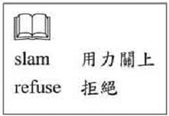

（Ｄ）29. Why was May angry?
(A) Her father refused to talk to her.
(B) Her mother spoke to her in a loud voice.
(C) She got hurt when she slammed the door.
(D) She was told to stop playing computer games.
（Ｃ）30. What does May’s father ask her to do in the letter?
(A) To study harder.
(B) To get up earlier.
(C) To talk to her mother.
(D) To do her homework carefully.
（31～33）
Bill and Jill were going to visit Da-wei and Li-hua Wu in Taiwan for several days.
Before they left America, Bill and Jill tried to learn about Chinese food and Taiwanese
ways of doing things. They wanted to be polite. They learned that most people in Taiwan
eat rice, drink tea, and take off their shoes when they go into a friend’s apartment. Bill and Jill even learned to use chopsticks.
At the same time, Da-wei and Li-hua learned about American food and American way of doing things. They wanted to be friendly. When Bill and Jill came to the Wu’s house, Da-wei and Li-hua told them to keep their shoes on. Later they went out for dinner. They ate pizza and drank Coke. The next few days, they had breakfast in a coffee shop and ate hamburgers in a fast-food restaurant.
On their way back to America, Bill and Jill were thinking about why they never ate rice or drank tea or ate with chopsticks. They never took off their shoes when they visited the Wu family. They thought that living in Taiwan was just like living in America.
（Ｄ）31. How did Bill and Jill prepare for their trip to Taiwan?
(A) They learned to speak Chinese.
(B) They prepared a new pair of shoes.
(C) They bought a lot of American food.
(D) They learned to do things the way Taiwanese people do.
（Ａ）32. Which made Bill and Jill think that Taiwan was just like America?
(A) The Wu family often ate fast food.
(B) The Wu family drank tea after dinner.
(C) The Wu family could speak good English.
(D) The Wu Family took off their shoes in the house.
（Ｂ）33.What does They mean in the reading?
(A) Bill and Jill.
(B) Da-wei and Li-hua.
(C) Most people in Taiwan.
(D) American ways of doing things.

（34～35）

Hi Brenda,
How are you doing? I am on vacation in Hollaya with my parents.
We have been here for two days. Yesterday we went to a restaurant
and tried calas. They were so delicious that we ate too much and
were too full to eat dinner.
Today my parents took me to visit Anita, my mother’s classmate in
high school. She moved to Hollaya about 10 years ago when she got
married. She was very nice, and she showed us around the city. In
the evening, we went to a theater to see a modern dance show.
Tomorrow we’re going shopping. I’ll tell you more later.
All the best,
Candy

（Ｄ）34.What does calas mean?
(A) A vacation.
(B) A restaurant.
(C) A dance show.
(D) A kind of food.
（Ｄ）35.Which is true about Anita?
(A) She can dance very well.
(B) She was born in Hollaya.
(C) She was a high school teacher.
(D) She is an old friend of Candy’s mother’s.

（38～39）
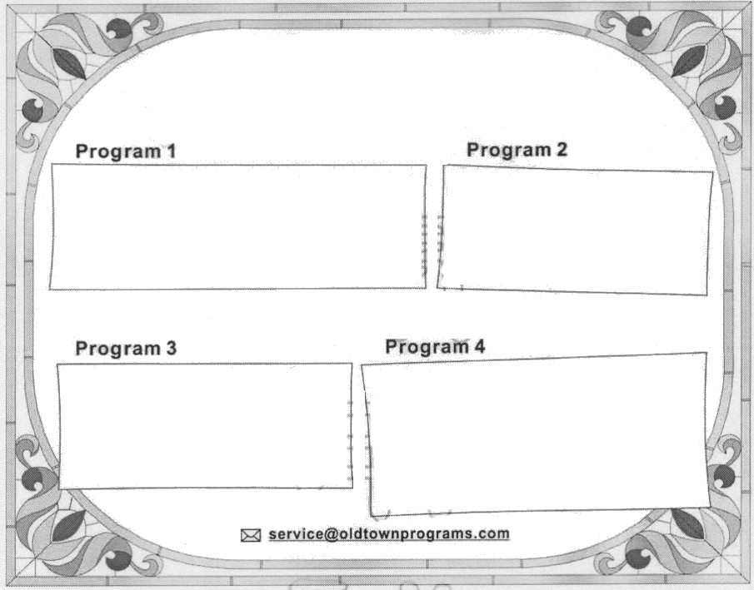
Welcome to Old Town. To make you
better understand this special small town,
We have four programs for you:
Going back to the past
◎ Enjoy food and toys from Grandma’s time
◎ Have a cup of tea under old trees
◎ Spend a day in an old house
Buying old things
◎ Shop at second-hand stores
◎ Visit the weekend market
◎ Buy an old-time party dress
Learning from the past
◎ Meet with the town’s old people
◎ Visit the history museum
◎ See the movie Good Old Times
Looking to the future
◎ Dance with the teenagers of Old
Town
◎ Visit old farms with new machines
◎ Watch the video program
A Modern Life in Old Town

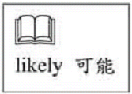
（Ｂ）36.Grace enjoys collecting old bags and clothes. If she takes a trip to Old Town, which program will she most likely be interested in?
(A) Program 1.
(B) Program 2.
(C) Program 3.
(D) Program 4.

（Ｂ）37.Who will most likely talk with visitors in Program 3?
(A) Ms. Vogel. She is a young dance teacher in Old Town.
(B) Mr. Devlin. He has lived in Old Town for more than sixty years.
(C) Alex Ryan. He is boy who enjoys climbing the old trees of Old Town.
(D) Aunt Dolly. She has visited her married daughter in Old Town three times.

（38～39）
Vivian sent a letter and a picture to Gloria.
Dear Gloria,
How have you been? I miss you very much. It’s my second
year in Burney. School is not a problem for me, and I have made some friends in my class.
Here’s a picture of my classmates. The girl standing next to
me is Sally. She has beautiful long hair. And the boy in the cap
is the cutest person in the class; we all call him Jolly Jerry. The
other boy is Jason. I think he is smart and nice. I’m thinking of
asking him to a movie. What do you think? Please give me
some suggestions on what I should do. Maybe I’ll have a
boyfriend when you see me next time!

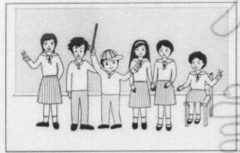


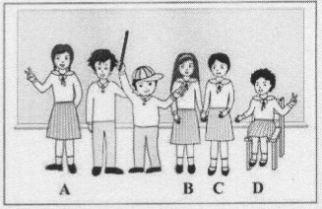
（Ｃ）38.Who in the picture is Vivian?
(A) A.
(B) B.
(C) C.
(D) D.
（Ａ）39.Which is true about Vivian?
(A) She likes Jason.
(B) Studying is difficult for her.
(C) She is Gloria’s classmate in Burney.
(D) She has lived in Burney for more than two years.

（40～42）
(Mrs. Cook arrives home after shopping for food.)
Walter: Mom, I can’t find my eraser.
Mrs. Cook: Again? That’s the fourth time this month! Have you checked your pencil box?
Water: Yes, but it’s not there.
Mrs. Cook: Did you look around in your room?
Water: Yes, I did.
Mrs. Cook: How about the living room?
Water: It couldn’t be there. I was going my homework in my room and didn’t even go
Into the living room.
Mrs. Cook: Well, then, borrow one from your brother for now. I’ll help you find it after I
Put all the food in the refrigerator.
Water: OK.
Mrs. Cook: Walter! Look what I’ve found.
Water: My eraser!
Mrs. Cook: In the refrigerator?
Water: Oh, I remember! I got some juice from the refrigerator, and…and…
Mrs. Cook: And put the eraser in the refrigerator?
Water: Well, I don’t remember that part.
Mrs. Cook: Well, take it, and be more careful next time.
（Ｃ）40.Where did Walter put his eraser?
(A) In the juice.
(B) In his pencil box.
(C) In the refrigerator.
(D) In the living room.
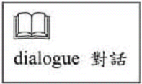
（Ｄ）41.What does did mean in the dialogue?
(A) To do homework.
(B) To borrow one eraser.
(C) To go to the living room.
(D) To look around in Walter’s room.
（Ｃ）42.What do we now about Walter?
(A) He is good at cooking.
(B) He is the only child in the family.
(C) He has lost his eraser several times.
(D) He went shopping for food with his mom.

（43～45）
Today’s Weather
The first typhoon of this year is coming fast from the Green
Sea. Although it will not arrive until tomorrow, strong winds and
heavy rains are here already.
It is quite windy in Greenton. The city’s famous bright sun
cannot be seen today because the rain is going to last all day.
Greenton’s temperature today is 21-24°C.
Ferilla is also windy and rainy. Its beautiful beaches are closed
because of the typhoon. People who want to have a vacation there
will have to change their plans. The city’s temperature today is 20-24°C.
The weather in Coco Town will still be good today, just like
yesterday, because it is on the north side of White Mountains, and
the mountains block most of the wind. The temperature in Coco
town is 25-29°C.


（Ｃ）43.Which picture shows Greenton today?
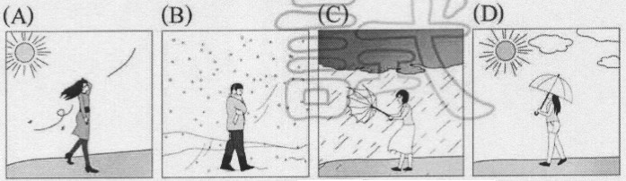

（Ａ）44.What is Ferilla?
(A) A city. (B) A beach.
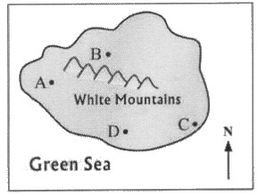
(C) A typhoon. (D) A mountain.
（Ｂ）45.Look at the map. Where is Coco Town?
(A) A. (B) B.
(C) C. (D) D.

