98學年度國中第二次基本學力測驗 英語領域
解析：陳潔老師

第一部分：下列各題（題號l～19），請依據題意選出一個正確或最佳的答案。
l. Look at the picture. The boy in long pants is the only one who is .
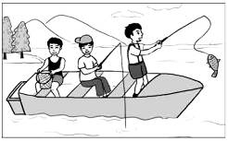
(A) fishing
(B) holding a basket
(C) sitting
(D) wearing a cap

答案：(D)
解析：看圖作答, 由圖中可得知，唯一穿著長褲的及男孩正戴著帽子。

2. Be when you pick up the broken dishes. Don’t cut yourself.
(A) careful (B) honest (C) polite (D) strong

答案：(A)
解析：1.要辨別be動詞之後接形容詞。
2.其重點為『撿起破裂的盤子』」，故選擇(A)要小心

3. The tall man over there is our new English teacher, ?
(A) is he (B) is there (C) isn’t he (D) isn’t there

答案：(C)
解析：關鍵字為be動詞『is』，直述句為肯定，附加問句為否定，tall man的代名詞為he。

4. The weather is nice and cool today. Let’s go for a on the grass and enjoy some food and drinks.
(A) drive (B) picnic (C) swim (D) vacation

答案：(B)
解析：關鍵字為on the grass，在草地上並享受食物與飲料，故選擇(B)去野餐。

5. Enya got up early this morning she did not want to be late for her trip.
(A) if (B) but (C) though (D) because

答案：(D)
解析：能理解因為不想遲到，所以早起之前因後果的連接詞。

6. Larry, my American friend in Taiwan, has learned to use well and can eat beef noodles the way most Taiwanese people do.
(A) chopsticks (B) forks (C) knives (D) spoons

答案：(A)
解析：能理解美國的朋友使用中國人吃飯工具的方式，故選擇(A)筷子。

7. My son has grown bigger and become too for me to carry on my back.
(A) long (B) heavy (C) handsome (D) serious

答案：(B)
解析：1.要能理解片語too…….to
2.太…-而無法將兒子背在背上，故選擇(B)太重了。

8. The baby birds were still hungry so their parents had to fly out to more food.
(A) get off (B) give up (C) look for (D) put on

答案：(C)
解析：1.能清楚背誦片語。
2.(A)下車，(B)放棄，(C)找尋，(D)穿戴。
3.鳥兒雙親是去找尋食物給饑餓的小鳥。

9. Yesterday I went to the beach with my brother. The sun was so that it hurt my eyes!
(A) big (B) bright (C) sunny (D) warm

答案：(B)
解析：1.要能理解片語so……that(如此~~~以至於)體
2.關鍵字為海邊，所以明亮的太陽會傷眼睛。

10. Cell phones are convenient; every person in my family has .
(A) it (B) one (C) them (D) those

答案：(B)
解析：1.能了解答案為代替前句之cell phones。
2.因為every person為單數，故答案選(B)one。

11. See the ruler on your right? Please it to me. I need to draw a line.
(A) check (B) collect (C) hand (D) turn

答案：(C)
解析：了解需要的東西在你右邊。故答案選(C)請轉交給我。

12. When Sean came to Taiwan several years ago, people knew about him. But now he is a famous cook in Taiwan.
(A) any (B) few (C) little (D) most

答案：(B)
解析：1.能了解修飾可數與不可數之形容詞。
2.(A)任何—用於可數與不可數(B)很少—用於可數(C)很少—用於不可數(D)大多數—用於可數。
3.現今有名，故答案選(B)以前很少人認識他。

13. The woman you met in the library yesterday our school a lot of books.
(A) giving (B) given (C) to give (D) will give

答案：(D)
解析：1.本題要能了解形容詞子句之用法。
2.The woman為三單，故答案選(D)。
3.(A) (B)的答案少了動詞，(C) 的答案—主詞之後無法接to…

14. This restaurant makes delicious chicken rice, so always full of people at mealtime.
(A) it is (B) they are (C) there is (D) there are

答案：(A)
解析：1.能了解答案為代替『餐廳』
2.了解片語be full of充滿了人，故答案選(A)。

15. Ms. Wu: What animals your sister like?
Herbert: She likes lions and tigers.
(A) do (B) does (C) are (D) is

答案：(B)
解析：1.了解like在此題中文為『喜歡』，所以它是動詞
2.一般動詞改疑問句需加助動詞，your sister為三單，故答案選(B)。

16. Carl: ?
Tina: It’s three thirty. Why? You look worried.
Carl: I have a math test at four o’clock.
(A) How much money do you have (B) What day is today
(C) When does your school begin (D) What time is it

答案：(D)
解析：1.理解片語。
2.(A)how much—問多少錢(B)what day—問星期(C)when—問何時(D)what time—問幾點幾分，故答案選(D)。’

17. Ted: Why didn’t Andy do his homework?
Joe: He said he lost his workbook last night.
Ted: Do you believe him? I think it’s just a(n) .
(A) excuse (B) interest (C) program (D) question

答案：(A)
解析：1.熟悉單字用法。(A)藉口(B)興趣(C)節目(D)問題。
2.在此未做功課的藉口是丟了作業簿，故答案選(A)。

18. Mom: What after school today?
Ryan: Well, I just read some comic books.
(A) did you do (B) do you do (C) are you doing (D) will you do

答案：(A)
解析：由just得知是過去所發生的事情。

19. Mark: We can’t enter the house. I can’t find my key!
Billy: Is it possible that you it in the car?
(A) caught (B) changed (C) found (D) left

答案：(D)
解析：因為找不到鑰匙，猜測是可能之前遺留在車裡，故選(D)left過去式。

第二部分：下列十一個題組，共有26題（題號20～45），請依據選文成所附圖表資料，選出一個正確或最佳的答案。
(20-22)
Shu-mei is in the third year of senior high school. She is very good at singing and 20
many prizes in the past few years with her beautiful voice. Although Shu-mei always gets good grades at school, she does not want to spend too much time studying. She 21 singing more than studying. Her biggest dream is to become a great singer in the future. Shu-mei’s parents have sent her to a music teacher to learn singing, and Shu-mei 22 hard every day. She hopes she can get into a music school to study singing after she finishes high school.
 prize 獎賞

20. (A) wins (B) was winning (C) has won (D) is going to win

答案：(C)
解析：在過去的幾年中得到許多獎項故用現在完成式。

21. (A) loves (B) loved (C) is loving (D) will love

答案：(A)
解析：She does not want to為現在式，因此喜愛唱歌屬於事實，也用現在式。

22. (A) practices (B) practiced (C) has practiced (D) is going to practice

答案：(A)
解析：由every day得知為每天，故答案故答案選（A）也用現在式。
(23-24)
John sells hot dogs outside the flower market. Sometimes people come up to him and ask for directions. Look at the map and answer the questions.

I.
Rose: Excuse me. Could you tell me how to get to the 23 ?
John: Of course. Just go down Market Road for two blocks and turn left. You’ll see a church. It’s next to the church, on First Street.
Rose: I see. Thanks.
John: You’re welcome.

II.
John: Good morning. Would you like a hot dog?
Fred: Yes, one please. By the way, where can l find a bookstore near here?
John: Go down Third Street and 24 . It’s between a shoe store and a music store.
Fred: Thank you.
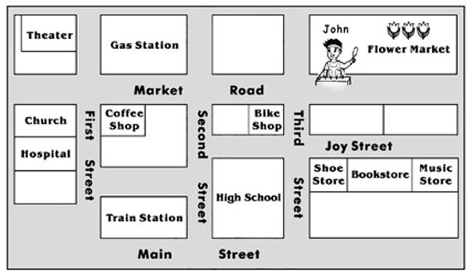
& direction指引方向 by the way順便問一下

23. (A) theater (B) train station (C) gas station (D) hospital

答案：(D)
解析：由對話中得知，延著Market Road走兩個街區再左轉，旁邊是所教堂，故答案選(D)醫院。

24. (A) turn to your right (B) stop at the bike shop
(C) turn left on Joy Street (D) walk past Main Street

答案：(C)
解析：書店在Joy Street上，所以延著Third Street走，必須左轉。

(25-26)
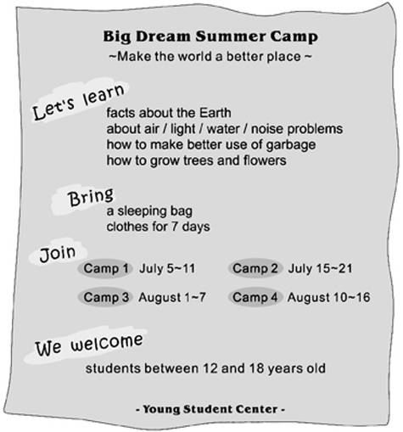
& logo標誌
25. Which is the best logo for the Big Dream Summer Camp?
& route路線
& route路線

(A) (B) (C) (D)

答案：(D)
解析：由第一段得知是有關地球空氣、水、噪音等問題，

26. Sally, a junior high school student, would like to go to the Big Dream Summer Camp. But she has to take math and English classes from July 10 to 3l, and her parents will take her for a trip on August 12.which camp could Sally join?
(A) Camp 1. (B) Camp 2. (C) Camp 3. (D) Camp 4.

答案：(C)
解析：從題目得知Sally從July 10~~31及August 12無法參加夏令營，故答案選(C)。

(27-28)
(Carol talks to Jason on the phone.)

Carol: Hello, are you ready to come?
Jason: I’m sorry, but l can’t go today.
Carol: Why not? What happened?
Jason: You know, it started raining last night. It rained so hard that the water came into our house.
Carol: That’s too bad. Is everything fine?
Jason: Well, there’s water almost everywhere, and the house is very dirty now. Luckily, the rain has finally stopped. Now we have a lot of work to do. That’s why I can’t go out with you today.
Carol: It’s OK. I can understand. But I heard that we’ll have this bad weather for another week. That’s really strange for November!
& everywhere到處

27. Why CAN’T Jason meet Carol?
(A) He has a cold. (B) He doesn’t like Carol.
(C) He has to clean the house. (D) He doesn’t like to go out on rainy days.

答案：(C)
解析：由文章中第七行得知，Jason家淹水並且房子很髒。

28. Which is true about the weather?
(A) It is always rainy in November. (B) It has rained heavily for a week.
(C) It will not become fine until tomorrow. (D) It is not raining when Carol talks to Jason.

答案：(D)
解析：(A)十一月並非總是下雨
(B)只有昨天下大雨
(C)今天天氣轉好。

(29-30)


29. Which is true about the basketball club?
(A) People can join the club without paying.
(B) Bob Miller is the person who started the club.
(C) People in the club play the sport in the early morning.
(D) The club is looking for people to play in a national game.

答案：(A)
解析：It’s free即表明免費，故答案選(A)。

30. Who CANNOT join the club?
(A) Steven, a high school student who is a basketball fan.
(B) Josh, an elementary school teacher who can play basketball well.
(C) Maggie, a ten-year-old girl who enjoys playing basketball on the computer.
(D) Barbara, a taxi drivel who has been interested in basketball since she was young.

答案：(C)
解析：文章內容表明，需滿十二歲且在公園練習籃球。

(31-32)
Last month Jim brought a baby cat home from the pet shop. She is beautiful with gray and white hair. Jim gave her the name Popo. He and his family love her very much and often talk to her. Popo is very shy and afraid of strangers. Every time Jim brings his friends home, she will hide herself. It takes time to make friends with Popo. But when she sees you as a friend, she will be happy to be with you all the time. Popo often lies quietly next to Jim when he is home. Sometimes she sits by the window looking at the flowers in the garden.
The family is always busy and it is not easy for them to get together. But since they got Popo they have tried to spend time together playing with their little girl who has become the center of their family life.

31. What can we learn from the reading?
(A) Flowers make a house more beautiful.
(B) Keeping a pet helps a family get together.
(C) We should be friendly to people who visit us.
(D) It takes time to make friends with people who love cats.

答案：(B)
解析：文章內容最後一段，since they got Popo, they have tried to spend time together playing with their little girl, who has become the center of their family life.說明了全家以Popo為重心。

32. Which is true about the little girl in the reading?
(A) She loves to hide herself when playing.
(B) She cannot be quiet when Jim is around.
(C) She does not feel comfortable with strangers.
(D) She was found by Jim when she got lost on the street.

答案：(C)
解析：文章內容Popo is shy and afraid of strangers. Popo很害羞且害怕陌生人。故答案選(C)它與陌生人相處並不覺得舒服。

(33-34)
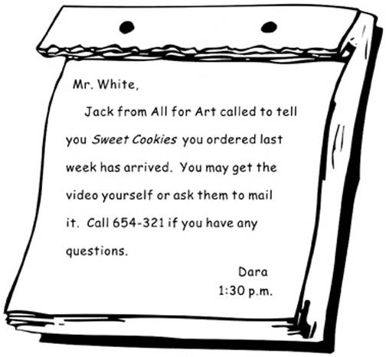

33. What can we learn from the note?
&
note便條留言
(A) Dara works at All for Art.
(B) Mr. White has to call back.
(C) Jack wants to see Mr. White soon.
(D) All for Art has got what Mr. White wanted.

答案：(D)
解析：文章內容Sweet Cookies you ordered has arrived，他所訂購的東西已到達。
& logo標誌
34. What is Sweet Cookies?
(A) A video. (B) A snack. (C) An art book. (D) A light meal.

答案：(A)
解析：文章內容you may get the video yourself or ask them to mail it.故答案選(A)，Sweet Cookies 即為錄影帶。

(35-36)
Here are the lyrics of a song.
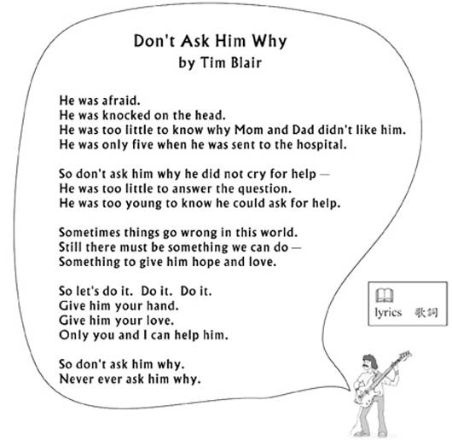
&
lyrics歌詞

35. What can we know from Tim Blair’s song?
(A) Children lie without knowing why.
(B) He wants to bring hope to children in need.
(C) Children can do well at school with special help.
(D) He believes children should speak for themselves.

答案：(B)
解析：文章內容提到Something to give him hope and love. So let's do it.他想帶來希望與愛給小孩。故答案選(B)。

36. Which is most likely to be true about the little boy in the lyrics?
& likely 可能
(A) He liked to ask questions.
(B) He was hit by his parents.
(C) He went to school at the age of five.
(D) He was afraid of singing in front of people.

答案：(B)
解析：文章內容提到He was afraid·He was knocked on the head，因此推論小男孩被打，故答案選(B)。
(37-39)
It is 8:00 at night, and Amy Bronte is usually home by now. But she isn’t. Her father is very worried about her. He has called everyone who may know where Amy is. Below is what Mr. Bronte has heard on the phone.

Uma, Amy’s teacher: “I saw her walking with Pam after school. It was about four thirty in the afternoon.”
Pam, Amy’s classmate: “Amy was with me on my way home, and she said she was going to see her boyfriend, I got home at five.”
Tony, who lives next door: “I saw Amy carrying some food just half an hour ago. She was with a red-haired boy. They were in a hurry, talking about buying tickets or something.”
Peter, the shopkeeper: “Amy? She bought some snacks and drinks around seven in the evening. With a red-haired boy called … Ray.”
Rachel, Ray’s sister: “Ray? Ray went out to meet his girlfriend. They were going to a party in the park next to Best Buy Supermarket. The party started at eight, I think.”
Now Mr. Bronte knows what happened. He is angry and waits for Amy to come home.

37. Where does Mr. Bronte think Amy is now?
(A) In a park. (B) At Pam’s house. (C) At a snack shop. (D) In a supermarket.

答案：(A)
解析：文章內容提到They were going to a party in the park next to Best Supermarket，因此推論Amy在公園。

38. What do we know from the reading?
(A) Amy is with a friend. (B) Amy left school at noon.
(C) Amy usually gets home late. (D) Mr. Bronte went out to find Amy.

答案：(A)
解析：文章內容一直提及She was going to see her boyfriend, She was with a red-haired boy called....Ray…，Amy要去見她的男朋友，Amy和一個紅頭髮男孩在一起。

39. Who did NOT sec Amy today?
(A) Ray. (B) Peter. (C) Tony. (D) Rachel.

答案：(D)
解析：文章Rachel所敘述的為Ray，因此推論Rachel並未見到Amy。

(40-42)
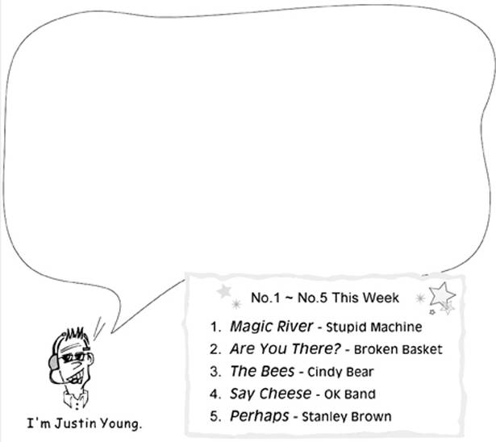

Welcome to Music Ground, a radio show that gives you a wonderful Friday night. I’m Justin Young. It’s time again for the best-selling songs of the week. Stanley Brown’s “Perhaps” is a new song that comes in at No.5 this week. “Say Cheese” by OK Band stays in the same place at No.4. “The Bees” by Cindy Bear falls down from No.2 to No.3. And No.2 is another new song called “Are You There?” by Broken Basket. Finally, there’s no change at No.1, with “Magic River” by Stupid Machine. Many people are calling in for this favorite song, so let’s listen to it right now. And don’t go away. Later we’ll talk over the phone with Stupid Machine about their plans for the coming year.

40. Which song does NOT change its place this week?
(A) “Are You There?” (B) “The Bees”
(C) “Say Cheese” (D) “Perhaps”

答案：(C)
解析：文章內容提及“Say Cheese”by OK Band stays in the same place at No.4·因此可知 “Say Cheese”仍然停留在第四名 。

41. How many songs listed above are new this week?
(A) One. (B) Two. (C) Three. (D) Four.

答案：(B)
解析：文章內容提及Stanley Brown’s “Perhaps: is a new song that comes in at No.5 this week. And No.2 is another new song called “ Are You There”，因此可知 Perhaps是為於第五名的新歌。第二名的新歌為”Are You There。

42. Which is NOT true about the radio show?
(A) You can listen to it once a week.
(B) It talks about the most popular songs.
(C) People can call in to hear their favorite songs.
(D) Stupid Machine is now in the radio station with Justin Young.

答案：(D)
解析：文章內容最後兩行提及Later we’ll talk over the phone with Stupid Machine about their plans for the coming year.由此可知，Stupid Machine是在電線連話，而並非本人在錄音室。

(43-45)
Isadora Duncan was born in America in l877. She was a great dance teacher who enjoyed dancing at an early age, and even began teaching other children to dance when she was only six. Although Duncan herself stopped going to school at ten, she later had students from all over the world.
Duncan was called the mother of modern dance because she brought lots of new ideas into the dancing of her time. She believed that dance is life itself and comes from the heart. Duncan also said that dance belongs to everyone, rich and poor young and old. That was why one time she did not agree to dance in a theater where the tickets were very expensive.
Duncan also surprised the people of her time by dancing in comfortable clothes and without shoes on. She broke the rules in many ways and gave dance a new language. Now people who are interested in modern dance are still getting new ideas from this great teacher.
 mainly主要
43. What is the reading mainly about?
(A) The history of American modern dance.
(B) The dancing life of an American dancer.
(C) The dance group Isadora Duncan started.
(D) The way of lit in Isadora Duncan’s time.

答案：(B)
解析：文章內容第二段Duncan was called the mother of modern dance because she brought lots of new ideas into the dancing of her time，Duncan被稱為現代舞蹈之母是因為她帶來許多新思想在她的舞蹈生命中。

44. What did Duncan think of dance?
(A) It shows how people feel. (B) It should be learned at an early age.
(C) It is a hobby that needs strong shoes. (D) It could be enjoyed more in a theater.

答案：(A)
解析：文章內容第二段She believed that dance is life itself and comes from the heart，她相信舞蹈即是生命的本身並且來自於真心，故答案選(A)它表現出人們的感受。

45. What does a new language mean in the reading?
(A) A new word for dancing. (B) New ideas about dancing.
(C) A new kind of dance music. (D) New rules hr selling dance tickets.

答案：(B)
解析：Duncan also surprised the people of her time by dancing in comfortable clothes and without shoes on…She broke the rules in many ways and gave dance a new language.....即說明了Duncan穿著舒適的衣服與不穿鞋子的表演令人驚訝，她打破舊觀付予舞蹈新思想，故答案選(B)。

